READ ME FIRST

Put SuperSID CD in computer

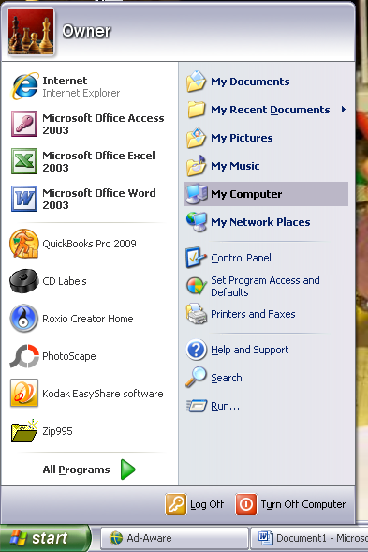
Go to My Computer
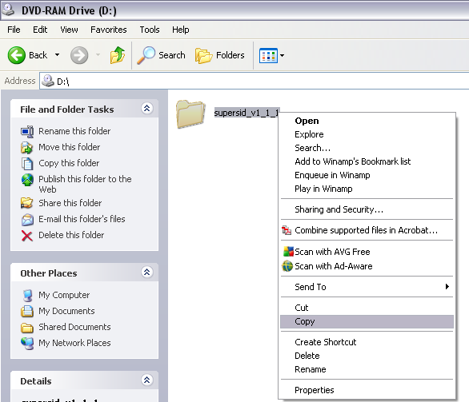
Open CD
Hi-light supersid_v1_1_1
Right click and COPY

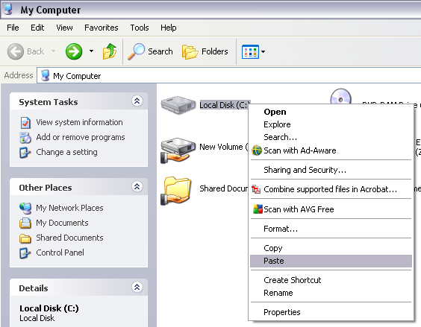
Go back to My Computer
Right click on Local Disk (C:) and PASTE
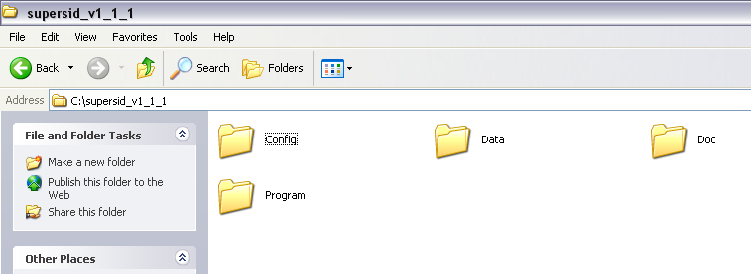
Open supersid_v1_1_1
You will see these 4 folders

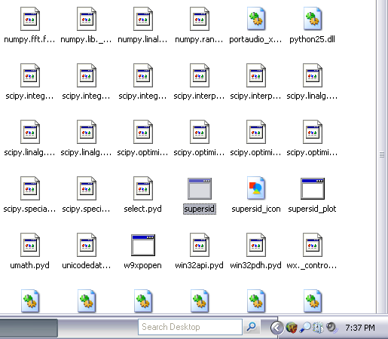
Open the Program file
Look for this supersid file
Make a Short Cut and put on desktop

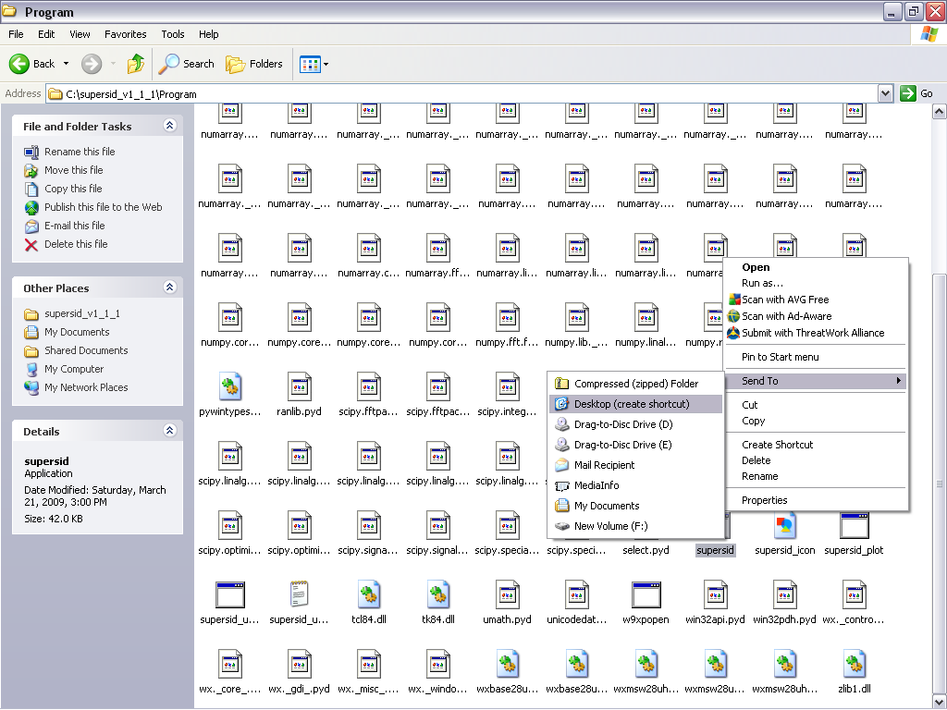
Right click on supersid
Select Send To
Select Desktop
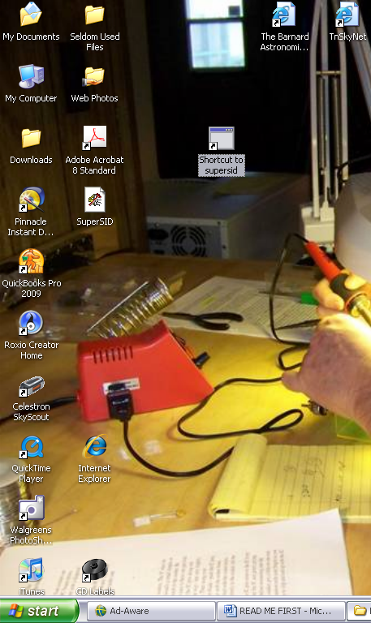
When you are ready to run supersid, click this icon
Be sure to read the SuperSID Users Manual for all the information you need to successfully operate the system and collect data.

For Linux Users

For Linux one can run the code directly.

If you install the distribution, under windows you will find the code in "\Program Files\SuperSID" the Folder "Code".

That is the folder which contains the source code which can directly be run by Linux Users. There is a file called "Note", which lists the libraries one needs to run these sources. Of course, one needs to have python under Linux as well.

If you have ordered/received coax cable and/or antenna wire, DO NOT CUT OFF ANY OF THE ENDS. The coax and antenna wire is ready to use once you make your frame.

