Space Weather Forecast

Space Weather Curriculum

Developed at Chabot Space & Science Center

For the Stanford Solar Center

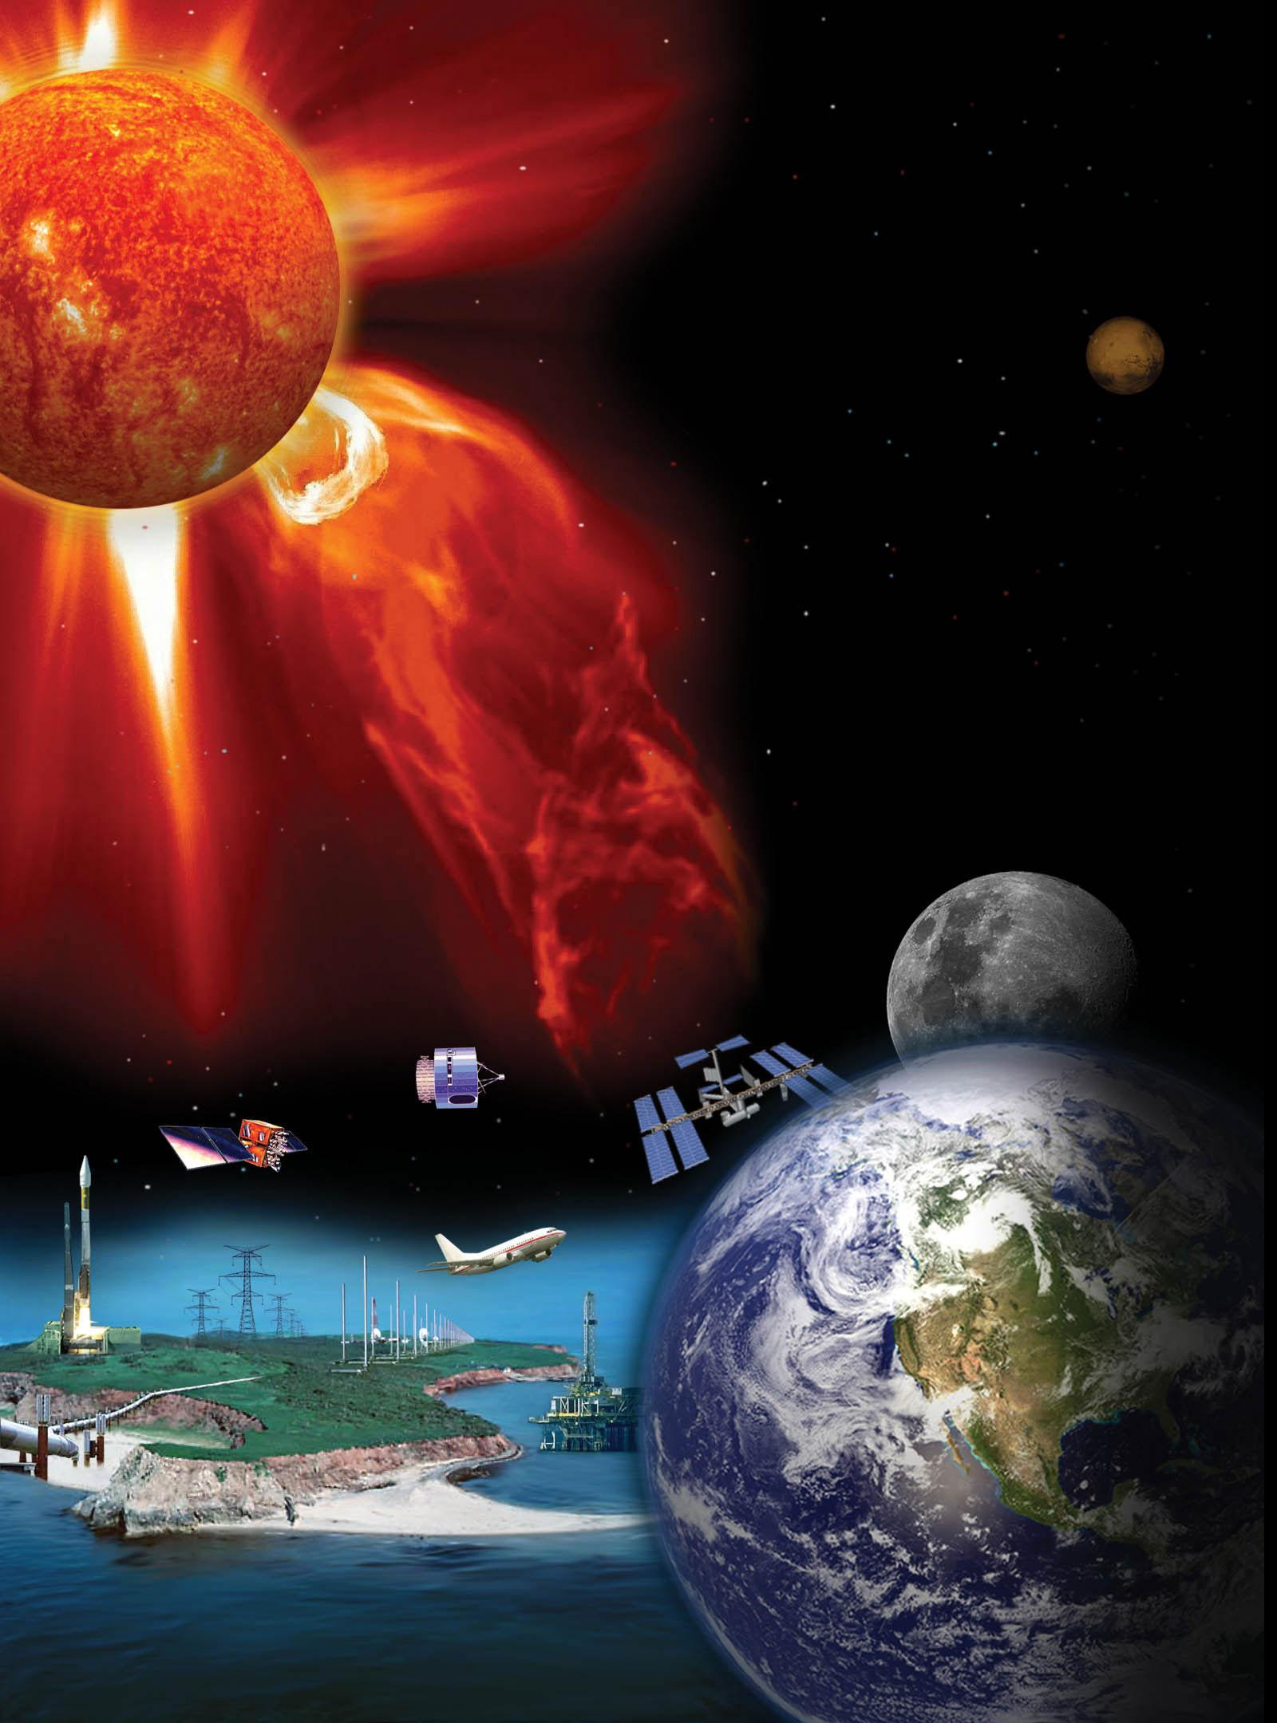

Updated June 2015

# Contents

Contents 2

Introduction 6

Overview 6

History and Science 7

As the Sun Turns 10

Introduction 10

Lay of the Landless: Geography of the Sun 10

East to West, or West to East 12

Modeling Sunspot Motion 13

What you will do 13

How you will do it 13

Materials and Skills 13

Step-by-Step 13

Drawing a Sunspot Map 15

What you will do 15

How you will do it 15

Materials and Skills 15

Step-by-Step 15

Measuring Solar Rotation—Image Scale Method 18

What you will do 18

How you will do it 18

Materials and Skills 18

Things to Think About 18

Data Collection 18

Analysis 19

Discussion on Sources of Data 24

Measuring Solar Rotation—Solar Latitude/Longitude Method 26

What you will do 26

How you will do it 26

Materials and Skills 26

Background 27

Step-By-Step 29

A Look on the Farside 33

Introduction 33

Farside Defined 33

Helioseismology 34

Getting Familiar With the Data 35

What you will do 35

How you will do it 35

Materials and Skills 35

Background 36

Spot Plots 38

What you will do 38

How you will do it 38

Materials and Skills 38

Background 38

Getting Oriented With the Rectangular Map 39

Tracking Motion on the Rectangular Map 40

Far Sight 42

What you will do 42

How you will do it 42

Materials and Skills 42

Background 42

Getting Familiar with the Farside Data 42

The Hunt 45

What you will do 45

How you will do it 45

Materials and Skills 45

Step-by-Step 45

Hunt Log 47

Flarecast! 48

Introduction 48

Flare Classes 48

Predicting a Flare 49

Relative Sunspot Number (RSN) 51

What you will do 51

How you will do it 51

Materials and Skills 51

Background 51

Example of Calculating Relative Sunspot Number 51

Step-by-Step 54

Relative Sunspot Number Worksheet 55

Charting a Forecast 56

What you will do 56

How you will do it 56

Materials and Skills 56

Step-by-Step 56

Improving your forecast 58

Forecasting Grid 59

Following Up 60

What you will do 60

How you will do it 60

Materials and Skills 60

Background 60

What to do with the data 62

The Smoking Gun 67

Introduction 67

Things To Think About 67

Sources of Data 67

Doing a Little Research 68

What you will do 68

How you will do it 68

Finding Space Weather Events 69

What You Will Do 69

How You Will Do It 69

Materials and Skills 69

Data Sources 69

Step-by-Step 69

Worksheet A: Solar Wind Event Properties 70

Tracking the Solar Wind Event to Its Source 71

What you will do 71

How you will do it 71

Materials and Skills 71

Finding the Event’s Departure Date from the Sun 71

Fingering the Suspect 71

Worksheet B: Tracking the Event to the Sun 72

Finding Other Effects on the Earth 73

What you will do 73

How you will do it 73

Resource Websites 74

Glossary 75

National Science Content Standards 80

Grades 5-8 80

Grades 9-12 82

Stonyhurst Disks 84

June 7 and December 7 (B0 = 0) 84

January (B0 = -5) 85

February, March (B0 = -7) 86

April (B0 = -6) 87

May (B0 = -3) 88

June (B0 = +1) 89

July (B0 = +4) 90

August, September (B0 = +7) 91

October (B0 = +6) 92

November (B0 = +3) 93

December (B0 = -1) 94

Sample SOHO MDI I-grams 95

Blank Rectangular Coordinate Grids 101

# Introduction

## Overview

Our Sun is not only the giver of life to our planet; it’s also a powerful opportunity to teach science, mathematics, and data acquisition and analysis.

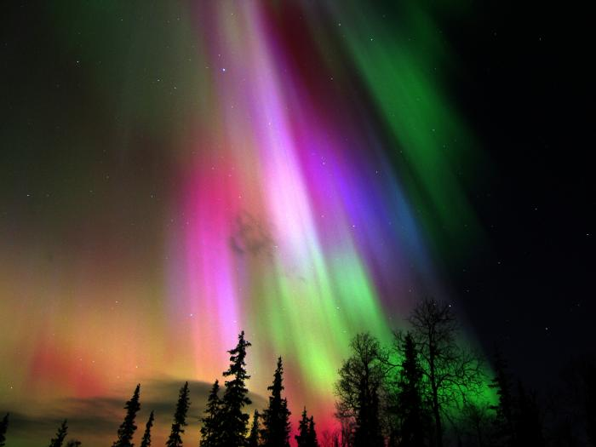

The Sun is an enormous physics laboratory, offering opportunities for inquiry into subjects like magnetism, nuclear physics, electricity, electromagnetic radiation, thermodynamics, and space-based observational technology. Furthermore, the Sun’s effects upon near-Earth space, Earth’s magnetosphere, atmosphere, and biosphere open the door to investigation of the properties of the *solar wind*, the aurora, and how the behavior of the Sun affects us here on Earth.

Using current solar data and imagery from cutting edge satellite observatories, you will: 1) Observe and analyze magnetically active regions on the Sun, 2) track solar rotation, 3) assess the potential for high-powered flare activity, and 4) correlate events in the *space weather* affecting Earth with their sources on the Sun.

The main investigations in this curriculum unit are:

* Sunspot Tracking and Solar Rotation
* A Look at the Farside of the Sun
* Forecasting Solar Flares
* Looking for the “Smoking Gun”

These activities are aligned with National Science Content Standards (see page 80).

Image: Multicolored aurora over Finland

## History and Science

Before humans became capable of sending telescopes and other scientific instruments into space, the physical conditions beyond Earth’s atmosphere and magnetosphere were largely unknown. Signs of what may have been going on in the space between the Sun and the Earth became evident, if not understood, in episodes of *aurora* activity, fluctuations in radio noise, and perhaps unaccounted-for variations in the Earth’s *magnetic field*.

Decades of space-based observations have given us a much better understanding of the intricate and varied relationships between the Sun and the Earth, and how solar activity dominates space within the Solar System.

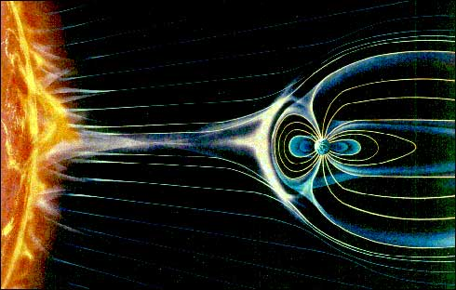The Sun, we now know, is the source of what we call *space weather*: dynamic flows of radiation, magnetism, and plasma that impact the Earth, whether it is the normal, steady stream of *solar wind* sculpting the “wind sock” shape of Earth’s *magnetosphere*, strong “gusts” in the solar wind that cause *geomagnetic storms* and auroras, or bursts of *X-ray* and *ultraviolet radiation* that impact and influence Earth’s *ionosphere*. The solar wind is a constant flow of electrically charged gases (plasma) and magnetic field emanating from the Sun, created when gases in the Sun’s atmosphere are heated enough to achieve escape velocity and fly off into the Solar System.

Right: Conceptual drawing of the solar wind and its effects on the shape of Earth’s magnetosphere. Image credit: NASA

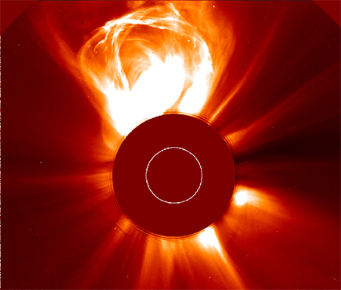Disturbances in the solar wind can be anticipated with some advance warning. Stronger than normal solar wind spews forth from *coronal holes*: regions in the Sun’s corona where magnetic field lines “open out” into space, allowing solar atmospheric plasma to escape more freely (*not unlike air escaping through a hole in a balloon—if you consider the air to be solar gases and the balloon rubber the confining solar magnetic fields*). Coronal holes can be seen in ultraviolet and X-ray images of the Sun as dark regions (dark because of less magnetic activity and therefore less heating of solar gases).

Left: A coronal mass ejection imaged by the SOHO/LASCO instrument. The Sun's bright photosphere is masked to reveal the fainter corona. Credit: NASA/ESA.

*Active regions*—locations on the Sun’s *photosphere* and atmosphere above undergoing intense magnetic activity and heating—are often the source of *coronal mass ejections* (CMEs) and *flares*. CMEs are what the name implies: ejections of enormous masses of material from the Sun’s *corona*—typically billions of tons of plasma hurled into space at a million miles per hour or more! CMEs can be seen in solar images as large blobs and streams of luminous gases blasting outward. SOHO’s LASCO instrument is specially designed to capture images of CMEs.

If directed toward the Earth, the blast from a CME can reshape Earth’s magnetosphere, compressing it on the sunward side and moving its effective boundary (the “bow shock”) closer to Earth, thus exposing volumes of near-Earth space normally under its protection to the direct effects of the solar wind. Sensitive satellites in orbit around Earth have been damaged or disabled by this loss of protection by Earth’s magnetic shield, and such space weather conditions are a serious, life and death concern to astronauts working in space.

On the ground, fluctuations in Earth’s magnetic field caused by the impact of a CME—called *geomagnetic storms*—can induce electrical currents in conducting structures. Geomagnetic storms have been known to overload power grids and cause damage to oil pipelines.

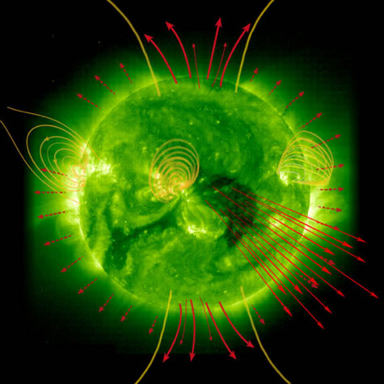Heightened activity in the solar wind, whether from high speed solar wind emanating from coronal holes or blasts caused by CMEs, can also produce increased aurora activity around Earth’s magnetic poles. Periods of increased solar activity, such as during *solar maximum* when the Sun’s magnetic activity reaches a peak, correlate with periods of greater performances by the aurora.

Right: SOHO-EIT extreme ultraviolet image of the Sun with magnetic field lines of force (yellow; loops) and solar wind flow (red; arrows) overlaid. Image credit NASA/ESA.

While the conditions and events in space weather produced by CMEs and coronal holes can be significant, the fact is that even a million mile per hour blast of plasma takes about four days to reach Earth after leaving the Sun. We can observe these events almost as soon as they occur on the Sun, giving observers a comfortable amount of time to determine the speed and approximate direction of the disturbance and make a forecast of space weather related events manifesting on Earth.

*Flares* have a different dynamic. Flares are relatively small, concentrated, and highly energetic explosions of superheated coronal gas caused by the “breakdown” and reconnection of intensely twisted magnetic fields (*not unlike a bundle of rubber bands being wound tighter and tighter until a breaking point is reached and the energy built up in the stretched bands is released in a sharp, often painful snap…*).

Gases within the confined region of a flare can be heated to 20 million degrees or more, emitting *electromagnetic radiation* of the most energetic forms: *X-rays* and *gamma rays*. Like all forms of electromagnetic radiation, X-rays and gamma rays travel at the speed of light, about 300,000 km/sec. So, when a flare erupts on the side of the Sun facing the Earth, these bursts of radiation cross the space from Sun to Earth in little over eight minutes.

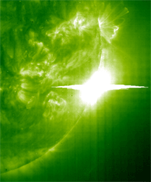Flare activity is usually associated with active regions on the Sun, and so the likelihood of observing a flare, by X-ray or other detection means, is related to the number and strength of active regions currently on the side of the Sun facing Earth. It may not be easy to predict individual flare events with much reliability, but the level of magnetic activity on the Sun can be a good indicator of times when flare events are more likely, and so can be an important tool in forecasting this aspect of space weather.

Left: SOHO EIT extreme ultraviolet image of Sun and an X-45 class flare. Image credit NASA/ESA.

# As the Sun Turns

## Introduction

The daily *apparent motion* of the Sun through Earth’s skies has been observable since there were creatures on Earth capable of observing it. Only in the past few centuries has that motion been demonstrated to be caused by the rotation of the Earth and not the motion of the Sun itself.

The *intrinsic motion* that we understand today as the Sun’s *rotation* has been observable at least since the invention of the telescope. Although pre-telescope solar observers did observe occasional *sunspots*, and noted changes in their positions from day to day, it wasn’t until *Galileo Galilei* observed and tracked sunspots with his telescope, making detailed records of the changes in their sizes, shapes, and location from day to day, that they were regarded as potential indicators of the Sun’s rotation.

### image of the longitude and latitude lines on the Sun, which appear similar to those on EarthgLay of the Landless: Geography of the Sun

Defining locations on an object like the Earth is a simple matter of establishing a coordinate system that is based on fixed references, such as geographical features. The standard coordinate system of latitude and longitude is a measure of two angular positions on Earth’s spherical surface with respect to fixed references.

The reference for latitude is the Earth’s equator, measured from 0 to 90 degrees north or south of it. The reference for longitude is a meridian line running from Earth’s North Pole to its South Pole, and through an arbitrarily determined location in Greenwich, England. Longitude is measured as a number of degrees east or west of this Prime Meridian.

Defining “heliographic” locations on the Sun is a somewhat different ballgame. Since the Sun is a gaseous, fluid object, it has no permanent surface features. Defining latitude on the Sun is fairly straightforward, since latitude is based on the Sun’s equator and poles, which are for all intents and purposes “fixed” characteristics determined by the Sun’s rotation.

Defining solar longitude is trickier. Even though the meridian of Greenwich, England is an arbitrary reference for longitude on Earth, at least it’s a distinct location that can be identified by Earth’s fixed surface geography. On the Sun, there are no fixed, solid surface features, and so nothing to pin a reference meridian to!

Because of this, the reference meridian on the Sun—the Sun’s Prime Meridian, or longitude 0 degrees—is an arbitrarily chosen meridian that rotates at the *sidereal* rotation rate at the Sun’s equator: about once in 25.38 days. Sidereal rotation is rotation with respect to the stars—in other words, the “fixed” frame of reference of the Universe at large.

However, since we observe the Sun’s rotation from the frame of reference of the moving Earth, we also define the period of time over which we observe a point on the Sun’s photosphere (such as a sunspot) to move fully around the Sun once and return to the same observed location on the Sun’s disk where it started. This period, called the Sun’s *synodic* rotation, is about 27.2753 days at the Sun’s equator.

The reason that the synodic rotation period is longer than the sidereal rotation period is because Earth revolves around the Sun in the same direction that the Sun rotates—so it takes spots on the Sun’s surface a little longer to “catch up” to our moving point of view on Earth. The diagram below shows this relationship, and how a spot viewed at dead center of the Sun as seen from Earth at position A must complete slightly more than one full solar rotation to return to dead center as viewed from Earth’s new position, B.

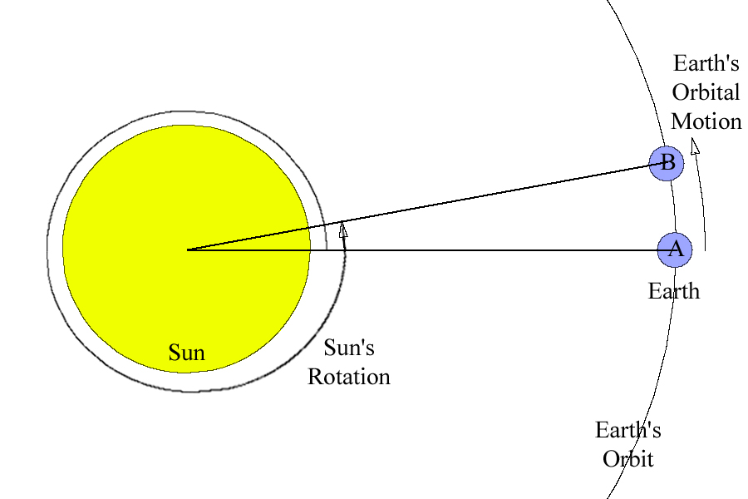

So, the sidereal period of 25.38 days is how long we would see the Sun to make one full rotation if Earth remained fixed and unmoving at point A, like a “fixed” star. But Earth moves along its orbit, creating the synodic period of 27.2753 days.

### East to West, or West to East

Another matter that must be mentioned regards the labeling of east and west on images of the Sun. After orienting an image of the Sun so that the Sun’s North Pole is at the top and the South Pole is at the bottom (which is the convention for orienting maps of the Sun as well as the Earth), what do you call the limbs (edges) of the Sun’s disk at the left and right sides of the picture? From this perspective, you will see sunspots move from the left limb toward the right limb of the image.

If you think of how we define east and west on the Earth, the Earth’s surface rotates *toward* the east (in other words, from west to east), which is why the Sun’s apparent motion across our sky is from east to west—the opposite of the actual motion of Earth’s surface.

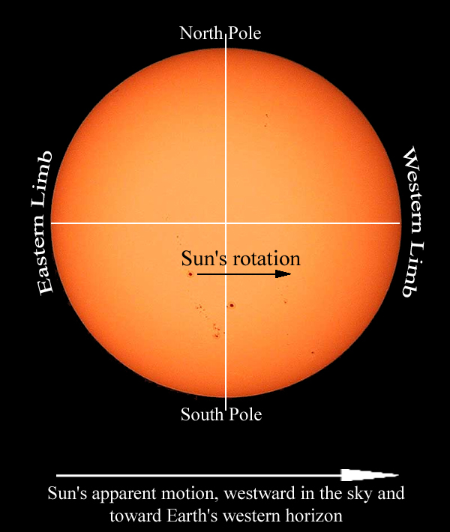Technically, we should apply the same definition to the Sun: we should label the limb toward which the surface rotates as the eastern limb, and the opposite limb the western. As it turns out, however, this is not the case with regard to observing the rotation of the Sun from Earth.

Somewhere along the line, astronomers got into the habit of referring to the east and west limbs of the Sun not by the geographic definitions of those words, but by the directions of the backdrop of Earth’s skies in which the Sun appears.

In other words, east and west got labeled based on the Sun’s apparent motion in our sky, not on the Sun’s intrinsic rotation. As we regard the Sun moving across our sky, it moves from east to west, and so the limb of the Sun on the side facing the Earth’s western horizon is referred to as the western limb.

## Modeling Sunspot Motion

### Dr. Michelle Larson modeling sunspots on a large 3-D sphere. What you will do

Gain an understanding of the *actual motion* of sunspots caused by the rotation of the spherical Sun in relation to their *observed motion* in 2-dimensional images.

### How you will do it

You will use a sphere—a ball—with spots marked on it surface to represent sunspots to model the rotation of the Sun and compare observed *lateral* sunspot motion to *line-of-sight* motion.

Right: Dr. Michelle Larson modeling sunspots.

### Materials and Skills

* A ball or sphere that can be marked on
* A marker (Sharpie, dry erase, wet erase, or other marker)

### Step-by-Step

To help you visualize what’s going on when you see sunspots moving across the Sun’s face, try this exercise:

1. Get a ball of some sort (a golf ball, basketball, beach ball, or something else spherical).
2. Mark a few spots on the surface of the ball, wherever you like (you might want to use an erasable marker, a crayon, or something else if you don’t want the marks to be permanent).
3. Hold the ball up at eye-level with one hand on top and the other hand on the bottom, or pinched between two fingers (if you’re using a smaller ball).
4. Rotate the ball, turning it in your hands, so that the spots on the surface move from left to right. Make sure to keep the *rotational axis* vertical, with the *poles* of rotation at the top and bottom of the ball.
5. As you spin the ball, watch the spots you drew move.

**Questions**

With respect to your point of view:

* How do the spots appear to move when they are near the *limb*, or edge, of the ball’s face?
* Compared to this, how do the spots appear to move when they are near the middle of the ball’s face, crossing the axis of rotation?
* If you wanted to measure how fast one of the spots actually moves, along with the ball’s surface, where should the spot you choose to measure be located?

**Definition**:

*Line-of-Sight Motion:*  The part of an object’s motion that is directly toward or away from an observer is called *line-of-sight* motion. Line-of-sight motion is difficult to determine by eye; something moving directly toward or away from you may be moving very fast, but appear to be perfectly still.

*Lateral Motion:* The part of an object’s motion that is perpendicular to the line-of-sight between the object and an observer is called *lateral* motion.

The motion of an object can be broken down into these two perpendicular vectors: line-of-slight and lateral.

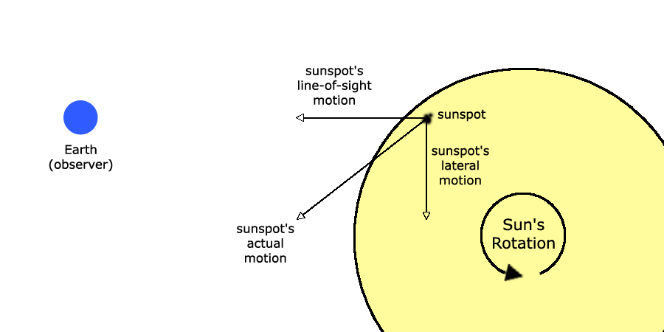

The motion of an object, such as a sunspot observed on the Sun, can be expressed in terms of two perpendicular vectors: the *line-of-sight* component and the *lateral* component.

## Drawing a Sunspot Map

### What you will do

You will observe and map sunspots by direct solar observation.

### How you will do it

You will use either a small telescope, binocular, or a specially build solar telescope (such as a Sunspotter) to create a projected image of the Sun and trace the positions of any observed sunspots on a piece of paper.

### Materials and Skills

* Small telescope, binoculars, or special solar viewing telescope
* A flat, white projection surface (white paper taped onto cardboard would work)
* Paper and marker
* Familiarity with using binocular or telescope

### Step-by-Step

#### Telescope or Binocular Setup

**Warning!** If you use a regular telescope or binoculars, keep firmly in your mind that you should **never** look at the Sun directly through these devices. **Your eyes can be permanently damaged by the focused sunlight.** Instead, you can use a small telescope or binoculars to project an image of the Sun onto a white piece of paper.

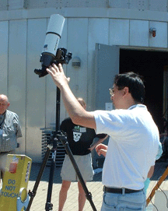To project an image of the Sun with a small telescope or binoculars, the steps are the same. In the case of the binoculars, you will only need to use one of the two “oculars,” so make sure to leave the lens cap on the side you won’t be using.

Right: Conrad Jung demonstrates a small telescope set up for projecting the Sun’s image onto a flat white screen (not in view).

1. Set up the telescope/binoculars on a tripod.
2. Point it toward the Sun, rotating it back and forth, up and down, until the Sun’s bright light beams out of the eyepiece—careful not to burn yourself; that focused light can be hot! And remember: **Do not look through the scope!**
3. If you have trouble finding the Sun, you can judge how close it’s pointing by the shape of the scope’s shadow: when a telescope is pointed at the Sun directly, its shadow will be a circle—otherwise, the shadow will be longer in one direction than the others.
4. When the sunlight is shining out of the telescope, hold a white piece of paper in the beam, a few inches from the eyepiece. You should see a bright disk of light on the paper. If the disk is fuzzy, move the paper toward or away from the 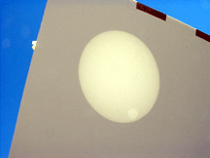eyepiece until the disk is least fuzzy.

Left: Image of the Sun projected by the telescope show in the picture above.

1. With the paper still held in that position, adjust the focus of the telescope or the binoculars until the edges of the bright disk are as sharp as possible. At this point, the image should be reasonably focused, and if there are any sunspots on the Sun today, you should see them as dark spots.

#### Sketching Sunspots

Once you have produced a focused projected image of the Sun, whether with a telescope, binoculars, or a Sunspotter, you can sketch a map of any sunspots you see by tracing their positions on the paper with a pen or pencil.

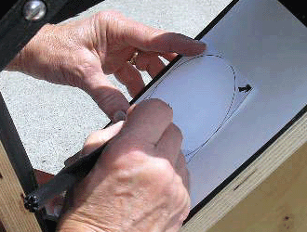Because you are mapping the positions of sunspots relative to the circle of the Sun’s disk, you will need to trace the Sun’s edges as well. However, this can be very tedious to draw as you are observing, so it is recommended that you prepare for your observation by drawing a circle of the same size as the Sun’s image, and simply fit the drawn circle to the Sun’s image before you sketch the sunspots.

1. Carefully trace the locations of all visible sunspots. Take care in accurately marking sunspot positions. Make sure that the Sun’s image remains perfectly lined up with the pre-drawn circle on your paper.

Left: Using a Sunspotter solar telescope to trace sunspots on the projected image of the Sun.

1. When you are done, you should be able to place your sketch under the projected solar image and see all of the sunspots in the image line up perfectly with the positions you marked. If not—if after your observation you see that your sketch doesn’t accurately match the Sun’s projected image—call that sketch a practice sheet, and try again!
2. Carefully mark the direction of west on your observation sheet. This is important as it will help you to rotate your sunspot maps made on a given day into the same orientation.

How do you do this? You may have seen that the Sun’s image moves slowly, but noticeably, across the projection surface. This motion is due to the Earth’s rotation. As the Earth rotates from west to east, the Sun appears to move from east to west (rises in the east, sets in the west, right?). So, the direction you see the Sun moving across the projection surface is west.

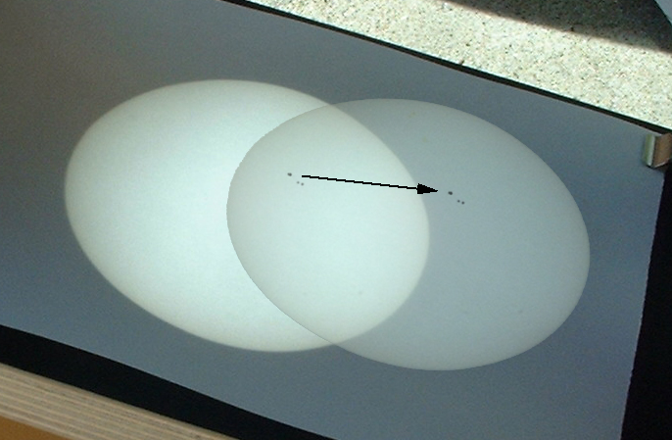

The motion of the Sun’s image caused by Earth’s rotation (indicated by the arrow drawn using a reference sunspot) moves westward in the sky

To mark the direction of image motion (and so the direction of west on the image), after completing your full-Sun sunspot map:

1. Center up your map with the projected Sun image and note the position of one sunspot (any sunspot will do) on the paper.
2. Next, allow the Sun’s image to move across the paper a bit. After the image has moved some, mark the new position of the same sunspot you originally marked, but in a different color so as not to mistake this mark for one of your sketched sunspots in your map.
3. Draw an arrow pointing from the first position to the second. This arrow points west on the sky.

Ultimately, you can use this west-pointing arrow to determine, approximately, the directions of the Sun’s north and south poles in the image by drawing a line that bisects the Sun’s image and is perpendicular to the arrow you have plotted.

## Measuring Solar Rotation—Image Scale Method

### What you will do

You will use full-disk solar images or sunspot maps taken at different times to track the motion of sunspots to determine the period of the Sun’s rotation.

### How you will do it

You will calculate an *image scale* for the solar images/maps you are analyzing and use it to calculate the actual speed of sunspots based on measurements of their motion in the images. You will use the actual speed of sunspots you measured to determine how long it will take them to move completely around the Sun one time. That period of time is the Sun’s period of rotation.

### Materials and Skills

* Printed out images of the Sun taken on different dates (for example, SOHO MDI Continuum or Magnetogram images)
* Ruler with millimeter scale
* Basic math skills: ratios, units of physical quantities, distance-speed-time equation, geometry of a circle (PI and diameter-to-circumference relationship)

### Things to Think About

* Observed sunspot motion is due mostly to rotational motion of the Sun.
* The Sun is a sphere.
* A sunspot will remain at about the same *solar latitude* from day to day.
* The Sun’s diameter is known.
* From Earth, we view the Sun approximately side-on (from over its equator—plus or minus a few degrees throughout the year).
* Motion along the *line of sight* (toward or away from us) is not measurable by the method you are using.
* The surfaces at the edges of the Sun are moving toward you or away from you; the surfaces near the axis of the Sun are moving laterally (side to side).

### Data Collection

1. Go to the SOHO data archive site:

[sohowww.nascom.nasa.gov/cgi-bin/realtime_query](http://sohowww.nascom.nasa.gov/cgi-bin/realtime_query).

1. Using the data query form, find at least two images that contain sunspots and which were taken *at least 12 hours (but no more than a few days) apart*. The query form allows you to search for images from all of SOHO’s instruments over a range of dates that you specify. For the purposes of this activity, select either MDI Continuum (“normal,” visible light images) or MDI Magnetogram (maps of magnetic fields on the Sun).

**Tip**: From the *Things to Think About* section, recall that you need to find sunspots that are moving across the *line of sight*, not toward or away from the telescope. Sunspots near the “limb” (or edge) of the Sun’s visible disk are not good choices since they are moving largely along the line of sight, toward or away from us, due to the Sun’s rotation.

1. Print out the images you have selected. Make sure that you know the time and date of each image and record these on each printout. (Many of the SOHO images have the time and date, in Universal or Greenwich Mean Time, printed directly on the image.)

### Sunspots from two different observations plotted together for comparison and measurement of motion. Analysis

Take a look at one of your solar images, and keep in mind that this is a flat, 2-dimensional image of what we know is a 3-dimensional sphere: the Sun. A sunspot seen to move from one limb (edge) of the Sun to the other is actually moving halfway around a circle—an actual distance equal to *half the circumference of the circle it is moving around*. Depending on the sunspot’s solar latitude (and thus the size of its circular path) that distance will vary.

Right: Sunspots from two different hand-drawn observations plotted together for comparison and measurement of motion

Hopefully, when you compare two of the images taken hours or days apart, you will notice a sunspot that has moved between the times the two images were taken.



#### Measure the *image scale*

The *image scale* is the ratio of a real distance to the same distance measured in an image.

1. You are given this fact: the Sun’s actual diameter is about 1,390,000 kilometers.
2. Measure the Sun’s diameter in the image in millimeters.
3. Calculate the image scale:

**Image Scale = (Sun’s actual diameter) / (Diameter of Sun’s image)**

Write the result here: ______________________

This image scale tells how many kilometers each image unit represents.

What are the *units* of your image scale?

_______________________________________

For example, if you measure the diameter of the Sun’s image to be 55 millimeters across, then the image scale for that image is:

1,390,000 km / 55 mm = 25,273 km/mm

You can use this image scale to calculate *actual* distances on the Sun by measuring distances on the image: you simply multiply the measured distance by the image scale. For example, if you measure a distance between two points on the image to be 10 millimeters, then the actual distance between those points is:

**(10 mm) x (25,273 km/mm) = 252,730 km**

#### Measure the *distance* a sunspot moved

To measure this distance, you will have to mark and compare the two positions of a single sunspot on the two different images. The method below assumes that you are working with two paper print-out images. If you are working directly with digital images and image viewing/processing/measuring software, the concept is the same. See the example images below.

1. Sandwich the two images together to form a 2-page flip book. Make sure that the Sun’s disk in each image are superimposed as closely as possible, and that the physical directions on the Sun (north and south poles, equator) are in the same rotation (on the SOHO site, solar full-disk images are all oriented with the Sun’s north pole pointing to the top of the image).
2. By flipping the pages back and forth, you can see the distance that sunspot moved from one time to the other. It will help to “transfer” the sunspot from one image to the other so that the two positions of that sunspot are marked on the same piece of paper. As carefully as you can, use a pencil to mark the sunspot on the “top” image on the “bottom” image (top and bottom of the flip book).
3. Measure the distance the sunspot moved in the image—the distance between the two spots.
4. Use the image scale factor to calculate the actual distance it moved.

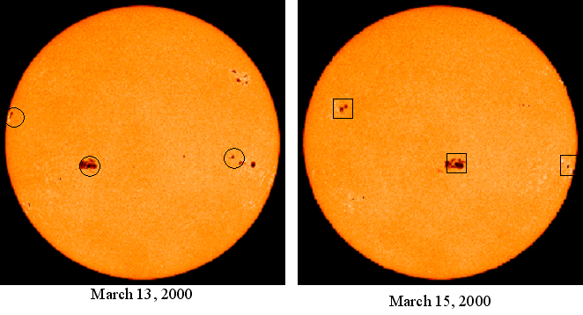

The picture above shows two SOHO MDI I-gram images of the Sun taken two days apart. Three groups of sunspots have been marked in each picture, with circles for their positions on March 13 and squares for their positions on March 15.

By overlaying, or sandwiching, these two pictures in a two-page flip book, you can mark the change in position for each of these sunspot groups on one of the images, or on a separate piece of paper, as shown in the example below.

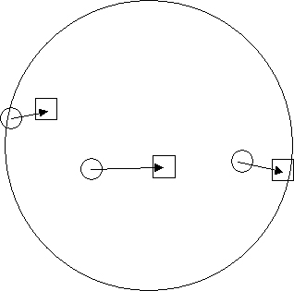

You can then measure with a ruler the distance on the image that the sunspots moved, and then multiply that measurement by your image scale factor to get the actual distance the sunspots moved laterally.

#### Calculate the *speed* of the sunspot

1. Use the distance/time/speed equation to calculate the actual speed of the sunspot:

**speed = distance / time**

The *time* period, in hours, between the two times can be calculated using the times/dates of the observations.

1. Record your result here: __________________________________________

#### Calculate the distance the sunspot would move during *one complete solar rotation*

If the sunspot were to move along through one complete rotation of the Sun, the distance it must move is equal to the circumference of the sunspot’s latitude circle—that is, the circle of latitude the sunspot is moving along.

To calculate this circumference, use the geometry of a circle and realize that since we view the Sun for the most part from the “side,” from over its equator, we see all of the circles of latitude about edge-on: they appear as parallel lines crossing the Sun’s disk, as viewed in the left image below. The length of each of these parallel lines as measured on our flat images is equal to the diameter of that circle of latitude, as shown in both images below for the latitude +30 degrees. The dotted line on the right image shows the diameter of the circle of latitude, which is the same length as that latitude line as viewed on the left.

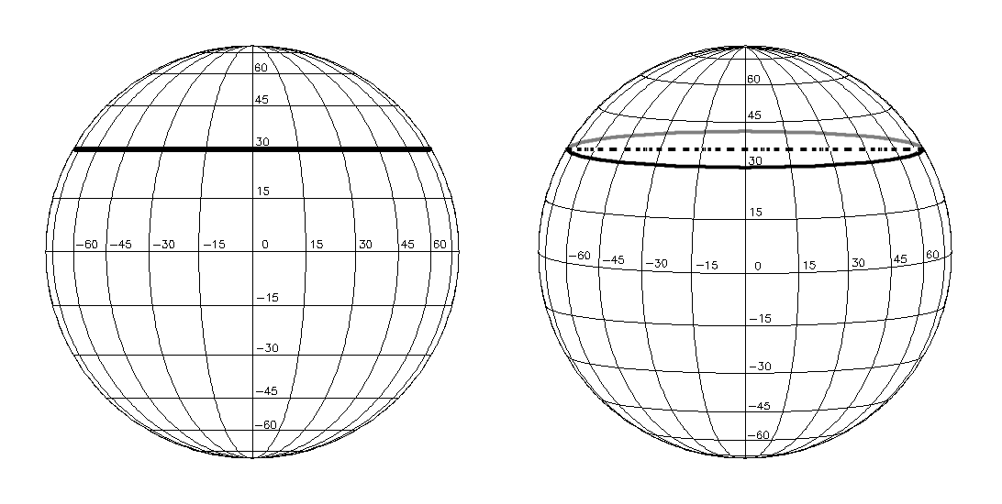

1. Assuming the sunspot is moving around the same latitude, draw a line through the two positions of the sunspot you are measuring (the positions of the spot on two different dates), crossing the Sun from limb to limb.
2. 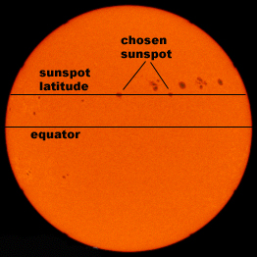Measure the length of this line from one limb of the Sun’s disk to the other. This is the diameter of that circle of latitude.
3. Calculate the actual diameter of that circle of latitude on the Sun using the image scale factor.

Right: Two SOHO MDI I-grams have been superimposed in this picture to show the motion of sunspots and the line of latitude a given sunspot is moving along.

1. Calculate the circumference of the latitude circle using the equation for the circumference of a circle:

**circumference = (Pi) x (diameter)**

Where Pi = 3.1415926, the ratio of a circle’s circumference to its diameter. This is the actual distance the sunspot would move during one solar rotation.

#### Calculate the period of one solar rotation

1. Now that you know how fast the sunspot is moving and how far it has to go to complete one solar rotation, you can easily calculate the time it would take for one solar rotation, using the distance/speed/time equation:

**time = distance / speed**

1. Record your result here: _____________________________________________

This is an *estimate* for the period of one solar rotation. The reason that this should be considered only an estimate is explained in the next section: *Measuring Solar Rotation—Solar Latitude/Longitude Method*.

### Discussion on Sources of Data

The data that you will need to track sunspots and determine the rate of solar rotation are full-disk, visible-light images of the Sun that reveal sunspots.

There are a number of possible sources for this data, including direct observation with a safe solar viewing telescope projection system. If you have made your sunspot sketches, you should try this activity using them first. Then, you can follow up by using images obtained over the Internet from a solar observatory.

There are several Internet sites for different solar observatories, both ground-based and space-based, where daily images of the Sun are accessible, including the current day’s image(s) and archived images.

A good source of space-based images of the Sun’s photosphere is the SOHO real-time data query site: [sohowww.nascom.nasa.gov/cgi-bin/realtime_query](http://sohowww.nascom.nasa.gov/cgi-bin/realtime_query). Here you will be able to access current and past archived images from all of SOHO’s instruments. For this activity, you can make use not only of the visible wavelength images taken by the MDI (Michelson Doppler Imager) instrument, but maps of magnetic polarity derived from MDI observations called “magnetograms.” The magnetic features represented in the magnetograms, coded in black or white depending on the magnetic polarity, are surface features just as the sunspots are, and are often simply the magnetic signature of sunspots themselves.

|  |  |
| --- | --- |
| **MDI Continuum**  **(reveals sunspots)** | **MDI Magnetogram**  **(reveals magnetic active regions)** |
| image of Sun showing several spots | magnetic image of the Sun showing magnetic fields in the same location as the spots on previous image |

Maps of solar active regions revealed by the MDI instrument on SOHO. Left: an “intensity-gram” showing sunspots. Right: a “magneto-gram” showing surface magnetic polarity.

Above are two examples of an “I-gram” (Continuum, left) and an “M-gram” (Magnetogram, right) obtained with the MDI instrument on the SOHO spacecraft. The I-gram, or “intensity-gram,” is a conventional, visible-light view of the Sun’s photosphere and sunspots. The M-gram, or “magneto-gram,” reveals the *polarity* of magnetic fields on the photosphere—white and black indicate N and S magnetic polarity.

Both types of data show different characteristics of the same thing: magnetically active regions on the photosphere. While the I-gram is a direct, visible light image of the photosphere, the magnetic polarities shown in the M-gram are derived from measurements of *polarization* in the light emitted by gases embedded in the magnetic fields.

Either of these types of images can be used in this activity to determine the rotation of the Sun.

## Measuring Solar Rotation—Solar Latitude/Longitude Method

### What you will do

You will make a more refined measurement of the Sun’s period of rotation by measuring the Sun’s *angular velocity*.

### How you will do it

You will use SOHO MDI I-gram or M-gram solar images and a specially plotted, transparent latitude/longitude grid called a **Stonyhurst Disk** (see example below) to track the motion of sunspots in terms of degrees of longitude. From this angular motion measurement, you will calculate the spot’s angular velocity, and from that result the rotation period of the Sun.

### Materials and Skills

* Printed out full-disk images of the Sun taken on different dates—SOHO MDI I-grams or M-grams recommended:

[sohowww.nascom.nasa.gov/cgi-bin/realtime_query](http://sohowww.nascom.nasa.gov/cgi-bin/realtime_query)

* Properly scaled transparency copy of a date-appropriate Stonyhurst disk (see Appendix on page 84)
* Sunspot Group Latitude/Longitude Tracking Log (page 31)
* Angular Velocity and Solar Rotation Period Worksheet (page 32)
* Familiarity with latitude and longitude and the geometry of a sphere
* Basic math skills: ratios, units of physical quantities

### Background

The method for measuring solar rotation in the previous activity makes the assumption that we view the Sun from a point in space directly over the Sun’s equator, which gives us a view of the Sun’s sphere, and its coordinate system of solar longitude and latitude, as shown in the following picture—similar to the view of Earth’s coordinate circles seen from above its equator.



Example of a Stonyhurst Disk, showing the Sun’s longitude and latitude coordinate lines as viewed from directly over the Sun’s equator. You will use a transparency copy of a Stonyhurst Disk (see Appendix starting on page 84) that corresponds to the month of the year in which your solar images were taken

Degrees in longitude, east and west of a reference meridian, and latitude, north and south of the equator, are marked, with the 0,0 point at the center of the disk.

In reality, the Sun’s rotational axis is tilted about 7.5 degrees from the *ecliptic* (the plane of Earth’s orbit around the Sun), and so the actual angle from which we view the Sun’s coordinate system changes as the Earth orbits around it. Only twice a year, on December 7 and June 7, does Earth cross the Sun’s *equatorial plane*, so only twice a year do we actually view the Sun from over its equator.

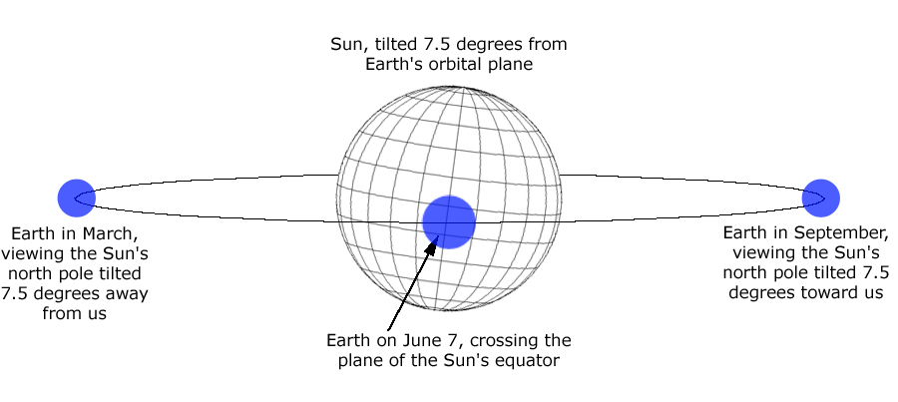

Diagram showing the changing view of the Sun’s tilted longitude and latitude coordinates as seen from Earth at different points in its orbit

At other times of the year, we view the Sun from above or below its equatorial plane. The picture below shows how we view the Sun’s surface from the most extreme angle—in this case from 7.5 degrees “above,” or north of, the Sun’s equator.



Stonyhurst Disk showing aspect of the Sun’s latitude and longitude system as viewed in September, from 7.5 degrees “above” its equatorial plane

### Step-By-Step

1. Select and print out a sequence of solar images with sunspots, taken anywhere from 6 to 48 hours apart. For this activity, it is recommended that you use SOHO MDI images (Continuum or Magnetograms), either from [sohowww.nascom.nasa.gov/cgi-bin/realtime_query](http://sohowww.nascom.nasa.gov/cgi-bin/realtime_query) or the sample MDI Continuum images found in the Appendix on page 95. See page 74 for other sources of data.
2. Select the appropriate Stonyhurst Disk for the month in which your images were taken and make a correctly scaled transparency copy of it.

A set of Stonyhurst disk coordinate templates are provided in the appendices under *Stonyhurst Disks*. Choose the disk for the month when your solar images were taken and make a copy of it. You may need to increase or decrease the scale of the copy so that the Stonyhurst overlay matches the size of the solar images you are working with. Once your copy is the right size, make a transparency copy of that.

1. Arrange your solar images in order by date.
2. In the first, or earliest, image, label any sunspots or sunspot groups with unique letters, numbers, names, or symbols, as you like. Also label these sunspots and groups in all of the other solar images in your image set. Make sure that you’re labeling the same sunspots with the same labels in all images.

|  |
| --- |
| **Stonyhurst Disk Transparency Overlay on a  SOHO MDI Continuum Image** |
| Stonyhurst disk overlay on a solar image |

1. For each solar image, carefully overlay the Stonyhurst disk transparency on the image, making sure the template is exactly aligned with the Sun’s disk.

In the SOHO images, the Sun’s North Pole is at the top edge of the picture. Use this fact to rotate the Stonyhurst disk in the proper direction, as shown in the picture to the right.

1. Record the latitude and longitude for each sunspot or sunspot group, along with the label you made for each of them, on a copy of the *Sunspot Group Latitude/Longitude Tracking Log* on page . Use one log sheet for each solar image.

For example, in the picture above there are four major sunspots/groups. Their coordinates, read off of the grid, are:

|  |  |  |  |
| --- | --- | --- | --- |
| **Sunspot Group Name** | **Solar Latitude** | **Solar Longitude** | **Notes** |
| A | 33 | 2 | Group of small spots |
| B | 25 | 6 | Irregularly shaped |
| C | 12 | 8 | Largest, very round |
| D | -4 | 18 | Oval |

1. Once you have measured and recorded the coordinates for all of the sunspots/groups on all of the images in your set, you can calculate the *angular velocity* of any of the spots. The angular velocity of a spot is the distance in degrees (of longitude, or latitude) it travels in a given period of time (hours, days—whichever unit you are working with).

**angular velocity = (distance in degrees) / (period)**

You may choose any sunspot to calculate an angular velocity for—or, if you want to be thorough, calculate an angular velocity for each of them! However, the best results will come from spots that you have been able to track for the longest period of time. Use the *Angular Velocity and Solar Rotation Period Worksheet* on page .

1. Once you have calculated an angular velocity, you can now take the final step and use it to calculate the period of rotation of the Sun. The angular velocity for a sunspot tells you how many degrees around the sphere of the Sun the spot traveled in a certain period of time—how many degrees per day, for example, the sunspot moved.

The period of time it will take a given spot to travel all the way around the Sun once—in other words, the period of the Sun’s rotation—is simply the full 360 degree rotation divided by the spot’s angular velocity:

**period of rotation = (360 degrees) / (angular velocity in degrees / day)**

(This equation assumes you are using days as the unit of time, and gives a result in terms of days; if you used a different unit of time, the result of the equation will be in that unit.)

Enter your results on the *Angular Velocity and Solar Rotation Period Worksheet* on page .

#### Sunspot Group Latitude/Longitude Tracking Log

|  |  |  |  |
| --- | --- | --- | --- |
| **Date and Time of Solar Image: ________________________________________________**  **Source of Solar Image (observatory/spacecraft, instrument): _______________________** | | | |
| **Sunspot Group Name** | **Solar Latitude** | **Solar Longitude** | **Notes** |
|  |  |  |  |
|  |  |  |  |
|  |  |  |  |
|  |  |  |  |
|  |  |  |  |
|  |  |  |  |
|  |  |  |  |
|  |  |  |  |
|  |  |  |  |
|  |  |  |  |
|  |  |  |  |
|  |  |  |  |
|  |  |  |  |
|  |  |  |  |
|  |  |  |  |
|  |  |  |  |
|  |  |  |  |
|  |  |  |  |
|  |  |  |  |

#### Angular Velocity and Solar Rotation Period Worksheet

|  |  |  |  |  |
| --- | --- | --- | --- | --- |
| **Time Period Between Image Pair** | **Difference in Latitude**  **(degrees)** | **Difference in Longitude**  **(degrees)** | **Angular Velocity**  **(difference in longitude) / (time period)** | **Period of Sun’s Rotation**  **(360) / (angular velocity)** |
|  |  |  |  |  |
|  |  |  |  |  |
|  |  |  |  |  |
|  |  |  |  |  |
|  |  |  |  |  |
|  |  |  |  |  |
|  |  |  |  |  |
|  |  |  |  |  |
|  |  |  |  |  |
|  |  |  |  |  |
|  |  |  |  |  |
|  |  |  |  |  |

# A Look on the Farside

## Introduction

Monitoring the Sun and its active regions can allow you to assess the general likelihood of observing flare events at a given time, just as in Earth-weather the monitoring of local conditions (temperature, humidity) can tell you how likely certain weather conditions are to form, such as fog, rain, snow, wind, heat waves, and the like. But by looking beyond what can be seen at present, it is possible to make predictions, to forecast, events in the near future. Weather forecasters on Earth use satellite imagery to examine conditions beyond their horizon to forecast future weather conditions.

While active regions on the side of the Sun facing Earth represent an immediate potential for flare events that can affect us, as the Sun rotates, individual active regions will be carried to the *farside* of the Sun, and active regions that may have formed on the farside will be carried onto the side facing the Earth. If we look at the Sun today and see few or no active regions, we might expect little or no flare activity—today.

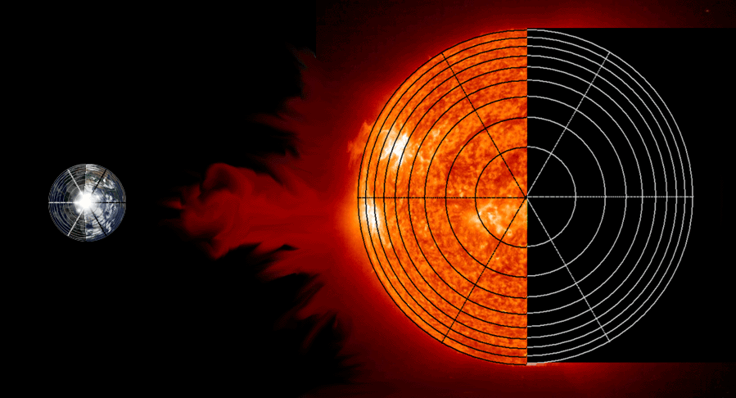

Artistic rendering showing Sun and Earth from above their north poles, showing the relationship between the Earth and the Sun’s Earthside and Farside. (Images not to scale!)

### Farside Defined

Just as with any sphere, orb, or ball, at any given moment you can only see *half* of its surface. The half of the Sun that we cannot see is referred to as the “farside,” and the half we can view directly is called the “Earthside.” Regions on the Sun’s surface carried along by its rotation are alternately carried into view on the Earthside and out of view onto the farside. Around Earth, we have multiple satellites that look at our planet from many directions, and so we can see the entire surface of our planet; but, we don’t have satellites looking at the Sun from every direction, and until we do there will always be a side of the Sun beyond our direct viewing.

But what’s happening on the farside of the Sun? What magnetic storms may be brewing around the Sun’s limb that will be carried into direct view by the Sun’s rotation? How can we anticipate the flare potential half a solar rotation from now, when the magnetic conditions commanding the farside of the Sun rotate into view from the Earth? So far, solar observatories in space observe the Sun from near, or relatively near, the Earth; we do not yet have a solar observatory in a position to observe the farside of the Sun directly.

### Helioseismology

Fairly recently, solar astronomers have developed techniques to gain insight into magnetic activity on the farside of the Sun. One technique makes use of data obtained by SOHO’s Michelson Doppler Imager (MDI). This technique, called “helioseismology,” takes advantage of the fact that, unlike light waves, seismic (“sound”) waves can travel through the Sun, just as seismic waves travel through the interior of the Earth. In both the Sun and the Earth, where those waves emerge and with what strength can determine changing conditions and interior structures in those bodies.



Right: Cutaway view of the Sun’s interior, showing how seismic waves (sound waves) refract and bounce around inside the Sun. Credit: SOHO.

When the seismic waves eventually reach the Sun’s surface, they emerge in the form of a “vibration,” a “ringing” up and down motion, in the Sun’s photosphere. The MDI instrument measures the *Doppler shift* in light coming from the photosphere to measure the rise and fall the gases, and so measure the strength and frequency of the seismic waves.

As it turns out, seismic waves travel faster through regions of the Sun dominated by strong magnetic fields than through regions less magnetically active. This difference in speed allows astronomers to detect, and even locate, magnetic field concentrations, such as active regions, in areas of the photosphere we cannot observe directly. This gives space weather forecasters a unique tool for predicting possible flare and CME activity a few days into the future.

## Getting Familiar With the Data

### What you will do

You will become familiar with *whole Sun data maps,* including where to find them on the Internet and how to interpret them.

### How you will do it

You will go to the Stanford Solar Center website ([soi.stanford.edu/data/full_farside/](http://soi.stanford.edu/data/full_farside/)) to access archives of whole Sun maps and examine them in detail. You will read descriptions designed to familiarize you with what the maps show and how they make the map. You will know the difference between the Earthside and the farside of the Sun, and where to find them on the maps. You will know the direction on the map representing the direction of the Sun’s rotation.

### Materials and Skills

* Whole Sun data maps
* Familiarity with latitude and longitude
* Familiarity with flat map projections of a sphere

### Background

Get whole-Sun rectangular maps of solar magnetic activity at <http://soi.stanford.edu/data/full_farside/>. This website offers current data maps as well as access to an archive of past maps.

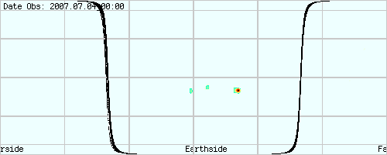

Whole-Sun rectangular map showing Earthside and Farside of the Sun

Each image is a whole-Sun map of real and suspected magnetically active regions, plotted as a rectangular “equal area” projection. It covers the entire *photosphere*: 180 degrees in latitude (pole to pole) and 360 degrees in longitude. The *solar equator* and every 30 degrees of latitude and every 60 degrees of longitude are marked (the top and bottom edges of the map being the north and south poles, respectively).

This representation of the entire surface of the Sun is equivalent to a map of the entire Earth as shown in the picture below. In this case the side of the Earth facing the Sun, the “sunside,” is the day side illuminated by sunlight, and the farside is the night side in shadow. Sunside and farside in this example are with respect to the Earth as viewed from the Sun, not the other way around.

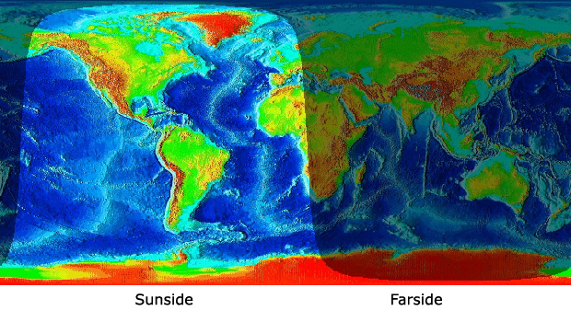

Whole-Earth rectangular map showing day (Sunside) and night (farside from Sun). Image courtesy of Fourmilab

In the Sun farside map, the border between Earthside and farside (bold line) is shown. This represents the *limb*, or “edge,” of the Sun’s disk as seen from Earth. If you view a succession of these maps you will see *surface features* remain at unchanging locations, while the lines representing the *solar limb* move along—opposite from what you may be used to seeing in images of the Sun as viewed from Earth, where sunspots and other features continually move with solar rotation and the solar limb (the edge of the disk) remains fixed. This is merely because the farside maps are plotted in absolute solar latitude/longitude, and since the longitude meridians rotate along with the Sun’s photosphere, the absolute coordinates of any given sunspot remains more or less fixed and unchanging. (It’s the same on Earth: geographic longitude rotates with the Earth’s surface, so any given fixed surface feature, like a mountain or a lake or a city, has a fixed longitude coordinate.)

Features on the Earthside come from magnetograms derived from MDI magnetic flux measurements. The data is color-coded to indicate the strength of the active region, with blues and greens indicating weaker strength, yellows intermediate strength, and oranges and reds as the strongest activity.

Data on the farside is computed from MDI Doppler/helioseismological measurements, revealing sound wave speed variations, with sources of faster sound waves indicating magnetic concentrations.

## Spot Plots

### What you will do

You will gain some experience working with the rectangular equal-area map format that the whole Sun maps are presented in.

### How you will do it

You will label the key points and features of a rectangular equal-area map. You will measure the distance between sets of points plotted on the map and calculate the actual physical distances on the Sun these point pairs represent.

### Materials and Skills

* Ruler with millimeter scale
* Geometry of a circle
* Basic trigonometry: cosine
* Spot plotting map grids (provided)
* Equatorial circumference of the Sun (provided)

### Background

The maps are plotted in the “Carrington” coordinate system of longitude, a system used by astronomers to locate and track solar photospheric features. The Carrington system is based on the average rotation rate of the Sun’s photosphere, with the reference longitude (“zero degrees longitude”) rotating with the photosphere at approximately the same rate. In this system, surface features remain approximately at the same longitude from one map to the next, just as Earth’s surface features remain at the same longitude as the Earth rotates.

In these maps, zero degrees longitude is at the left edge, 180 degrees longitude is shown at center, and 360 degrees longitude is at the right edge. Similarly for latitude, 90 degrees north latitude is at the top edge, 90 degrees south latitude is at the bottom edge, and the equator (0 degrees latitude) is at the middle.

### Getting Oriented With the Rectangular Map

The relationship between the Sun’s global coordinate system as represented in a half-globe diagram and its representation in a full-globe rectangular format is shown in this diagram. You may already be familiar with how the spherical view of the Earth’s globe corresponds to its rectangular representation; it’s the same way with the Sun.

Shows a side-view of Sun's coordinate system, howing half ot he Sun's globe
Plus a rectangular map of the Sun's oordinate system, representing the Sun's entire globe

As an exercise to get familiar with the full-globe rectangular format, mark/label the following features on the blank rectangular map grid below, using the diagram above as a reference:

1. Equator
2. North and south poles
3. Latitude of each parallel, including the equator—degrees north (positive) and south (negative) of the equator
4. Longitude of each meridian—degrees of longitude, starting with the center meridian as 0 degrees, and with meridians to the left as negative values and meridians to the right as positive
5. An arrow indicating the direction of rotation of the Sun (left to right)



Blank rectangular equal-area map of Sun

### Tracking Motion on the Rectangular Map

Being flat, rectangular projections of a sphere, these maps have inherent distortions to distances, just as a cylindrical or Mercator type projection of the Earth’s globe does. The greater the distance from the equator (the greater the latitude, north or south), the shorter the distances measured east-west, in longitude--but the longer are the distances measured north-south, in latitude.

The actual distance across the full width of the map along a given line of latitude is equivalent to the *circumference* of the latitude circle that line represents, and can be calculated with this trigonometric equation:

**Distance = (Sun’s Circumference at Equator[1]) x cos( latitude )**

Assuming that the map below is a Carrington map of the Sun’s photosphere, answer the questions below. The answers are given at the end of this section.

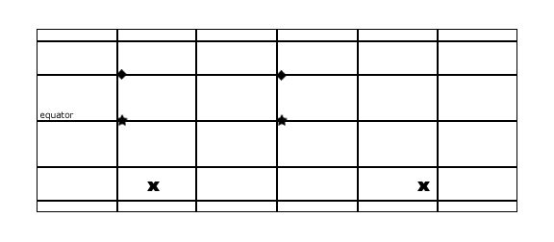

1. What is the physical distance along the Sun’s photosphere between the two diamond symbols? (The two diamonds could represent two different points on the Sun’s photosphere, or the distance traveled by a specific feature, like a sunspot, over a period of time.)
2. What is the physical distance along the Sun’s photosphere between the two stars symbols?
3. What is the physical distance along the Sun’s photosphere between the two “x” symbols?

The two diamonds appear to be the same distance apart as the two stars. Did you find this to be true for the distances they represent on the Sun’s surface?

The two x’s appear to be the farthest apart of all three sets of marks. Did you find *this* to be true for the distance they represent on the Sun’s surface?

**Solutions to the problems from page 40:**

1. The two diamonds are separated by a distance equal to 33.1% of the width of the map. Their latitude is 30 degrees North. Using the equation for map distortion on page , the full circumference of this circle of latitude is:

Distance = (4,369,955 km) * cos(30) = 3,784,492 km

So the distance between the two diamonds is:

33.1% of 3,784,492 = 1,252,667 km

1. The two stars are separated by a distance equal to 33.1% of the width of the map, just as the two diamonds are. But the stars are located on the equator, at a latitude of 0 degrees. Again using the equation for map distortion, the full circumference at the equator is:

Distance = (4,369,955 km) * cos(0) = 4,369,955 km

So the distance between the two stars is:

33.1% of 4,374,762 = 1,446,455 km

1. The two X’s are separated by a distance equal to 56.1% of the width of the map. They are located at a latitude of about 48 degrees South. Again using the equation for map distortion, the full circumference at the equator is:

Distance = (4,369,955 km) * cos(48) = 2,924,071 km

So the distance between the two stars is:

56.1% of 2,924,071 = 1,640,404 km

# 

## Far Sight

### What you will do

You will search for farside data features on the whole Sun maps that are possibly real locations of magnetic activity.

### How you will do it

You will examine multiple whole Sun maps in a rotation series (a set of maps taken at intervals over one complete solar rotation) and look for data features that appear on the farside that persist at the same location (latitude/longitude) when it rotates onto the Earthside.

### Materials and Skills

* Whole Sun maps, found at [soi.stanford.edu/data/full_farside/](http://soi.stanford.edu/data/full_farside/)

### Background

On the surface, the whole Sun magnetic maps may appear to show us what’s going on over the entire solar globe—what amazing perception! It is important to remember, however, that these maps are a cutting-edge attempt to “see what’s over the horizon” without actually being able to see.

The maps are composed of information derived from two very different techniques, one that detects magnetic activity on the Sun’s Earthside by direct measurement, and one that attempts to detect magnetic activity on the Sun’s farside through an indirect, secondary measurement. While the Sun’s Earthside is laid out before us and its features plainly readable, our perception of the farside is more like hearing vague echoes in the distance, or glimpsing a darkened world filled with shadowy ghosts.

When analyzing farside data maps, one task is to attempt to “weed out” the false information: alleged detection of magnetic concentrations that are in reality caused by something else, or nothing at all—what scientists call “noise.”

### Getting Familiar with the Farside Data

**Grab some data:**

1. Go to the whole Sun magnetic map website at [soi.stanford.edu/data/full_farside/](http://soi.stanford.edu/data/full_farside/)
2. Go to the farside Image Lists section (click on link).
3. Choose a rotation range from the list and click to go to that archive. Record the Rotation numbers, the start date, and the end date.

You will be faced with a long series of whole Sun image maps. The maps were created at times 12 hours apart, and are arranged in time sequence.

1. Examine the series of maps. You can either scroll up and down with your browser, or you can print off the page and examine the printed images (be warned: this may use up dozens of sheets of paper!)

**Things to Notice:**

* The date and time associated with each map. The format is YEAR.MONTH.DAY_TIME (with time shown in whole hours only--no minutes or seconds).
* The bold lines that represent the location of the Sun’s limb, as seen from Earth, divide the map into Earthside and farside.
* The position of the Sun’s limb changes location from map to map, while the latitude and longitude lines remain fixed. The rotation of the Sun is shown by the moving limb boundary.
* Magnetic features shown on the Earthside do not move from map to map. Remember, the Carrington coordinate grid (latitude and longitude) rotates with the rotation of the Sun, just as the Earth’s coordinate grid rotates with the Earth—in both cases to provide a fixed reference system for locating features on their surfaces.
* Examine the spots marked on the Earthside and spots marked on the farside as you compare a series of maps. Are there any differences in the appearance or behavior of the Earthside versus the farside spots?

The appearance and behavior of magnetic features shown on the Earthside of the map can serve as a benchmark when searching for real magnetic features on the farside, under the assumption that real magnetic active regions behave the same no matter what side of the Sun they are on (unless they try to get away with things when we’re not looking…). Because of the direct measurement technique possible for Earthside data, we can be reasonably certain that most of what we see there is real activity.

Write a brief description of the observed appearance and behavior of Earthside spots over a series of consecutive maps whole Sun magnetic maps, specific to these characteristics:

1. Size and shape (with special attention given to how they do or do not change from map to map)
2. Location (for example, is there a latitude or a longitude range where spots are most often seen?)
3. Persistence and continuity (how long a spot in a given location lasts over a series of maps)

Compare these characteristics of Earthside spots to the farside spots.

**Questions:**

* In general, how do Earthside and farside spot data compare with respect to the three characteristics above?
* Can you find any farside spots whose characteristics resemble the Earthside spots?
* If you identify a farside spot as being a possible real magnetic active region, how might you use the data set to confirm this?

Write down “real spot search criteria”: You can write up your own, or you can finish these sentences:

1. A farside data spot is MORE likely to be a real magnetic active region if....
2. A farside data spot is LESS likely to be a real magnetic active region if….

Write down “real spot confirmation criteria”:

1. A farside data spot is CONFIRMED as a real magnetic active region if….

## The Hunt

Put what you have learned to good use: Go and hunt some farside magnetic active regions!

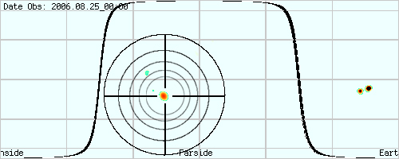

### What you will do

You will attempt to identify and confirm spots on the farside of whole Sun magnetic maps that are real magnetic active regions.

### How you will do it

Using your *search criteria*, analyze the whole Sun magnetic map data sets and as you find *suspected* farside real features, enter them in a log (such as the example *Hunt Log* on page ).

### Materials and Skills

* Whole Sun map rotation sets
* Hunt Log (page 47)

### Step-by-Step

1. You should feel free to hunt through as many rotation data sets as you like, and look for as many farside real magnetic active regions as you can. Keep note of how many and which rotation sets you search through, regardless of whether you find any suspected magnetic active regions.
2. Summarize your findings here:

|  |  |
| --- | --- |
| How may rotation sets did you search through? |  |
| How many suspected magnetic active regions did you log? |  |
| How many of the suspected magnetic active regions that you logged were you able to confirm were real magnetic active regions? |  |

1. Choose one of the rotation data sets that you searched through—preferably one in which you found at least one suspected magnetic active region.
2. For the chosen rotation series, tally all of spots that you see in the farside data on all of the maps. (Yes, this might be tedious!) Note: A spot that persists in the same location in multiple maps may be added to the tally only once, but each spot that comes and goes in a single map should be counted as one.
3. Summarize your findings here:

|  |  |
| --- | --- |
| What was your tally for all data spots in the rotation series? |  |
| How many suspected magnetic active regions did you find in that rotation series? |  |
| What is the percentage of suspected magnetic active regions as compared to all spots found in the data? |  |

**Questions:**

* How reliably do you think you can identify possible farside magnetic active regions from these data sets?
* How confident are you in deciding which farside data spots might be real magnetic active regions and which are just “noise”?
* As a tool to predict the appearance of magnetic active regions rotating into Earthside view, do you think that these whole Sun magnetic maps are useful?

### Hunt Log

|  |  |  |  |  |  |  |
| --- | --- | --- | --- | --- | --- | --- |
| **Rotation** | **Start** | **End** | **Persistence** | **Approx Lat** | **Approx Lon** | **Confirmed?** |
|  |  |  |  |  |  |  |
|  |  |  |  |  |  |  |
|  |  |  |  |  |  |  |
|  |  |  |  |  |  |  |
|  |  |  |  |  |  |  |
|  |  |  |  |  |  |  |
|  |  |  |  |  |  |  |
|  |  |  |  |  |  |  |
|  |  |  |  |  |  |  |
|  |  |  |  |  |  |  |
|  |  |  |  |  |  |  |
|  |  |  |  |  |  |  |
|  |  |  |  |  |  |  |
|  |  |  |  |  |  |  |
|  |  |  |  |  |  |  |
|  |  |  |  |  |  |  |
|  |  |  |  |  |  |  |
|  |  |  |  |  |  |  |
|  |  |  |  |  |  |  |

* Rotation is the numbered solar rotation in which you found this spot.
* Start is the date and time (whole hour) of the map on which the spot you found first appears.
* End is the date and time (whole hour) of the map on which the spot you found last appears. If you find a spot that persists over a series of maps, but isn’t present in every map of that series, it is up to you to decide the end date and time—that is, whether or not to ignore occasional absences of the spot from the maps.
* Persistence is the duration of the spot, in days and half-days, which you can calculate from the Start and End dates. For example, “End – Start = 2006.08.10_00 - 2006.08.01_12 = 2006.08.10.0 – 2006.08.01.5 = 0000.00.08.5 = 8.5 days”.
* Approx Lat and Approx Lon are the approximate latitude and longitude of the spot.
* Confirmed? Yes or no. Apply your Real Spot Confirmation Criteria test. If a spot is not confirmed, it remains a *suspected* real spot that may be unconfirmable, or requires an independent confirmation.

# 

# Flarecast!

## X-class solar flare imaged by SOHO EIT.Introduction

Solar flares are powerful explosions in the Sun’s corona, releasing in minutes the energy of a billion megatons of TNT and heating solar atmospheric gases to many millions of degrees. Flares occur near magnetic active regions, usually between areas of opposing magnetic polarity.

Right: X-class solar flare imaged by SOHO EIT. Credit NASA/ESA..

Flares arise when build-up of powerful magnetic fields become so intense and unstable that they reach a breaking point. The strands of magnetic force “snap” and rearrange themselves into a more stable, lower energy state, and the energy released superheats gases in the Sun’s atmosphere. Temperatures in a relatively small region can rise in a few minutes to 10 million Kelvin or more and electromagnetic radiation across the spectrum, from radio waves to X-rays to gamma rays, is released into space.

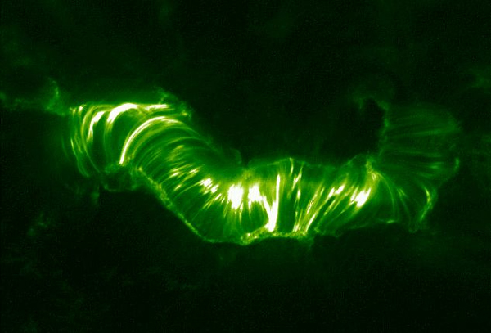*Question: Why are these solar images green? Answer: These images are “false colored.” The light that was observed to create them is extreme ultraviolet, a wavelength of electromagnetic radiation that is invisible to human eyes, and therefore has no “color” as defined by human vision.*

Left: The magnetic field complex that produced the powerful Bastille Day Flare. Image credit NASA/TRACE.

The flash of electromagnetic energy moves outward into the Solar System at the speed of light, traveling one astronomical unit (the mean distance from the Sun to Earth) in little over 8 minutes.

### Flare Classes

The power of flares ranges widely, from very minor to those of extreme power. A scale of power has been created to classify flares, similar to the Richter scale of earthquake power. The solar flare class scale is based on the brightness of a flare’s X-rays measured in the wavelength range from 1 to 8 Angstroms.

The least powerful flares are of classes A, B, and C (A being the weakest). “Medium” strength flares are labeled “M” class. The most powerful flares are “X” class.

Further, each of these classes is subdivided into nine smaller steps, from 1-9. Thus, depending on its strength, an M-class flare, for example, can be rated M1 (the least powerful M-class flare) all the way up to M9 (the most powerful).

**Flare Class Descriptions:**

* C-class flares (and smaller: A and B) go mostly unnoticed at Earth, other than through direct observation of the Sun and monitoring of its X-ray emissions.
* M-class flares are more powerful, and can cause short radio blackouts around Earth’s polar regions, and possibly minor “storms” in the solar wind.
* X-class flares are the most powerful. They can cause planet-wide radio blackouts and long-lasting space weather storms.

Protected as we are on Earth by our atmosphere and magnetosphere, you might think that solar flares are no big deal; that even the most powerful flare will probably go unnoticed by an average person on the ground, except possibly by radio or TV interference. But as our society becomes more dependent on global communication networks and satellites, the potential effects of flares are becoming a greater concern. And, as more and more humans are venturing into space, beyond the protection of Earth’s atmosphere, the conditions of space weather, dominated by solar activity, are a real and life-threatening concern.

For these reasons, and others, the science of forecasting space weather events is becoming, in certain aspects, comparable to the meteorological tracking of a powerful hurricane.

### Predicting a Flare

Predicting the moment a flare will occur and how strong it will be is a little like forecasting the weather on Earth. By observing atmospheric conditions, a forecaster can predict the *likelihood* for stormy weather versus fair, but it’s not possible to know with certainty what will really happen.

How likely is it for a flare to occur on a given day? How will that likelihood, or probability, change in the near future? The answer is that it depends on the current and near future conditions on the Sun, especially in the corona where flares occur.

On any given day, about half of the Sun’s photosphere (and slightly more than half of its atmosphere) is within direct view from the Earth—the *nearside,* or *Earthside,* of the Sun. The electromagnetic energy emitted by flares that occur on the Earthside have a direct line of sight to Earth, and so pose an immediate potential for flares that we can observe, and which can affect the Earth.

One criterion for calculating a potential for flare activity on a given day would be to assess the magnetic activity on the nearside of the Sun—in the simplest way, “count up” the features of magnetic concentration (active regions, sunspots, prominences). You might also take into consideration the strength, or intensity, of magnetic features, with the idea that larger, stronger magnetic active regions pose a greater potential for producing flares, and for producing more powerful flares, than weaker regions.

Scientists predict solar flares by making very detailed examinations of the magnetic characteristics of individual active regions on the Sun, looking in particular for magnetic field “shear,” or twisting, between adjacent regions of opposing polarity. The greater the shear, the more likely the magnetic fields will snap and reconfigure, producing a solar flare in the process.

In these activities, you will forecast flare potential not by detailed examinations of the magnetic structure of active regions, but by a more “birdseye” assessment of magnetic activity.

Basing your forecast criteria on *population* and/or *strength* of magnetic features as a measure of flare potential (the probability that a flare will occur) can be thought of using the “chicken farm” analogy. Imagine the Sun to be a chicken farm, the chickens to be magnetic active regions, and the crowing of the chickens to be solar flare events. While you really cannot predict when an individual chicken might crow (other than how often, on average, an average chicken crows), the more chickens in the farm, the *greater the likelihood of* *hearing one of them crow* at any given time. And if some of the chickens are big, robust, and lively birds that like to crow more often, or more loudly, or both, then those individuals contribute to the prediction both by increased frequency and also the potential for more powerful flares. What do chickens have to do with solar flares? Nothing! Remember, it’s an analogy….

## Relative Sunspot Number (RSN)

### What you will do

You will learn to calculate the Relative Spot Number (RSN) index from visible-light solar images, such as SOHO MDI I-grams, and compare your calculations to the official numbers.

### How you will do it

You will select five different visible-light solar images taken by the same observatory. For each image, you will identify and label each individual sunspot group, and record the sum. Also for each image, you will count all of the sunspots—those by themselves and in groups—and record the sum. You will use these counts in a standard equation to calculate the RSN for each image. You will obtain the official RSN for the day of each image and compare them to your calculated numbers.

### Materials and Skills

* Selected full-disk visible-light solar images (SOHO MDI I-grams recommended)
* Relative Sunspot Number Worksheet (page 55)
* Basic arithmetic and algebraic equations

### Background

Astronomers use a slightly more complicated method for assessing daily solar magnetic activity than by simply counting up the number of sunspots each day. They use a method called the *Relative Sunspot Number,* or *RSN*. This method takes into account the fact that different solar observers counting sunspots may be using widely different sizes of telescopes, and while a smaller telescope may reveal a certain number of sunspots, observations with a larger telescope may reveal far more. So, reports of simple sunspot counts from different sources/observatories may yield widely different results, even though they’re all looking at the Sun at the same time.

### Example of Calculating Relative Sunspot Number

Calculating the Relative Sunspot Number is fairly simple. It requires that you not only count the number of individual sunspots, but also the number of *sunspot groups*—areas of one or more sunspots that appear to be related to the same magnetic disturbance, or active region. Sometimes it will be obvious which clusters of sunspots are associated with a single active region, other times it is a matter of judgment.

The standard method for determining what constitutes a sunspot group can be summed up this way: If a group of sunspots all fall within the same 10 degrees of longitude and at about the same latitude, they can be considered all part of the same group. You can use a properly scaled Stonyhurst disk to measure distances between spots and groups.

Once you have counted the individual sunspots and the sunspot groups, plug those numbers into the following equation to get your Relative Sunspot Number:

**R = 10g + s**

Where R = the Relative Sunspot Number, g = the number of sunspot groups seen on the Sun’s Earthside and s = the total number of individual sunspots (both in groups and alone). (There is also a “quality” factor left out of the above equation that is applied to account for things like the size of the telescope and the observing conditions; this factor typically has a value of 1 or less. For this activity, assume it is 1.)

For example, examine the SOHO MDI I-gram below:

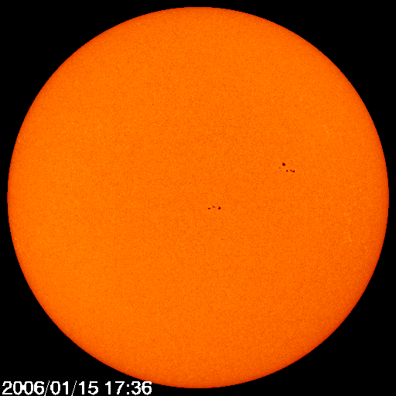

One might count a total of 2 sunspot groups and 11 individual sunspots. Plugging these numbers into the equation for R, this would give:

**R = 10(2) + 11 = 31**

Here’s another example:

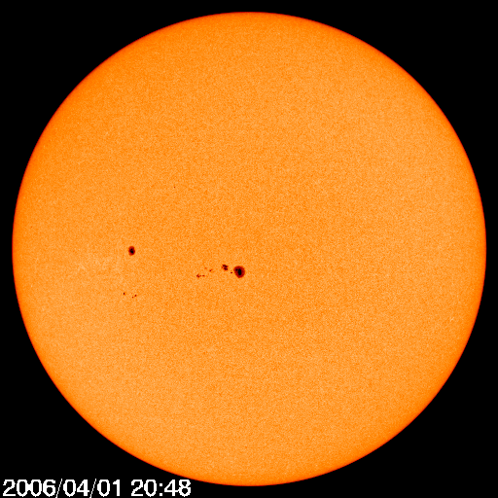

In this image, you might identify 3 sunspot groups: the large one near the center (that looks like the Hawaiian Islands), the single large spot to the left, and the cluster of small spots below that one. Notice that the single sunspot is also counted as a group. You might count a total of 14 individual spots. This would give:

**R = 10(3) + 14 = 44**

Obviously, the number of different groups, or magnetically active regions, has a strong influence on the assessment of R.

### Step-by-Step

1. Acquire and print out 5 full disk visible light solar images. The SOHO MDI I-grams are recommended.
2. For each image, identify and label with a number each sunspot group.
3. Count the number of sunspot groups in each image and record the number in the table below.
4. Count the total number of sunspots in each image—those which are separate individuals and those in groups alike. Record the number in the table below.
5. Calculate the RSN, R = 10g + s, for each image.
6. Research the official daily sunspot numbers for each of your image dates and record the number in the table below. One place to check for these numbers is at [www.ngdc.noaa.gov/stp/SOLAR/ftpsunspotnumber.html](http://www.ngdc.noaa.gov/stp/SOLAR/ftpsunspotnumber.html).

How well did you do? How well did your numbers match the official ones?

*Unexpected Numbers?* The numbers you find in these archives are not those calculated and reported by a single observatory, but many. The reports are averaged to arrive at these numbers, and you may find them to be values that cannot be calculated by the single equation you are using. For example, by the equation you are using, if there are no sunspots observed on the Sun, then there are 0 sunspot groups and 0 sunspots, and the RSN you calculate is 0. If there is but a single sunspot on the Sun, then, by definition, there is 1 sunspot as well as 1 sunspot group—because any sunspot is also counted as part of a sunspot group, even if it’s the only one. In this case, the calculated RSN is 11. If you see a number like, say, 5.5 in the official sunspot number archive, just keep in mind that it’s the result of an average (for example, if two different observers reported 0 sunspots and 1 sunspot respectively, then their calculated RSNs of 0 and 11 would average out to 5.5).

### Relative Sunspot Number Worksheet

|  |  |  |  |  |
| --- | --- | --- | --- | --- |
| **Image (date)** | **Number of Sunspot Groups** | **Total number of Sunspots** | **Calculated RSN (R)** | **Official RSN** |
|  |  |  |  |  |
|  |  |  |  |  |
|  |  |  |  |  |
|  |  |  |  |  |
|  |  |  |  |  |

## Charting a Forecast

### What you will do

You will assess the potential for solar flare activity and attempt to make a 4-day forecast of solar flare activity.

### How you will do it

You will use whole Sun maps of Earthside and farside magnetic activity, using the Earthside data to assess present (current day) overall solar magnetic activity. You will then identify possible farside magnetic activity. You will take into account the rotation of the Sun and make a day-to-day prediction of the overall Earthside magnetic activity as suspected farside features rotate onto the Earthside and as Earthside features rotate out of view onto the farside.

### Materials and Skills

* A whole Sun map with farside data
* Forecasting Grid (provided on page 59)
* Ruler with millimeter scale
* Basic measurement skills
* Basic math: ratios

### Step-by-Step

You could choose to use any of a number of different solar images and data maps to assess the potential for flare activity, but for this exercise you will use the whole Sun magnetic maps from the SOHO MDI farside observations. This will not only provide you with data on Earthside magnetic activity, but also possible magnetic activity on the farside, allowing you to take a stab at making predictions into the near future.

1. Select the most recent full-Sun image from the website [soi.stanford.edu/data/full_farside/](http://soi.stanford.edu/data/full_farside/). Save the image for future reference, and print it out. (Hint: It may help if you can enlarge the printout, ideally to fill one standard sheet of paper.)
2. Label each magnetic feature with a letter, starting with A.
3. On the map, note which way the Sun rotating. Mark this direction with an arrow.
4. In the Forecasting Grid, under the column labeled “Size,” assign a number from 1 to 5 based on the size of the magnetic feature, 1 being the smallest and 5 being the largest. You’ll have to decide what ranges of sizes will fall into each of these size numbers, either by a visual comparison or by measuring them.
5. For each feature, determine its “DFL,” or “Days From Limb,” and enter that value in that column of the grid. For the purpose of this activity, round the number to the nearest whole number.

**How to calculate DFL:** Referring to the example map below, the DFL is the number of days until that feature reaches the limb of the Sun—either crossing from the farside to the Earthside or the Earthside to the farside. To do this, first measure the distance from the feature to the solar limb (the bold line) it is traveling *toward*, along the feature’s latitude. Next, divide that distance by the full width of the map (which represents the full 360 degrees of longitude of the Sun) to get the distance to the limb in terms of a fraction of one full solar rotation. Finally, multiply that fraction by the total number of days in one full solar rotation: 27.2753 days.

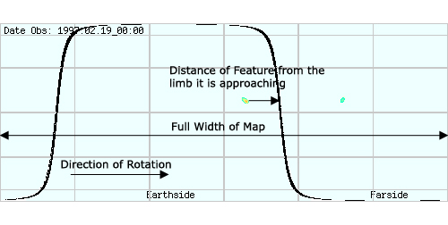

1. The rest of the columns in the grid represent the days in your 4-day forecast, Day 0 representing the present day (the day the measurements on your map were made). For each magnetic feature on each day, you will enter a number that represents its potential for producing a flare that we can observe directly. For any day that a given feature resides on the farside, it contributes “0” to the overall flare potential. For any day that a given feature resides on the Earthside, it contributes to the overall flare potential by the value of the size you assigned to it.

The easiest way to fill out these columns is as follows. For each magnetic feature:

1. In the column for Day 0, enter either a “0” if the feature is on the farside, or the size you assigned the feature if it is on the Earthside.
2. Then, fill in the same number that you entered in the Day 0 column into the next N Day columns, N being the number you calculated for the feature’s DFL (Days From Limb). Obviously, if a feature is more than 3 days from the limb, it will remain on the side it started on (Earthside or farside) throughout this forecast.
3. Finally, for the remainder of the Day columns, fill in the flipside number. That is, after a feature has crossed the limb from Earthside to farside, enter a 0 for the remaining days; if the feature has crossed from farside to Earthside, enter the strength you assigned to the feature.
4. For each Day number column, add all of the numbers and write the sum at the bottom, in the Flare Potential Rating row. This is the number on any given day of your forecast intended to represent the likelihood of flare events.

**Questions:**

* This method of flare forecasting is a simplified one, and relies on certain assumptions. Can you think of any assumptions in this method that may or may not be very useful? What are they?
* Can you think of any ways to make this method potentially more accurate?
* What information/data that is not available to you would you find useful for improving the accuracy of your forecast?

### Improving your forecast

The whole Sun magnetic map is composed of information derived from two different techniques: one of direct observation of magnetic features on the Sun’s Earthside, the other from indirect measurement of a secondary source of data. While calculating a flare potential from the Earthside magnetic data might be fairly reliable, depending on the farside data for predicting near-future flare potential can be dicey. It’s not quite as mystical as trying to see the future through a crystal ball, as the data is based on scientific measurement and physical principles that are understood. But every feature shown in the farside data contributes to the flare potential rating, whether or not it is a real magnetic feature or a ghost of noise. False farside data exaggerates the future flare potential rating.

What ways might you refine the forecasting technique to attempt to make it more accurate? Here are a couple of suggestions you might try:

1. Eliminate farside data spots from your forecasting calculation whose sizes are below a set threshold. In other words, if the spot is below a certain size, throw it back!

Why choose to do this? How might this improve your forecast?

The assumption here is that small farside spots are more likely to be false data, or noise, than real features, so by eliminating them is to eliminate probable false data from your calculation and so improve your forecast.

Whether or not this is a valid assumption, eliminating small spots from your calculations may eliminate some false data while only sacrificing real features that are small, and less influential in your calculation.

If it works, great! If not, try something else….

1. Examine one or two previous whole Sun maps (say, from 12 hours earlier, 24 hours earlier, etc.) and eliminate any spots that do not persist from one to the next (those that only show up in the current map, and not the recent previous maps).

The assumption here is that any spot that isn’t present in a pair of consecutive maps is most likely noise, instead of a real magnetic feature, which tend to last more than 12 hours.

### Forecasting Grid

|  |  |  |  |  |  |  |
| --- | --- | --- | --- | --- | --- | --- |
| **Forecast Section** | | | | | | |
|  | | | **Day** | | | |
| **Feature** | **Size** | **DFL** | **0** | **1** | **2** | **3** |
| A |  |  |  |  |  |  |
| B |  |  |  |  |  |  |
| C |  |  |  |  |  |  |
| D |  |  |  |  |  |  |
| E |  |  |  |  |  |  |
| F |  |  |  |  |  |  |
| G |  |  |  |  |  |  |
| H |  |  |  |  |  |  |
| I |  |  |  |  |  |  |
| J |  |  |  |  |  |  |
| K |  |  |  |  |  |  |
| L |  |  |  |  |  |  |
| M |  |  |  |  |  |  |
| N |  |  |  |  |  |  |
| O |  |  |  |  |  |  |
| **Follow-Up Section** | | | | | | |
| **Flare Potential Rating:** | | |  |  |  |  |
| **Daily Relative Spot Number:** | | |  |  |  |  |
| **X-ray Flare Reports:** | | **A** |  |  |  |  |
| **B** |  |  |  |  |
| **C** |  |  |  |  |
| **M** |  |  |  |  |
| **X** |  |  |  |  |

## Following Up

### What you will do

You will check the accuracy of your flare forecast by comparing it, after the fact, with real observations of solar magnetic and flare activity made on the days of your forecast.

### How you will do it

You will obtain and examine various sources of data and reports of solar and flare activity and search for correlations between your forecast and the data. You may access X-ray flux data, flare reports, solar images, and other sources of data. You will also make a Relative Sunspot Number calculation for each day of your forecast, also for purposes of comparison.

### Materials and Skills

* Full-disk visible-light solar images for the days of your forecast
* X-ray flux graphs covering the days of your forecast
* Solar event reports covering the days of your forecast
* Graphing skills

### Background

So did it work? Do you think your flare forecast had any resemblance whatsoever to actual flare events and conditions that followed? How do you put it to the test?

The answer, of course, is to compare your predictions with actual observations that indicate flare activity. There are a number of places on the Internet where you can find solar activity reports of a number of types, including solar images (visible light, ultraviolet, X-ray) and other acquired data. You are free to—even encouraged to—wade through all the various logs and lists and images and reports of solar and space weather activity and conditions that you can find.

For the purposes of testing your flare forecast, you may choose to focus on one source of information, one type of data. You could choose to examine daily ultraviolet and X-ray images (such as SOHO extreme-ultraviolet images, GOES X-ray images, or Hinode X-ray images) to look for flares: extreme points of brightness in those wavelengths. However, most solar images provided by ground based and space based observatories only update on the web once or twice a day—and flare events can come and go in a matter of hours, or even minutes. Also, even if a flare were present in one of these daily images, could you distinguish it from an active spot that may be intensely hot, but not actually a flare?

#### Relative Sunspot Number

One thing you can compare your forecasted flare potentials to is the Relative Sunspot Number index for each day of your forecast. You can either calculate your own RSN (see the activity on page 51), or obtain official daily sunspot numbers from the Internet or other source. However you arrive at a number, record it on the Forecasting Grid in the Follow-Up section, in the row beneath your Flare Potential Ratings.

#### X-ray Flux Data

Fortunately, there is a source of data that we can use that has a much higher “cadence” than the daily solar images. (*Cadence* is how frequently a particular measurement is made.) The National Oceanographic and Atmospheric Administration (NOAA) operates the GOES satellites, which, in addition to capturing periodic X-ray images of the Sun, almost continuously monitor the Sun’s X-ray *flux—*the overall brightness of the Sun in X-rays. This data can be found at the Space Environment Center (SEC) home page, [www.sec.noaa.gov/](http://www.sec.noaa.gov/).

The X-ray flux of the Sun measured by the GOES satellites are presented in more than one form on this website. First, graphs showing the measured X-ray flux--*GOES Solar X-ray Flux—*can be reviewed (see the example below). The graph shows the X-ray brightness measured in different wavelength ranges and by different GOES satellites. A flare will be revealed in this data as a sudden increase, or “spike,” in the X-ray brightness, followed by a more gradual fall-off to the normal X-ray levels as the heated gases cool. The class of a flare can be quickly read from this graph on the right-hand axis, showing A, B, C, M, and X levels of X-ray brightness.

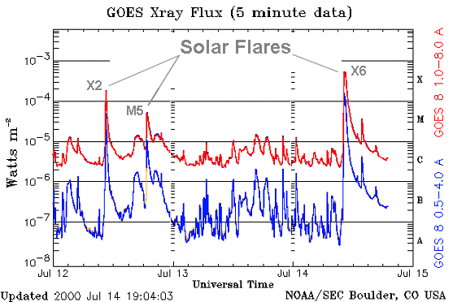

Another record you can use to check the recent history of flare events are the “edited” solar event reports. These are not raw data, but rather reports made from the analysis of the raw X-ray flux data. In these reports, not only have the occurrences of flares been identified for you, but also their classification.

On the SEC website, click on

*Alerts/Warnings*,

*Solar Event Reports*

This will present you with a list of files, beginning with a file containing information about the event reports contained in all the other files. Here is a sample of one event report (from a day during Solar Minimum when there were not very many events to report on):

:Product: 20060910events.txt

:Created: 2006 Sep 12 0302 UT

:Date: 2006 09 10

# Prepared by the U.S. Dept. of Commerce, NOAA, Space Environment Center.

# Please send comments and suggestions to SEC.Webmaster@noaa.gov

#

# Missing data: ////

# Updated every 30 minutes.

# Edited Events for 2006 Sep 10

#

#Event Begin Max End Obs Q Type Loc/Frq Particulars Reg#

#-------------------------------------------------------------------------------

5610 + 0248 0251 0304 G12 5 XRA 1-8A B1.0 9.2E-05

5620 + 0649 0723 0815 G12 5 XRA 1-8A B6.0 2.3E-03 0909

5620 0655 0759 0814 G12 5 XFL S08W25 1.2E+03 2.5E+03 0909

5630 + 1925 1930 1943 G12 5 XRA 1-8A B1.4 1.3E-04 0909

**Description of the report:**

The table lists events by an arbitrary Event Number (first column), and shows the Universal Time on that report’s day when the event began, reached its maximum intensity, and then ended (under those columns). The observatory that reported the event is listed next (above, “G12” means the GOES-12 satellite). The “Q” value indicates the “quality” of the report or observing conditions.

The “Type” of the event is where you will look to find X-ray flares detected by either the primary or secondary GOES observing satellite, indicated by “XRA.” For the purposes of your forecast verification, this type of event is the only one you really need to look for and add up.

As you find XRA events, look also to the “Particulars” column to find and record the class of the flare.

The “Loc/Frq” column gives information on the location of the event on the Earthside of the Sun and the wavelength or frequency of radiation in which the observation was made. For the purposes of our own forecast verification, we don’t need to worry about the location of the event—but out of your own curiosity, you may decide to use any location information provided to see which magnetic active region caused the event….

### What to do with the data

The purpose of the *Flarecast* activities is to try to predict solar flare activity by working out a method to calculate the probability, or likelihood, of flares occurring on a given day based on the expected amount of magnetic active regions within line of sight of the Earth.

In the days following your forecast plot, additional full-Sun magnetic maps will be created, daily solar X-ray flux graphs and event reports will be made—and you’ll be on the edge of your seat each day waiting to see them!

#### Record flare events

For each day of your forecast, find and tally any XRA type events (X-ray flares detected through GOES X-ray flux data). One row on the Forecasting Grid is provided for you to note any X-ray flare event reports. Simply tally the total count of flare events on a given day, for each class of flare. If you wish to include more information, such as recording exact flare class ratings (“B6” instead of just “B,” for example), feel free to do so; if you need more room for your recordings, don’t feel limited by those little boxes!

#### Graph the results

After collecting the four days of follow-up data, you should be ready to put your original flare forecast to the test. As always, if you have a creative idea for how to do this, try it out! Otherwise, follow these steps to produce a graph of your predicted flare potential and the actual flare activity over the two week period of your prediction.

To create the graph:

1. Label the horizontal axis by Day number, from 0 to 3—the period of your forecast.
2. Label the *left* vertical axis as Flare Potential Rating. Before marking off the intervals, choose the range for this axis’ numbering that best fits the range of your data (the lowest and highest flare potentials that you calculated in your forecast).
3. Graph your flare potential ratings. If you’re doing this by hand (and not with a graphing computer program), select the shape and/or color for these data points.
4. Label the *right* vertical axis as Actual Flare Activity. (If your graph doesn’t have a right-hand vertical axis, then draw one!) Again, choose the range for this axis that best fits the range of your data (in the case, the minimum and maximum number of flares of the class of which there were the most).
5. Graph the actual flare events. In each Day on the graph, plot the number of flares that occurred of each class (you’ve recorded the numbers of individual flare classes separately, and now you’ll plot them separately as well). Be sure to label each flare total you plot with the class (A, B, C, M, or X)—or just use the class letters as the style of plot point.

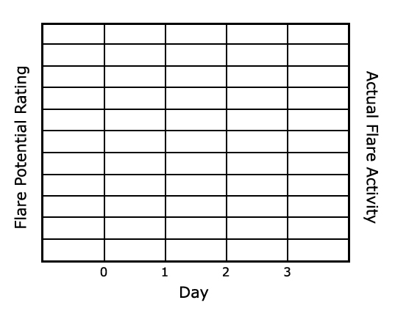

Sample Graph: Flare Potential and Actual Flare Activity versus Day

**Questions:**

* How well does the data correlate with your prediction? Does your predicted flare potential rating data set match up at all with the actual flare activity? Not at all? Somewhere in the middle?
* Can you think of a scheme for “grading” your prediction—rating its power to predict on a scale, say of 1 to 10? How would you rate the forecast? Be honest now; this is for posterity….
* Can you think of anything you would do differently if you were to go through the *Flarecast* experiment again? Advice you’d give to someone just starting the experiment? Advice you wish someone had given you when you started?
* If you were to make another *Flarecast*, do think you could make it work better? Why, or why not?

**Check the accuracy of the farside data**

While your Day 0 flare potential rating is based on actual magnetic active regions visible on the Earthside of the Sun, the Day 1 through Day 3 flare potentials you calculated may be influenced increasingly by farside data. The purpose of this activity is to determine, after the fact, how realistic your flare potentials were—in other words, how reliable the farside data was in your prediction.

1. You have already calculated or obtained a Relative Sunspot Number for each day of your forecast and recorded them on the Forecasting Grid.
2. Make a graph. This will be a graph of the Day (horizontal axis), the flare potential rating (left vertical axis), and the Relative Sunspot Number (right vertical axis). See the sample graph below. Label the intervals on both vertical axes appropriately to fit the ranges of their data points.
3. Plot both series of points on the graph: the flare potential rating and the Relative Sunpot Number for each day.

Do you see any correlations between the two sets of data points? Keep in mind that because each set of points are numbers determined by different methods, the actual values of the numbers will probably not agree with each other—but that’s not what you’re looking for in the correlation.

Each set of points is an attempt at assessing the overall level of magnetic activity on the Earthside of the Sun for each of four days, so if both methods of calculation are valid, then you might expect to see a correlation of trends in the data—the shapes of the curves, or the slopes of the lines.

If you don’t see any correlations, do you have any ideas why this might be?

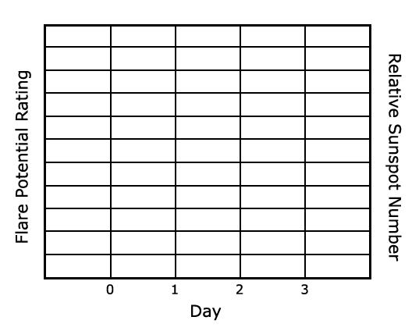

Sample Graph: Flare Potential and Relative Sunspot Number versus Day

# The Smoking Gun

## Introduction

Solar flares were suspected to have effects on the Earth practically since the day they were discovered. The first detection of a solar flare occurred in 1859, the discovery made independently by English astronomers Richard Carrington and Richard Hodgson while they were observing a group of sunspots. The day following the observation there was an aurora that spread so far south of the northern polar region that it was seen in Cuba! Carrington suspected a connection between the two events—and as it turns out, he was right.

### Things To Think About

* The solar wind is always flowing outward from the Sun and past Earth.
* The average velocity of normal solar wind is between 200 and 400 kilometers per second.
* Events on the Sun, such as coronal mass ejections, flares, and coronal holes, can cause the velocity and proton density of the solar wind to increase, sometimes abruptly.
* Increases in the solar wind can be detected by satellites and can cause increases in auroral activity and fluctuations in Earth’s magnetic field (in extreme cases this is called a “geomagnetic storm”).
* The solar wind that affects Earth tends to come from the Sun’s equatorial regions.
* How long does it take solar wind to flow from Sun to Earth?
* How much will the Sun have rotated since the disturbance left the Sun?
* Coronal Mass Ejections headed toward Earth are most easily found in coronagraph images, like SOHO’s LASCO instrument.
* Coronal Holes are easiest to find using X-ray and ultraviolet images, such as the GOES SXI and SOHO EIT instruments.
* Flares, which can begin and end in a very short time, can be difficult to find using images that are updated only once or twice a day.

### Sources of Data

* SOHO/CELIAS/MTOF/PM. Data of solar wind velocity and proton density as measured by the CELIAS/MTOF Proton Monitor sensor on SOHO. Go to “Online Data Available from the PM” and click on “Solar wind data arranged by Carrington number” to access archived plots and tables: [umtof.umd.edu/pm/](http://umtof.umd.edu/pm/).
* SOHO. Especially EIT images to look for coronal events and features that affect solar wind, such as flares, coronal mass ejections, and coronal holes. [sohowww.nascom.nasa.gov/](http://sohowww.nascom.nasa.gov/).
* GOES. X-ray images: [www.sec.noaa.gov/](http://www.sec.noaa.gov/).

## Doing a Little Research

### What you will do

Do some basic research to become familiar with selected topics around Space Weather.

### How you will do it

Using Internet, print, video, CDROM, or other sources of information, research and answer the following questions:

1. What is the solar wind?
2. What is solar wind made of?
3. Where does solar wind come from?
4. How does solar wind affect the Earth and surrounding space?
5. How fast is the solar wind?
6. Name three places on the Internet where you can find real-time or archived solar wind data. Be sure to tell where the data came from (what satellite or other observatory).

## Finding Space Weather Events

### What You Will Do

You will search solar observational data for high-speed solar wind events.

### How You Will Do It

You will find at least three episodes of increased solar wind activity at the Earth using direct measurements of solar wind velocity and density. You will characterize each event by its rise time—the time it takes for the solar wind speed to rise from normal levels to the peak speed of the event—and the percentage increase in solar wind velocity.

### Materials and Skills

* Solar wind velocity and density data
* Worksheet A: Solar Wind Event Properties (provided on page 72)
* Graph-reading skills
* Basic math skills: percentages, time calculation

### Data Sources

There is more than one source of solar wind data available, and you are welcome to use whatever data you would like. This activity assumes you are using solar wind velocity and density data as measured by the Proton Monitor (PM) sensor on the CELIAS/MTOF instrument on the SOHO spacecraft. Keep in mind that SOHO is about 1 million miles closer to the Sun than the Earth is.

### Step-by-Step

1. Search the most recent few months of plots or data lists found at the CELIAS/MTOF site: “Solar wind data arranged by Carrington rotation.”
2. Find three dates on which the velocity of the solar wind increased by at least 50%-75%. Try to estimate to the hour (as best as you can) the time at which the increase in velocity began.
3. For each of the three solar wind events you have found, record on Worksheet A on page the following:

* date and time at beginning of the event
* solar wind velocity at beginning of the event
* date and time of the event’s maximum velocity
* solar wind velocity at maximum

1. Calculate the solar wind *rise time*—the amount of time, in hours and minutes, that it took to go from the beginning of the event to the maximum solar wind velocity:

**Rise time = Tmax – Tbeg**

Write the result on Worksheet A.

1. Calculate the solar wind *velocity increase*—the percent increase in solar wind velocity from the beginning of the event to maximum:

**Velocity increase = ( (Vmax – Vbeg) / Vbeg) * 100**

Write the result on Worksheet A.

### Worksheet A: Solar Wind Event Properties

|  |  |  |  |  |  |
| --- | --- | --- | --- | --- | --- |
| **Date/Time at Start** | **Velocity at Start** | **Date/Time at Maximum** | **Velocity at Maximum** | **Rise Time** | **Velocity Increase %** |
|  |  |  |  |  |  |
|  |  |  |  |  |  |
|  |  |  |  |  |  |

## Tracking the Solar Wind Event to Its Source

### What you will do

You will attempt to identify suspected solar events (active regions, coronal holes, CMEs or flares) as the source of the solar wind events that you identified in the activity *Finding Space Weather Events* on page .

### How you will do it

For each solar wind event you found, you will calculate the approximate travel time of the solar wind from Sun to Earth to estimate the time at which the disturbance would have left the Sun.

For each of the times you calculated for when the disturbance would have left the Sun, you will check X-ray data.

You will examine solar images taken at the time you have calculated in an attempt to identify the solar event that may have caused the episode.

### Materials and Skills

* Selected solar images and other data
* Your results from Worksheet A: Solar Wind Event Properties
* Worksheet B: Tracking the Event to the Sun (page )

### Finding the Event’s Departure Date from the Sun

For each of the three events you found in the *Finding Space Weather Events* activity, do the following:

1. In Worksheet B on page , write down the date/time and maximum solar wind velocity of the event.
2. Calculate the travel time from the Sun to the Earth of the solar wind using its maximum velocity. Use the distance/time/velocity formula:

**travel time = (distance) / (velocity)**

Write the result on Worksheet B.

1. Calculate the departure date/time of the solar wind event from the Sun by subtracting the travel time from the date of the solar wind event at Earth:

**departure date = (date of solar wind event) – (travel time)**

Write the result on Worksheet B.

### Fingering the Suspect

In this part of the activity you will search solar images on or near the date you have calculated for the departure from the Sun of your solar wind event. Do the following for each of the three events you have found.

1. Find and download solar images as close to the departure time as possible. Recommended images: SOHO EIT (especially the EIT 284), GOES X-ray, and SOHO/LASCO. A visible light image, such as the SOHO MDI I-gram, may be useful as well.
2. Search all of the images for solar features—sunspots, coronal mass ejections, flares, active regions, coronal holes—that could be the source of the solar wind disturbance at Earth. It may not be easy to find an obvious candidate, or any at all, but don’t let that discourage you. (Richard Carrington really did just get extremely lucky!) With any luck, you will find a candidate feature for at least one of the three events. Also see the background information section, especially the section on “Which Way the Wind Blows.”
3. If you find a solar feature that you think is responsible for the solar wind disturbance, try to identify what kind of feature it is and write that down on Worksheet B. If you find nothing, write that down.

### Worksheet B: Tracking the Event to the Sun

|  |  |  |  |  |
| --- | --- | --- | --- | --- |
| **Date/Time at Maximum** | **Velocity at Maximum** | **Travel Time Sun to Earth\*** | **Date/Time of Departure from Sun** | **Suspected Associated Solar Event** |
|  |  |  |  |  |
|  |  |  |  |  |
|  |  |  |  |  |

* You can use a Sun-Earth distance of 93 million miles (or 148.8 million kilometers) to make this calculation. If you’re using data from SOHO, remember that SOHO is 1 million miles closer to the Sun than the Earth is.

## Finding Other Effects on the Earth

### What you will do

You will expand the scope of your search for solar event related effects on the Earth to include other phenomena and signs.

### How you will do it

There are a lot of places on the Web to find data, reports, and other information on specific solar events: auroral activity, geomagnetic disturbances, radiation storms, solar flares, mass ejections.

In this activity, browse the Internet to see if you can find additional reports of conditions—either at the Earth or on the Sun—that may be related to the events you have found.

Summarize your findings for this activity in your overall project report.

**Here are some suggestions**:

* On the CELIAS/MOTF/PM page (<http://umtof.umd.edu/pm/>), under *Interplanetary shocks and other interesting events*, see if there was a report of an event in the solar wind around the time and date of the event you found using the Proton Monitor plots. (This list in not a complete one, so don’t worry if the event you found is not here.)
* On the NOAA Space Weather Center site (<http://www.sec.noaa.gov/>), wade through the trove of solar and space weather event reports and data under *Reports/Summaries*. Also take a look at the archives of Satellite Environment Plots.

# Resource Websites

Stanford Solar Center: [solar-center.stanford.edu/](http://solar-center.stanford.edu/)

Stanford Solar Center—Whole Sun Data Maps: [soi.stanford.edu/data/full_farside/](http://soi.stanford.edu/data/full_farside/)

Spaceweather.com: [www.spaceweather.com/](http://www.spaceweather.com/)

About flares, NASA/Goddard Space Flight Center: [solarscience.msfc.nasa.gov/flares.htm](http://solarscience.msfc.nasa.gov/flares.htm)

SOHO: [sohowww.nascom.nasa.gov/](http://sohowww.nascom.nasa.gov/)

SOHO data archive: [sohowww.nascom.nasa.gov/cgi-bin/realtime_query](http://sohowww.nascom.nasa.gov/cgi-bin/realtime_query)

Full-Sun magnetic maps: [soi.stanford.edu/data/full_farside/](http://soi.stanford.edu/data/full_farside/)

Space Environment Center: [www.sec.noaa.gov/](http://www.sec.noaa.gov/)

National Geophysical Data Center sunspot numbers archive: [www.ngdc.noaa.gov/stp/SOLAR/ftpsunspotnumber.html](http://www.ngdc.noaa.gov/stp/SOLAR/ftpsunspotnumber.html)

Solar wind velocity and proton density data measured by CELIAS/MTOF: [umtof.umd.edu/pm/](http://umtof.umd.edu/pm/).

# Glossary

Active region: A region on the Sun’s photosphere and atmosphere experiencing increased and often intense magnetic activity. On the photosphere active regions are usually marked by sunspots, and in the atmosphere above superheated gases and magnetic structures are revealed in ultraviolet and X-ray images.

Angstrom, unit of length: A small-scale unit of length often used to express the wavelength of electromagnetic radiation. One Angstrom equals 10-10 meters.

Angular velocity: The rate of rotation of an object, usually in degrees per unit time (for example, degrees per minute, degrees per day, etc.).

Apparent motion, Sun: The observed motion of the Sun through the sky each day caused by the Earth’s rotation.

Astronomical Unit (AU): The mean distance of the Earth from the Sun, equal to 149,597,870,691 meters or about 92,956,000 miles.

Aurora: The Northern and Southern Lights; light emanating from the upper atmosphere around the Polar Regions generated by interactions between energized plasma in Earth’s magnetosphere colliding with ionized gases in the ionosphere.

Axis of rotation: The imaginary line around which a rotating object spins.

Carrington coordinates: A system of latitude/longitude on the Sun’s photosphere whose meridians of longitude rotate with solar rotation, similar to how Earth’s system of latitude/longitude rotates with the Earth to establish constant geographic coordinates for fixed surface features.

Chromosphere: The layer of the Sun’s atmosphere immediately above the photosphere. Chromosphere means “sphere of color.”

Conformal latitude: In a rectangular projection map of a spherical surface, where horizontal (east-west) distances represented on the map become more and more stretched out farther and farther from the equator, the conformal latitude for a given map is the latitude where north-south distance are at the same scale as east-west distances.

Corona: The layer of the Sun’s atmosphere above the chromosphere and extending a great distance into space.

Coronal hole: A region in the Sun’s corona where magnetic field lines “open out” into space, allowing solar atmospheric plasma to escape. Coronal holes appear as dark areas in extreme ultraviolet and X-ray images because these magnetically open and “relaxed” areas experience less heating than magnetically active and closed regions.

Coronal mass ejection: An eruption from the Sun into space of hot plasma and magnetic fields, often containing billions of tons of material (mostly hydrogen nuclei and electrons) moving at a million or more miles per hour.

Doppler Effect: The change in pitch or frequency of a wave phenomenon, like sound or light, caused by differences in relative speed/velocity between the wave source and an observer.

Earthside: The half of the Sun’s surface that can be directly viewed from an observer on Earth at any given time. See Farside.

Electromagnetic radiation: All types of radiation composed of electromagnetic waves. Depending on the wavelength of the electromagnetic radiation, this can be visible light, X-rays, ultraviolet light, infrared light, microwaves and radio waves.

Equator: The circle on the surface of a sphere midway between its two poles or rotation (north and south). On the Earth and on the Sun, the equator is defined at a latitude of 0 degrees.

Equatorial plane: An imaginary, infinite plane coincident with a sphere’s equator, be it of the Earth, the Sun, or any other planet, moon, or star.

False color: A color, usually chosen arbitrarily, applied to an image or other graphical data set either to artificially accentuate or make visible quantities or qualities in the data. In solar imaging, for example, X-ray or ultraviolet images of the Sun must be colored artificially since those forms of light are invisible to human eyes and therefore have not defined colors of their own.

Farside: On the Sun, the farside is the half of the Sun that cannot be directly viewed from an observer on Earth at any given time. See Earthside.

Flare, classes: A scale of power to classify the power of flares, similar to the Richter scale of earthquake power. The solar flare class scale is based on the brightness of a flare’s X-rays measured in the wavelength range from 1 to 8 Angstroms.

Flare: Relatively small, concentrated and highly energetic explosions of superheated coronal gas, caused by the “breakdown” and reconnection of intensely twisted magnetic fields.

Flux: In general, the quantity of energy or material that is incident on a surface, real or imaginary, over a given amount of time. Sunlight flux, for example, is how much solar energy strikes a surface of one square meter in one second—or Watts per square meter.

Galileo Galilei: The Renaissance astronomer touted as the first person to have used a telescope to observe celestial objects, in 1610 CE. Among other observations, Galileo recorded and tracked sunspots, and was the first to argue from observational evidence that sunspots are features on the surface of the Sun.

Gamma radiation: The most energetic, shortest wavelength form of electromagnetic radiation.

Geomagnetic storm: On the ground, fluctuations in Earth’s magnetic field caused by the impact of a CME—called “geomagnetic storms”—can induce electrical current in conducting structures. Geomagnetic storms have been known to overload power grids and cause damage to oil pipelines.

GOES: Geostationary Operational Environmental Satellite. Among other measurements, GOES monitors solar X-ray emissions.

Greenwich Mean Time (GMT), Universal Time (UT): GMT is global standard time, based on the time in Greenwich, England, which is located on the Earth’s Prime Meridian (this city, in fact, defined the Prime Meridian as the reference for longitude on Earth). UT is the universal time used by astronomers, and is for all practical purposes equivalent to GMT.

Heliographic: Having to do with the “geography” of the Sun (Helios), usually in reference to the system of solar latitude and longitude.

Helioseismology: A young science that observes Doppler effects caused by seismic, or sound, waves moving through the Sun to infer the Sun’s internal structure and conditions.

Intensity-gram, I-gram: An image formed by measuring differences in the intensity, or brightness, of light coming from different locations on an object. This is a fancy way of saying “photograph.”

Intrinsic motion: The actual motion of an object being observed, as opposed to perceived motion that is caused by the motion of the observer.

Ionosphere: An upper layer of Earth’s atmosphere composed of different layers of gases that have been ionized by the Sun’s ultraviolet radiation.

Kelvin, temperature scale: The temperature scale based on the absolute lowest possible temperature at which all motion of atoms and molecules stops: 0 Kelvin. 0 Kelvin is equal to -273 degrees Celsius.

Lateral motion: The part of an observed object’s overall motion that is seen from side-to-side. An object that is moving directly toward or away from an observer has no observed lateral motion (doesn’t appear to move side-to-side); all of the object’s motion is line-of-sight.

Latitude: The angular distance along the surface of a sphere measured from its equator north or south toward its poles.

Longitude: The angular distance along the surface of a sphere measured east or west between a meridian and a reference meridian.

Limb, solar: The “edge” of the Sun’s disk as seen by an observer. The solar limb marks the boundary between the Sun’s Earthside and Farside.

Line-of-sight motion: The part of an observed object’s overall motion that is measured as moving directly toward or away from an observer. See lateral motion.

Magnetic field: The field of magnetic force generated by accelerated electrical charges, such as in an electromagnet, in the Earth’s iron core, and in the plasma in the Sun.

Magnetogram, M-gram: A map of the Sun’s photosphere that shows regions of strong magnetic field and their polarities (N or S magnetic poles). Magnetograms are derived from measurements of the polarization of light emitted by gases embedded within the solar magnetic fields.

Magnetosphere: The overall magnetic field generated by the Earth, the Sun, or any other planet or moon that has a magnetic field.

MDI: Michelson Doppler Imager, an instrument on board the SOHO spacecraft that takes I-grams and M-grams of the Sun.

Meridian: An imaginary line running north-south along a sphere’s surface, from one pole to the other.

Photosphere: The visible “surface” of the Sun as seen in visible light. It means “sphere of light.”

Plasma: The “fourth state of matter,” after solid, liquid, and gas. Plasma is gas whose atoms have been ionized, either by heating or by interaction with high-energy electromagnetic radiation or particles. Plasma is electrically charged, and is influenced strongly by magnetic fields.

Polarization: The effect in electromagnetic radiation when a majority of the light waves are “lined up,” or polarized, in the same direction. Light can be polarized by reflection, by passing through certain transparent materials, by passing through polarizing filters, and when the light emitting atoms or molecules have been rotated in the same orientations by the influence of a magnetic field.

Poles—solar: The two points, North and South, on the surface of the Sun intersected by the imaginary line of its rotational axis. Equivalent to Earth’s North and South Poles.

Rectangular projection: A method of projecting a spherical surface onto a flat rectangular map.

Relative Sunspot Number: A conventional method for calculating and reporting the overall daily magnetic activity on the Sun from observations of sunspots and sunspot groups. The formula for calculating the Relative Sunspot Number is:   
R = k(10g + s), where g is the number of sunspot groups, s is the total number of individual sunspots, and k is a factor that depends on the size/quality of the telescope used to observe the sunspots as well as observing conditions.

Rotation, differential: Differences in the rate of rotation of the Sun’s surface at different latitudes.

Rotation, solar—sidereal, synodic: The sidereal rotation of the Sun in relation to the “fixed” frame of reference of the stars. One sidereal rotation of the Sun’s equator takes about 25.38 days. The synodic rotation of the Sun in relation to the moving frame of reference of the Earth, which revolves around the Sun as the Sun rotates. From our point of view on the Earth, we see the Sun’s equator rotate once every 27.2753 days.

Scale, image: The ratio between a distance measured on an image and the actual physical distance represented by that image distance.

SOHO: The European Space Agency’s *Solar and Heliospheric Observatory*.

Solar cycle: The period between two successive peaks in overall solar magnetic activity. This cycle has been observed in data taken over the last few centuries, and, though the period varies, is typically around 11 years long.

Solar maximum, minimum: The times of highest and lowest solar magnetic activity, respectively; the peak and trough of a solar cycle.

Solar wind: The constant flow of solar plasma and magnetic field emanating from the Sun. Though exceedingly thin, the solar wind flows by Earth at speeds of 200 to 400 kilometers per second, or faster.

Space weather: The conditions of electromagnetic radiation and moving particles in space, outside of Earth’s atmosphere and magnetosphere, due mainly to solar activity, including the solar wind and disturbances in it caused by coronal mass ejections, flares, and coronal holes on the Sun.

Stonyhurst Disks: A set of full-disk latitude/longitude coordinate grids plotted for the different viewing angles of the Earth at different times of the year. Stonyhurst disks are used to measure the solar latitude and longitude of sunspots and active regions.

Sunspot: A region on the Sun’s photosphere that has been cooled somewhat by the presence of strong magnetic fields emerging from within the Sun. Sunspots are typically 3000 to 4000 Celsius, as compared to the average temperature of the photosphere of 6000 Celsius.

Sunspot group: A grouping of sunspots related to the same magnetic disturbance on the photosphere. Sunspots are considered to be part of the same group if they lie within about 10 degrees of longitude of each other and at about the same latitude.

Ultraviolet: Electromagnetic radiation with wavelengths shorter than visible light but longer than X-rays.

X-ray: Electromagnetic radiation with wavelengths shorter than ultraviolet light but longer than gamma rays.

# National Science Content Standards

## Grades 5-8

***UNDERSTANDINGS ABOUT SCIENTIFIC INQUIRY***

* Different kinds of questions suggest different kinds of scientific investigations. Some investigations involve observing and describing objects, organisms, or events; some involve collecting specimens; some involve experiments; some involve seeking more information; some involve discovery of new objects and phenomena; and some involve making models.
* Current scientific knowledge and understanding guide scientific investigations. Different scientific domains employ different methods, core theories, and standards to advance scientific knowledge and understanding.
* Mathematics is important in all aspects of scientific inquiry.
* Technology used to gather data enhances accuracy and allows scientists to analyze and quantify results of investigations.
* Scientific explanations emphasize evidence, have logically consistent arguments, and use scientific principles, models, and theories. The scientific community accepts and uses such explanations until displaced by better scientific ones. When such displacement occurs, science advances.
* Science advances through legitimate skepticism. Asking questions and querying other scientists' explanations is part of scientific inquiry. Scientists evaluate the explanations proposed by other scientists by examining evidence, comparing evidence, identifying faulty reasoning, pointing out statements that go beyond the evidence, and suggesting alternative explanations for the same observations.
* Scientific investigations sometimes result in new ideas and phenomena for study, generate new methods or procedures for an investigation, or develop new technologies to improve the collection of data. All of these results can lead to new investigations.

***PHYSICAL SCIENCES: MOTIONS AND FORCES***

* The motion of an object can be described by its position, direction of motion, and speed. That motion can be measured and represented on a graph.
* An object that is not being subjected to a force will continue to move at a constant speed and in a straight line.

***PHYSICAL SCIENCES: TRANSFER OF ENERGY***

* Energy is a property of many substances and is associated with heat, light, electricity, mechanical motion, sound, nuclei, and the nature of a chemical. Energy is transferred in many ways.
* Heat moves in predictable ways, flowing from warmer objects to cooler ones, until both reach the same temperature.
* Light interacts with matter by transmission (including refraction), absorption, or scattering (including reflection). To see an object, light from that object--emitted by or scattered from it--must enter the eye.
* In most chemical and nuclear reactions, energy is transferred into or out of a system. Heat, light, mechanical motion, or electricity might all be involved in such transfers.
* The sun is a major source of energy for changes on the earth's surface. The sun loses energy by emitting light. A tiny fraction of that light reaches the earth, transferring energy from the sun to the earth. The sun's energy arrives as light with a range of wavelengths, consisting of visible light, infrared, and ultraviolet radiation.

***EARTH AND SPACE SCIENCE: EARTH IN THE SOLAR SYSTEM***

* The earth is the third planet from the sun in a system that includes the moon, the sun, eight other planets and their moons, and smaller objects, such as asteroids and comets. The sun, an average star, is the central and largest body in the solar system.
* The sun is the major source of energy for phenomena on the earth's surface, such as growth of plants, winds, ocean currents, and the water cycle. Seasons result from variations in the amount of the sun's energy hitting the surface, due to the tilt of the earth's rotation on its axis and the length of the day.

***SCIENCE AND TECHNOLOGY: UNDERSTANDINGS ABOUT SCIENCE AND TECHNOLOGY***

* Scientific inquiry and technological design have similarities and differences. Scientists propose explanations for questions about the natural world, and engineers propose solutions relating to human problems, needs, and aspirations. Technological solutions are temporary; technologies exist within nature and so they cannot contravene physical or biological principles; technological solutions have side effects; and technologies cost, carry risks, and provide benefits.
* Science and technology are reciprocal. Science helps drive technology, as it addresses questions that demand more sophisticated instruments and provides principles for better instrumentation and technique. Technology is essential to science, because it provides instruments and techniques that enable observations of objects and phenomena that are otherwise unobservable due to factors such as quantity, distance, location, size, and speed. Technology also provides tools for investigations, inquiry, and analysis.

***SCIENCE IN PERSONAL AND SOCIAL PERSPECTIVES: NATURAL HAZARDS***

* Internal and external processes of the earth system cause natural hazards, events that change or destroy human and wildlife habitats, damage property, and harm or kill humans. Natural hazards include earthquakes, landslides, wildfires, volcanic eruptions, floods, storms, and even possible impacts of asteroids.
* Natural hazards can present personal and societal challenges because misidentifying the change or incorrectly estimating the rate and scale of change may result in either too little attention and significant human costs or too much cost for unneeded preventive measures.

## Grades 9-12

***SCIENCE AS INQUIRY: UNDERSTANDINGS ABOUT SCIENTIFIC INQUIRY***

* Scientists usually inquire about how physical, living, or designed systems function. Conceptual principles and knowledge guide scientific inquiries. Historical and current scientific knowledge influence the design and interpretation of investigations and the evaluation of proposed explanations made by other scientists.
* Scientists conduct investigations for a wide variety of reasons. For example, they may wish to discover new aspects of the natural world, explain recently observed phenomena, or test the conclusions of prior investigations or the predictions of current theories.
* Scientists rely on technology to enhance the gathering and manipulation of data. New techniques and tools provide new evidence to guide inquiry and new methods to gather data, thereby contributing to the advance of science. The accuracy and precision of the data, and therefore the quality of the exploration, depends on the technology used.
* Mathematics is essential in scientific inquiry. Mathematical tools and models guide and improve the posing of questions, gathering data, constructing explanations and communicating results.
* Scientific explanations must adhere to criteria such as: a proposed explanation must be logically consistent; it must abide by the rules of evidence; it must be open to questions and possible modification; and it must be based on historical and current scientific knowledge.
* Results of scientific inquiry--new knowledge and methods--emerge from different types of investigations and public communication among scientists. In communicating and defending the results of scientific inquiry, arguments must be logical and demonstrate connections between natural phenomena, investigations, and the historical body of scientific knowledge. In addition, the methods and procedures that scientists used to obtain evidence must be clearly reported to enhance opportunities for further investigation.

***PHYSICAL SCIENCE: INTERACTIONS OF ENERGY AND MATTER***

* Waves, including sound and seismic waves, waves on water, and light waves, have energy and can transfer energy when they interact with matter.
* Electromagnetic waves result when a charged object is accelerated or decelerated. Electromagnetic waves include radio waves (the longest wavelength), microwaves, infrared radiation (radiant heat), visible light, ultraviolet radiation, x-rays, and gamma rays. The energy of electromagnetic waves is carried in packets whose magnitude is inversely proportional to the wavelength.

***EARTH AND SPACE SCIENCE: ENERGY IN THE EARTH SYSTEM***

* Earth systems have internal and external sources of energy, both of which create heat. The sun is the major external source of energy. Two primary sources of internal energy are the decay of radioactive isotopes and the gravitational energy from the earth's original formation.

***SCIENCE AND TECHNOLOGY: UNDERSTANDINGS ABOUT SCIENCE AND TECHNOLOGY***

* Scientists in different disciplines ask different questions, use different methods of investigation, and accept different types of evidence to support their explanations. Many scientific investigations require the contributions of individuals from different disciplines, including engineering. New disciplines of science, such as geophysics and biochemistry often emerge at the interface of two older disciplines.
* Science often advances with the introduction of new technologies. Solving technological problems often results in new scientific knowledge. New technologies often extend the current levels of scientific understanding and introduce new areas of research.
* Creativity, imagination, and a good knowledge base are all required in the work of science and engineering.
* Science and technology are pursued for different purposes. Scientific inquiry is driven by the desire to understand the natural world, and technological design is driven by the need to meet human needs and solve human problems. Technology, by its nature, has a more direct effect on society than science because its purpose is to solve human problems, help humans adapt, and fulfill human aspirations. Technological solutions may create new problems. Science, by its nature, answers questions that may or may not directly influence humans. Sometimes scientific advances challenge people's beliefs and practical explanations concerning various aspects of the world.

***SCIENCE IN PERSONAL AND SOCIAL PERSPECTIVES: NATURAL AND HUMAN-INDUCED HAZARDS***

* Normal adjustments of earth may be hazardous for humans. Humans live at the interface between the atmosphere driven by solar energy and the upper mantle where convection creates changes in the earth's solid crust. As societies have grown, become stable, and come to value aspects of the environment, vulnerability to natural processes of change has increased.
* Some hazards, such as earthquakes, volcanic eruptions, and severe weather, are rapid and spectacular. But there are slow and progressive changes that also result in problems for individuals and societies. For example, change in stream channel position, erosion of bridge foundations, sedimentation in lakes and harbors, coastal erosions, and continuing erosion and wasting of soil and landscapes can all negatively affect society.

# Stonyhurst Disks

## June 7 and December 7 (B0 = 0)

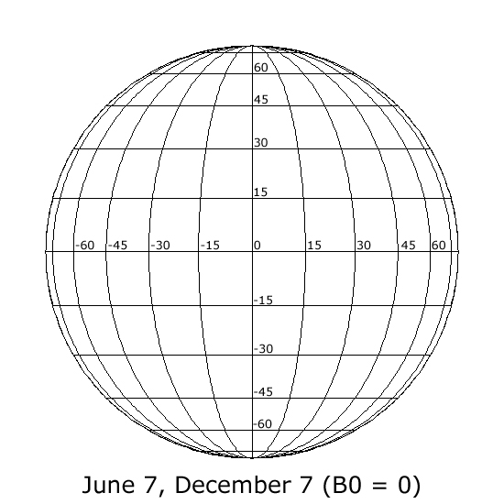

## January (B0 = -5)

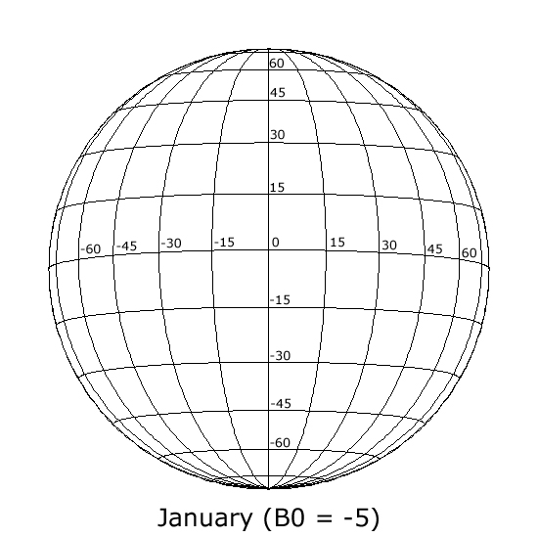

## February, March (B0 = -7)

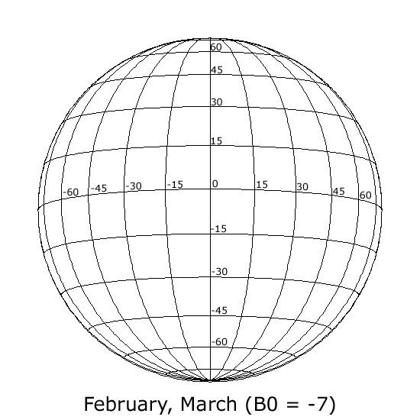

## April (B0 = -6)

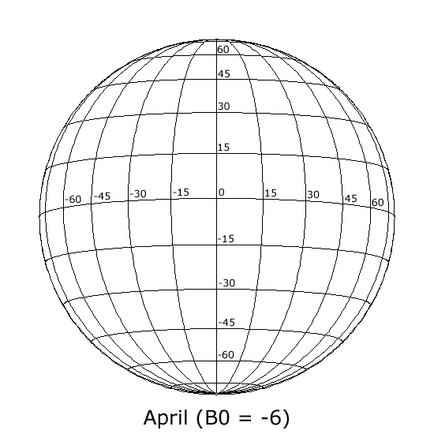

## May (B0 = -3)

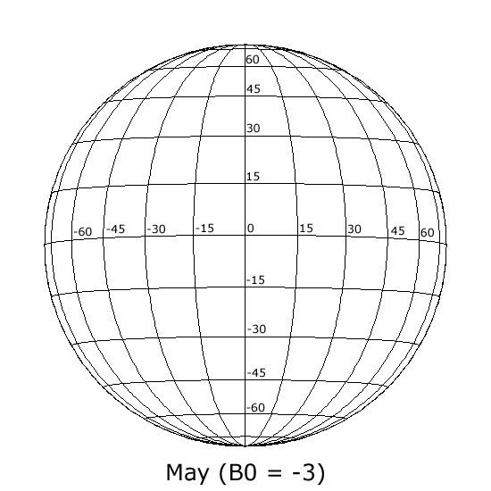

## June (B0 = +1)

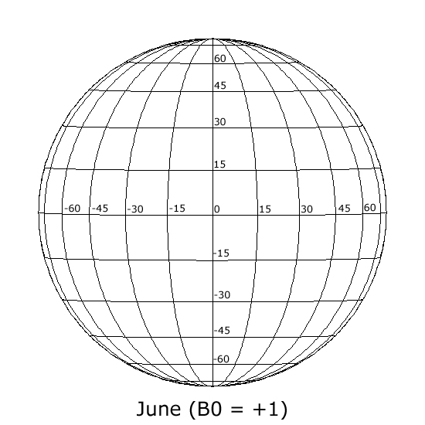

## July (B0 = +4)

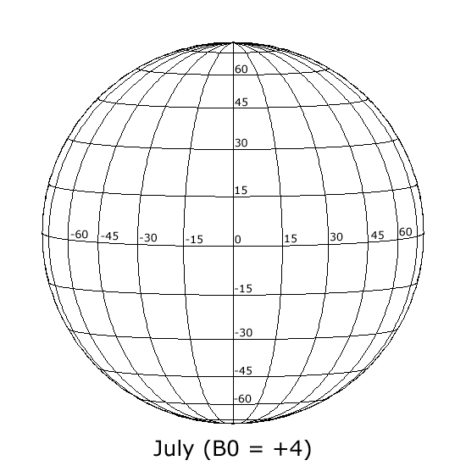

## August, September (B0 = +7)

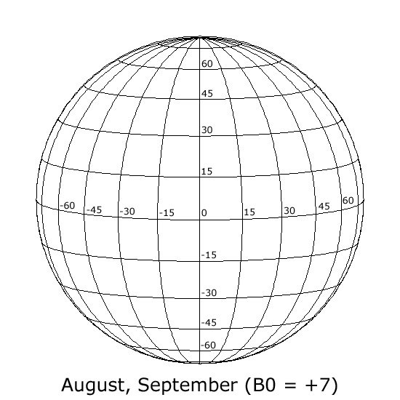

## October (B0 = +6)

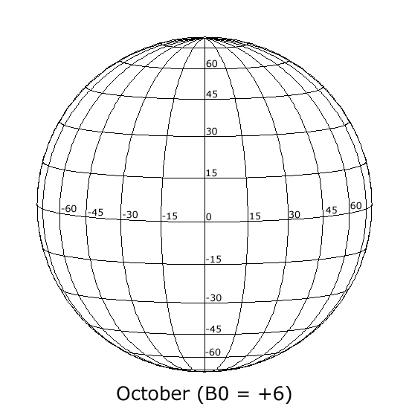

## November (B0 = +3)

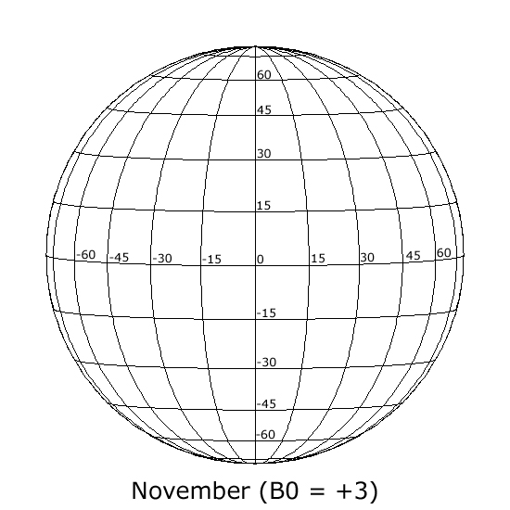

## December (B0 = -1)

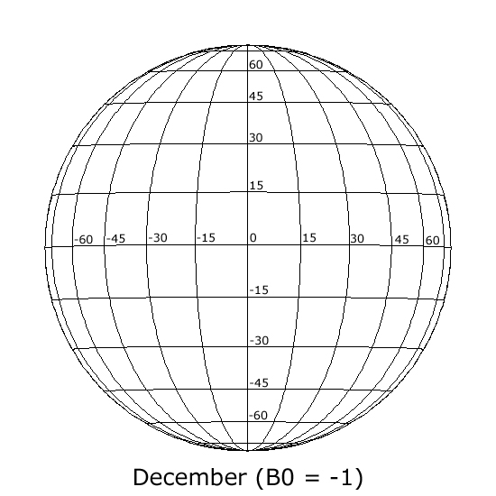

# Sample SOHO MDI I-grams

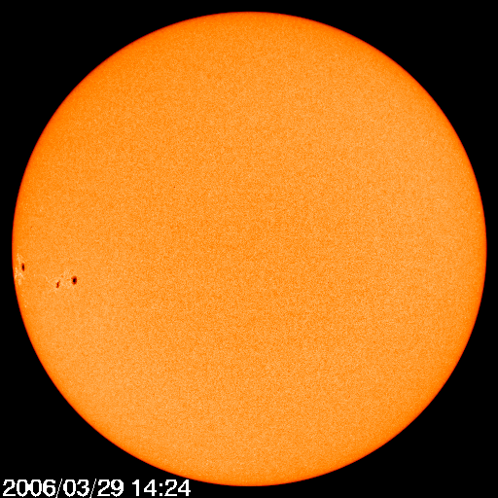

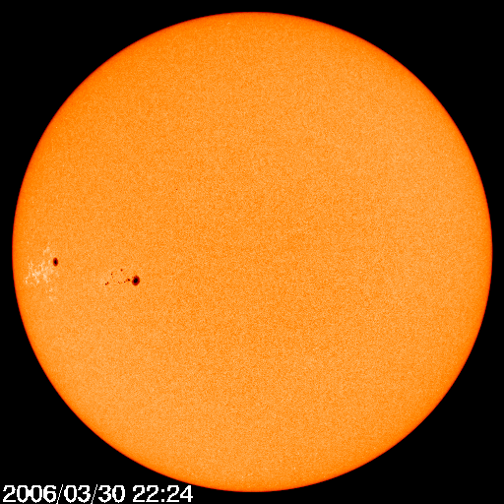

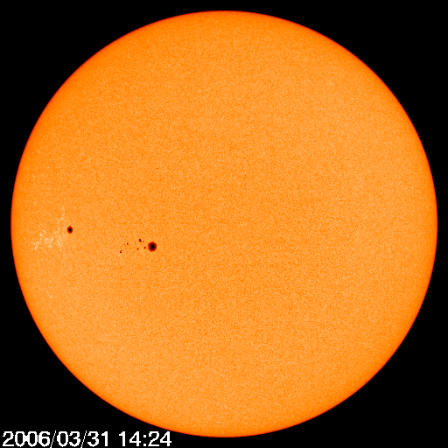

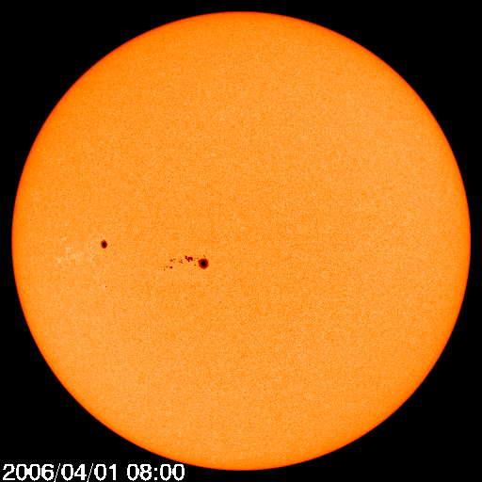



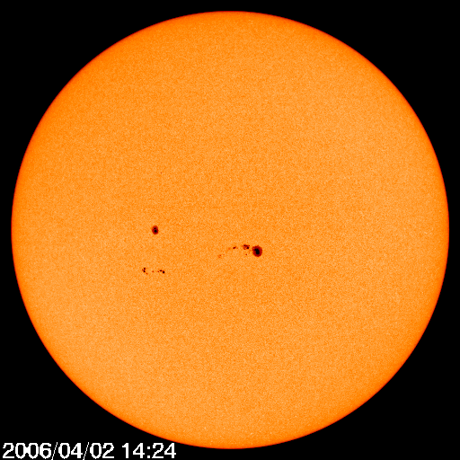

# Blank Rectangular Coordinate Grids









1. Sun’s equatorial circumference = 4,369,955 km