Stanford University

Electrical Engineering
STAR Laboratories
Very Low Frequency (VLF) Group

By Morris Cohen

2005 VLF Receiver
Documentation

Autumn, 2005

“If we do not succeed, then we run the risk of failure”
-Dan Quayle

Table of Contents

- Introduction to the Stanford 2005 VLF receiver
- Improvements in the 2005 VLF receiver
- Clock accuracy
- Schematics
- Preamp DC biases
- Parts list
- Cabling pin connections
- Calibration circuit
- GPS Communication
- FPGA code
- Antenna design
- Dummy loop design
- Hum Sniffer Design
- Testing and set-up
- Calibration and characterization instructions
- Using the software
- Deployment checklist
- Guide to CD Contents
- Troubleshooting Guide
- Additional comments
- Acknowledgements
- User Comments

i.
Introduction to the Stanford University 2005 VLF Receiver

The Stanford University Electrical Engineering Department’s Very Low Frequency (VLF) group is engaged in studies of electromagnetic phenomenon in the ionosphere and magnetosphere. One of the primary ways of studying these effects is through the use of ultra sensitive ground based VLF receiver instruments, consisting of an antenna (or two) and electronics to process the antenna’s signal. The electronics is designed to capture frequencies in the ELF/VLF range, which is roughly 30 Hz-50 kHz. By studying the data recorded from the antenna, a wide range of atmospheric effects can be understood because they create disturbances in the typical magnetic field.

As such, the VLF group has been building and using VLF receivers for decades, refining the design over the years. The receivers have reached the point of sensitivity where nearly any signal above the ambient Earth noise floor can be detected. For example, it will pick up the miniscule signal from a digital watch in the vicinity. This is important because some of the observed disturbances in the electromagnetic field are very small.

In spring 2003, Justin Tan and Morris Cohen began building the newest incarnation, and it was completed in fall 2004. A prototype line receiver, modeled almost exactly off of an older version, was completed in June 2003. Full development began in autumn 2004, and was assembled in spring 2004. Initial field testing and final changes were made during summer 2004. A number of deployments occurred in fall 2004, during which time the support structures were finalized, and this documentation packet as well, meaning that everything needed for the VLF receiver redesign was finalized around the beginning of 2005. Thus, from this point on, the receiver will be referred to as the 2005 VLF receiver. Though based on previous designs, the newest version adds a number of new improvements and modifications over the old VLF receivers, to be highlighted later. The rest of this packet will discuss the design, use, and performance of the 2005 VLF receiver.

Note that this documentation report will focus on specific working and use of this design and implementation, including the receiver electronics, all the supporting hardware and software, information needed to build and deploy, etc. For a more technical report on the design criteria for VLF receivers, performance calculations, etc, refer to Evans Paschal’s report The Design of Broad-Band VLF Receivers with Air-Core Loop Antennas. This report and it’s conclusions laid the groundwork for some of the most important aspects of the 2005 VLF receiver.

The data from the 2005 VLF receiver is often used in one of two ways: Broadband analysis and narrowband analysis. In broadband analysis, the entire frequency spectrum between the cutoffs is retained, and often presented in the form of a spectrogram. Shown here is an example of a spectrogram, created by MATLAB. It shows the frequency content over a 10 second snippet. The red areas indicate strong signals at that frequency and that time, while the yellow and blue areas indicate a weak and very weak presence at those frequencies.

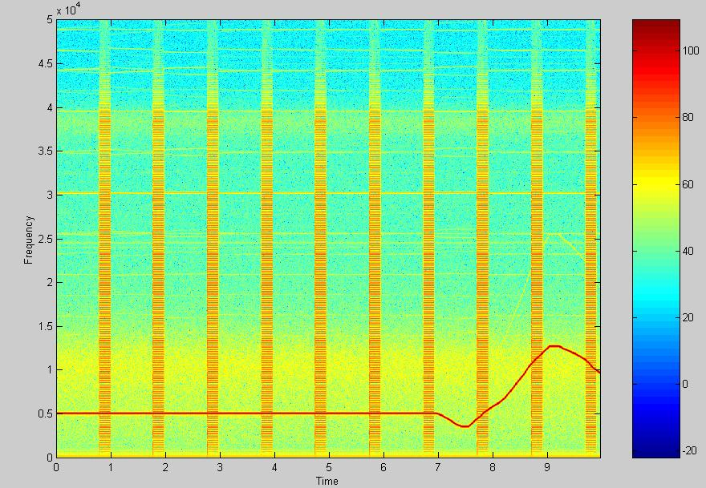

In this example, there is a strong single frequency signal at 5 kHz for the first seven seconds (indicated by the horizontal red line), that then drifts around for the last few seconds. There is also a broadband signal appearing once per second (this was a test calibration signal to be discussed later). The noise floor is a bit elevated around 10 kHz as can be seen by the yellowing there. The color scale is in decibels. This spectrogram represents one channel of data.

Narrowband analysis is done a little differently. The data stream is filtered out except for one very small frequency band (usually corresponding to a VLF transmitter frequency). Using fourier analysis and demodulation, the amplitude and phase at that frequency can be determined and recorded (this is done in software). Narrowband analysis is particularly valuable when VLF instruments are in remote areas, with limited ability to transmit data back to Stanford. The narrowband data would look something like this (amplitude shown only – data taken from http://www-star.stanford.edu/~hail/exdata.html, Stanford VLF group)
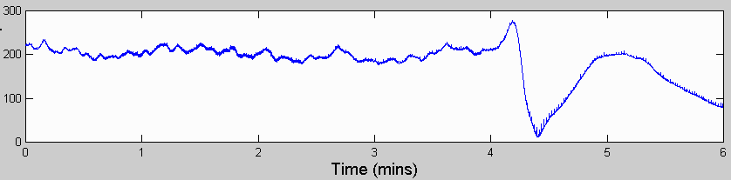

Figure 1 illustrates the basic block diagram of the VLF receiver The 2005 VLF receiver consists of three main components: First, an antenna to create electrical signals from electromagnetic field disturbances. Second is a preamplifier to amplify the signal without introducing much noise, and driving the signal over a long cable. The cable runs to a line receiver which filters and processes the data so it can be recorded. In addition, the line receiver synchronizes the data with a GPS timing signal, and passes those to a PC, with running software that records the signal and times.

1Ω 1mH
Antenna
Preamp
Line Receiver
PC
GPS Receiver
Figure 1: 2004 VLF Receiver Block Diagram

The antenna used is a magnetic loop, made by wrapping wire in a circle so that magnetic field changes create small currents in the antenna. The antenna can be made arbitrarily large or small (larger antennas will be more sensitive), the only restriction on the antenna is that the resistance of the wire loop be 1 Ω, and the inductance be 1 mH, as the electronics are designed for these characteristics. Further technical detail on different sizes and configurations to make a valid 1 Ω, 1 mH antenna can be found in the Paschal report. The antenna is best placed in a “quiet” area, as far as possible from electromagnetic noise sources like power lines, generators, buildings. Since the antenna is built from a planar loop of wire, it will only capture signals propagating with a magnetic field component in the plane. Thus, in order to capture signals from all azimuths, it is necessary to set up two antennas, orthogonal to each other. Generally, one antenna captures the North/South component of incoming signals, and a second antenna captures the East/West component. It is possible, however, to orient the two antennae in any desired configuration. All the signal electronics in the preamp and line receiver are designed for two antenna channels, though one can be left out if it is not needed for a particular application. So this receiver is not designed to capture signals with three degrees of freedom (ie, like nearfield radiation).

Figure 2: VLF Two Channel Orthogonal Magnetic Loop Antenna Configuration

Preamp
E/W Antenna
N/S Antenna
North

Figure 3 illustrates the block diagram of the preamplifier. The preamp should be placed as close as possible to the antenna, so that small signals aren’t attenuated over long cables. Since the antenna is outdoors, the preamplifier must be housed in a weatherproof container. The preamplifier’s electronic operation is relatively simple compared to the line receiver’s. This is intentional, in order to minimize interference into the antenna. The main amplification in the preamp comes from a differential amplifier designed with discrete transistors. A very important component, though, is a custom built transformer between the antenna and the transistors that closely matches the 1 Ω resistance of the antenna to the small signal resistance of the transistor circuit. Following the transistor amplifier, a number of op-amps buffer the signal, set the low frequency response cutoff, and the gain. An RFI (radio frequency interference) suppression circuit is added to the front end. Made from an LC low pass filter, this circuit ensures that high frequency signals like AM/FM radio broadcast do not affect the electronics.

The preamp also includes a calibration circuit to determine the frequency response of the system. The calibration circuit is described in detail in a later section, but it works by injecting a test signal at the very front end of the preamplifier, and the output of the receiver could be read to determine the system’s frequency response. The calibration circuit is activated by the line receiver, which provides power to run it.

The preamp is placed inside a NIMA-4 rated weather proof box since it is normally placed outdoors. The preamplifier is connected to the line receiver through a cable that has four pairs of conductors: two for the antenna signals, one for the power signals, one for the calibration signal. Each pair is shielded to prevent crosstalk and interference.

RFI Suppression
Signal
Transformer
Differential Amplifier
Adjustable Filter and Gain
Figure 3: Preamplifier Block Diagram
Output Coupling Transformer
Input from Antenna
Output to Line Receiver
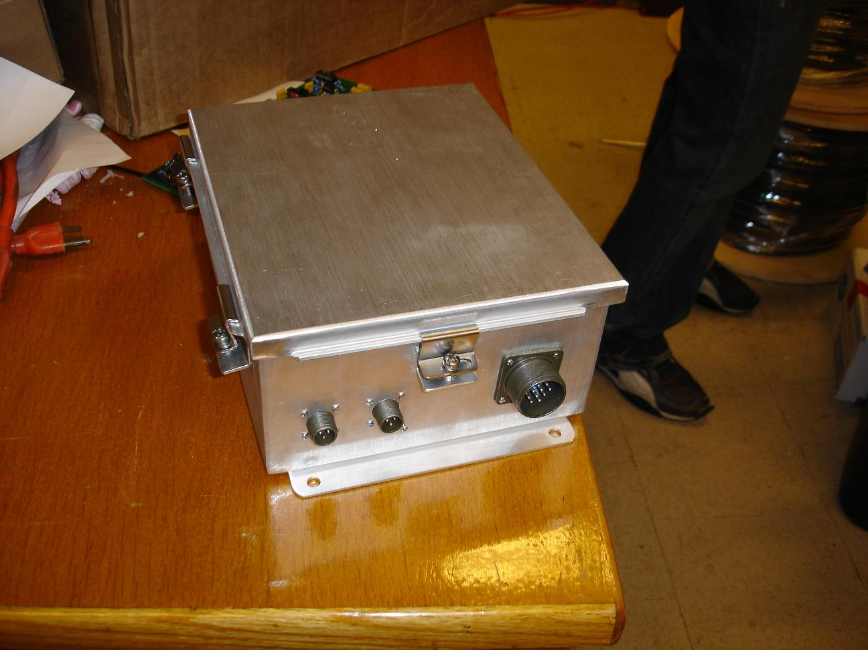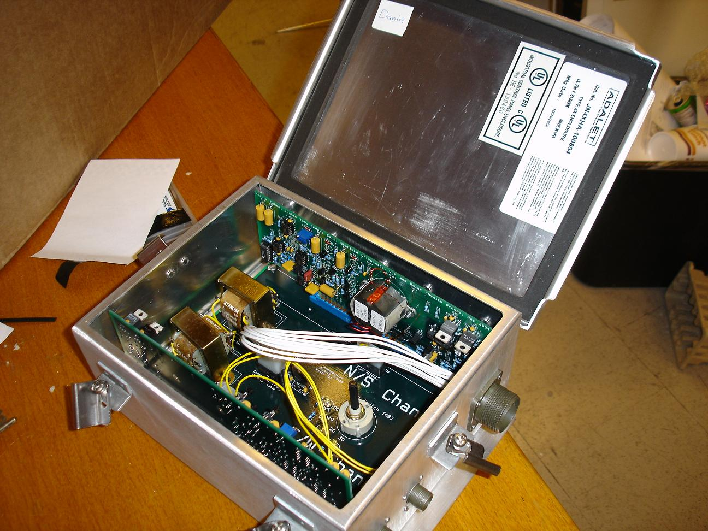
Preamplifier From Outside Open Preamplifier Box

The line receiver’s operations are noticeably more complicated than the preamp’s. The line receiver should be placed 100 ft or more from the preamplifier through a shielded cable, so that the electronics in the line receiver does not emit radiation that couples into the antenna. The line receiver must be placed close to a computer which can record the data coming from it. The line receiver serves many functions, including signal processing, digitization control, GPS management, power management, and system calibration. The line receiver is placed in a custom built box though it is not designed for outdoor use.

In processing the signal, the line receiver includes a clip protection circuit, which clips the top of signals when they get too strong (and sets of an indicator light). If calibrated correctly, though, this should only be triggered in the event of exceptionally strong signals or an electrical failure. The most important part, though, is an anti-aliasing filter. For most VLF group applications, the data is sampled at 100 kHz, thus the anti-aliasing filter should be fixed between 40 and 50 kHz. A pair of identical filter chips 12 poles total takes care of that filtering.

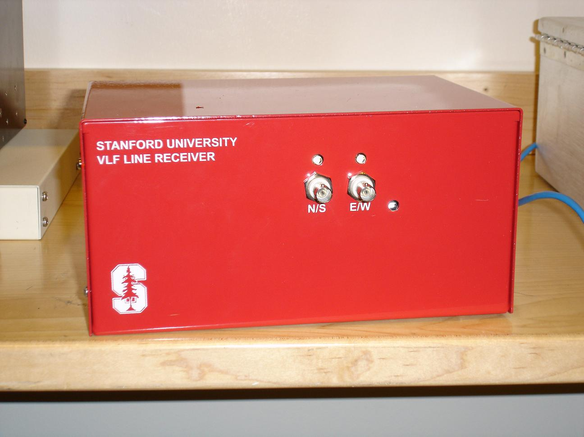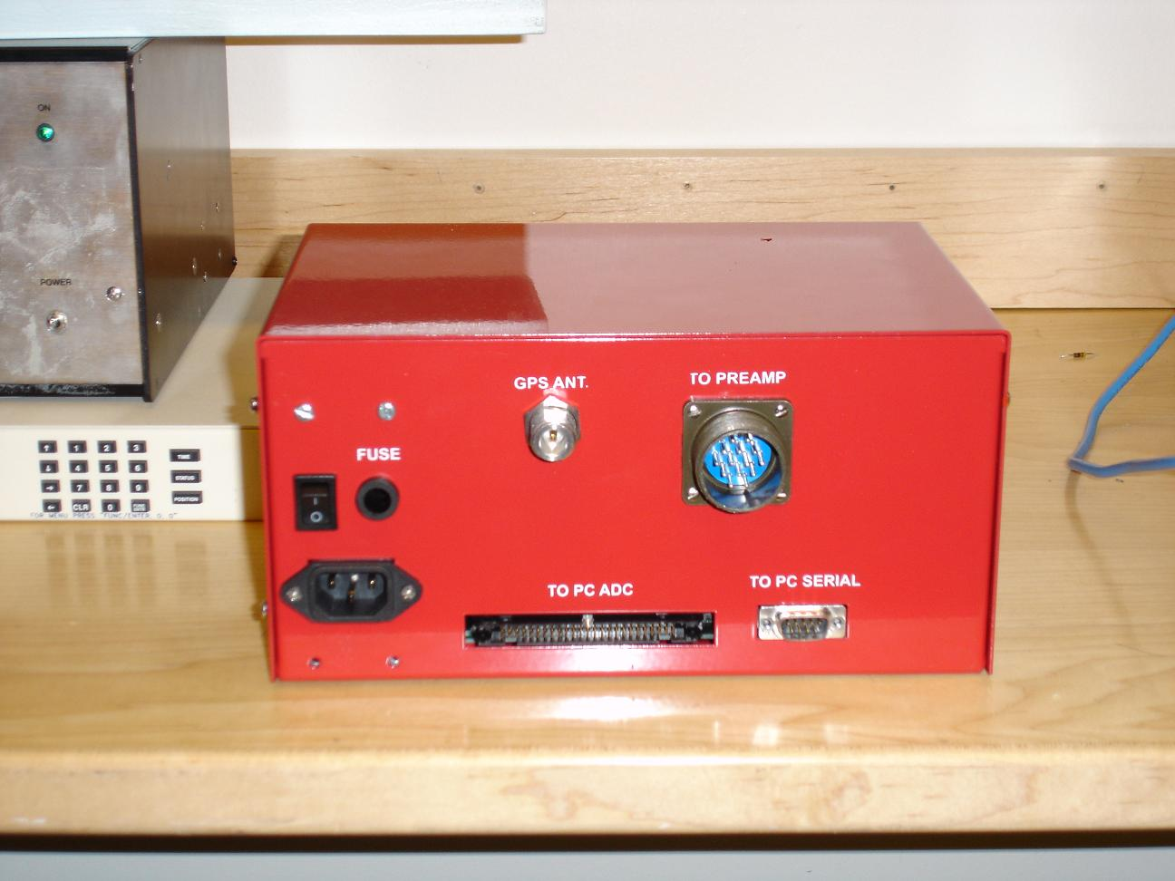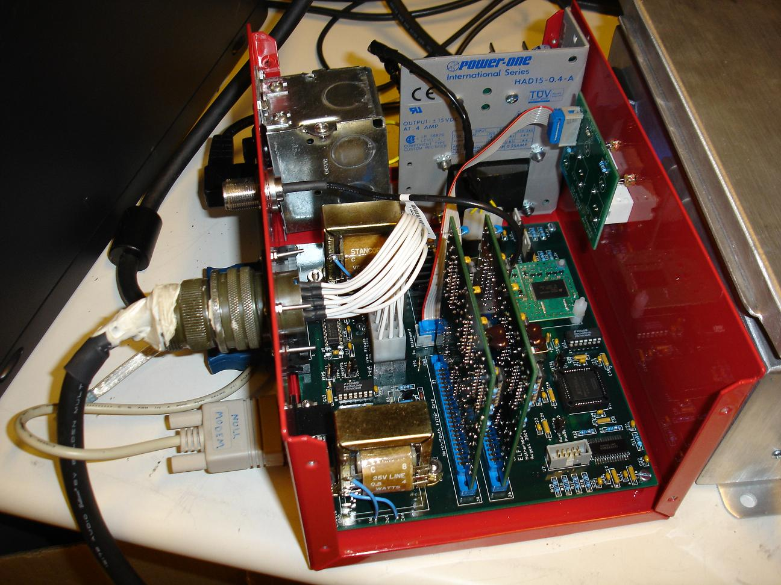
Line Receiver Front Line Receiver Back Line Receiver Inside

One of the key requirements for the 2005 VLF receiver is very high accuracy sampling, in order to synchronize the sampling in different systems and provide precise phase information in narrowband analysis. This requirement is met by providing the ADC card with a low-skew, low-draft clock. The line receiver does this by using a GPS locked signal, and a trim-adjustable 10 MHz oscillator. Using the GPS timing signal (1 Hz), and a feedback circuit, the 10 MHz clock is adjusted so that it is as accurate as possible. The 100 kHz sampling signal is generated from this accurate clock. The details and performance characteristics of this are included later.

The GPS signal needed for this circuit comes in from an antenna and is attached to an on-board card made by Motorola. The GPS antenna does not need to be in a quiet location, but it should have a clear view of much of the sky in order to communicate with GPS satellites. An FPGA in the line receiver communicates with the Motorola board and uses it to synchronize the sampling clock, and to provide a time stamp for all the data through a serial port.

The line receiver is also responsible for providing power to the preamplifier. The power is generated from 60 Hz, 110V AC power by an external power supply inside the line receiver box. If using in an area that does not provide 60 Hz 110 V power, you will need to find a way to convert your power, or to drive the line receiver’s DC input voltages directly from an external source. The voltages +/- 15 V are delivered along the same cable that brings the signals from the preamp (the shielding of the cable pairs enables this to be possible without degradation of the data).

Finally, the line receiver controls and activates the calibration circuit in the preamp, by sending a 15 V power signal over the cabling. The FPGA on board also controls this, activating the calibration circuit at predetermined internals by turning on a transistor driver circuit.

Clipper and Comparator
Anti-Aliasing Filter
Calibration Circuit
Driver
Figure 4: Line Receiver Block Diagram
Input from Preamp
Output to ADC Card
Clip Light Indicator
Input Coupling Transformer
10 MHz Oscillator
FPGA
GPS Antenna
Output to Preamp
Output to Serial port
+/- 15V

The data is usually digitized with a card installed in the PC. The card used is made by National Instruments, and goes into a PCI slot in the computer. Alternatively, a PCMCIA version is available for a laptop computer. The PC has installed software, created by the VLF group, that is capable of producing raw MATLAB data files, demodulating and breaking down the data for selected frequencies (narrowband studies), and sending the information over the internet (ftp).

ii.
Improvements in the Stanford University 2005 VLF Receiver

The 2005 VLF receiver includes a number of modifications in electrical performance, mechanical layout, cost, and ease of use. Since some users of the 2005 VLF receiver may already be familiar with older design iterations, it is helpful to highlight these changes and additions specifically.

Elimination of line driver circuit: The previous VLF receivers contained an elaborate line driver card in the preamplifier, in order to drive the signal over as much as 2000 ft of cabling to the line receiver. In the 2005 VLF receiver, this whole card was eliminated, and the output op-amp in the preamp card was swapped with one that has more output drive ability. This greatly simplifies the design of the preamplifier.

Elimination of 35 V preamp supply: In previous designs, the preamp was powered from a 35 V signal coming from the line receiver. The 35 V was generated in the line receiver directly from 110V AC power. Once in the preamp, this 35 V single ended voltage would then be regulated into a +/- 15 V bipolar supply. The chief disadvantage was that the preamp and line receiver had different grounds (ground for the preamp was at +17.5 V for the line receiver), which made it impossible to probe signals in the preamplifier without shorting out the DC signals.. Instead, the 2005 VLF receiver sends a direct +/- 15 V signal from the line receiver to the preamplifier. This removes the AC-DC regulation circuit in the line receiver and the DC-DC regulation in the preamp.

Single cable connection between line receiver and preamp: The former VLF receivers had two coaxial BNC cables, one for each channel, connecting the preamplifier to the line receiver. The N/S channel also transmitted the 35 V power signal. This has been replaced with a new four-pair shielded cable made by Belden, the 1217B. Not only has the power signal been decoupled from the transmission line for the signals, but there is now only one cable instead of two, and the 75 Ω impedance of the cable used reduces the signal attenuation for the long cable lengths.

Improvements in low frequency response: Though previous VLF receivers were deployed in places that required measurements of frequencies as small as 30 Hz, a number of undocumented hardware changes were required in order to achieve this response. This is mostly because the older version was designed primarily to be a narrowband system, optimized for the frequency range of 10-40 kHz. In addition, the line transformers, on either side of the transmission lines, had some peaking at in the frequency response at about 1 kHz and began to rolloff a little below that. The 2005 VLF receiver is designed by default to work at frequencies as low as 30 Hz. The newer version replaces the line transformer with a better one, which has a lower cutoff.
Improvements in high frequency response: Our VLF receiver systems are sampled at 100 kHz, which is why the anti-aliasing filter is set at 40 kHz or so. The new receivers implement this filter with a sharper circuit (LTC1562), which has both a flatter response in the passband, and a sharper brick wall response. As a result, the new anti-aliasing filter raises the bandwidth of useful data to 45-47 kHz. The filter cuts off at 47 kHz, and reaches 100 dB of attenuation by 55 kHz, ensuring that data up to 45 kHz is free of aliasing. These `two pictures show the improved anti-aliasing filtering of the 2005 Stanford VLF Receiver. The red line indicates the amplitude, and the blue line indicates the phase.

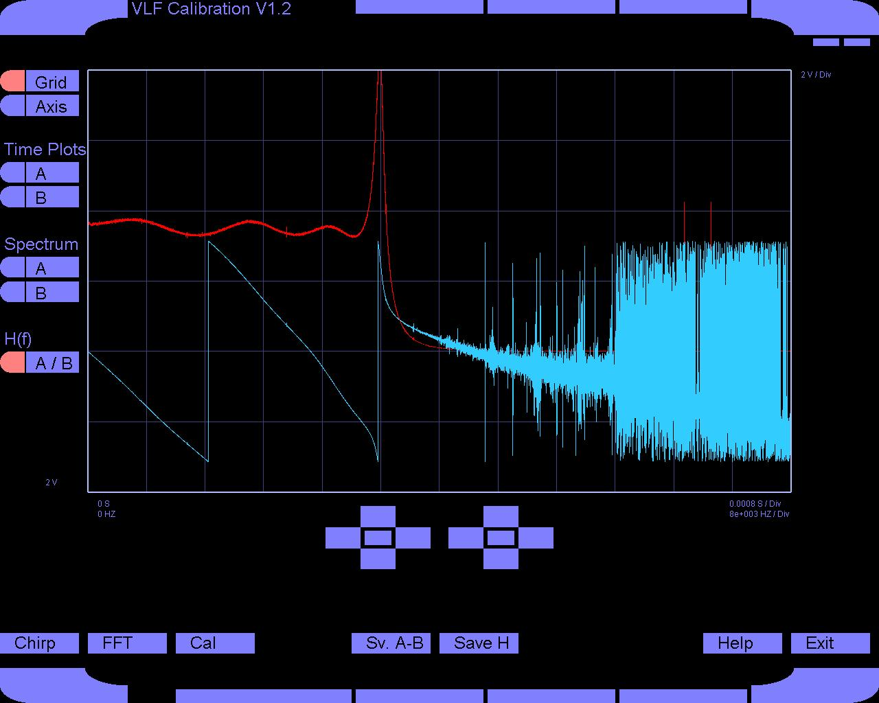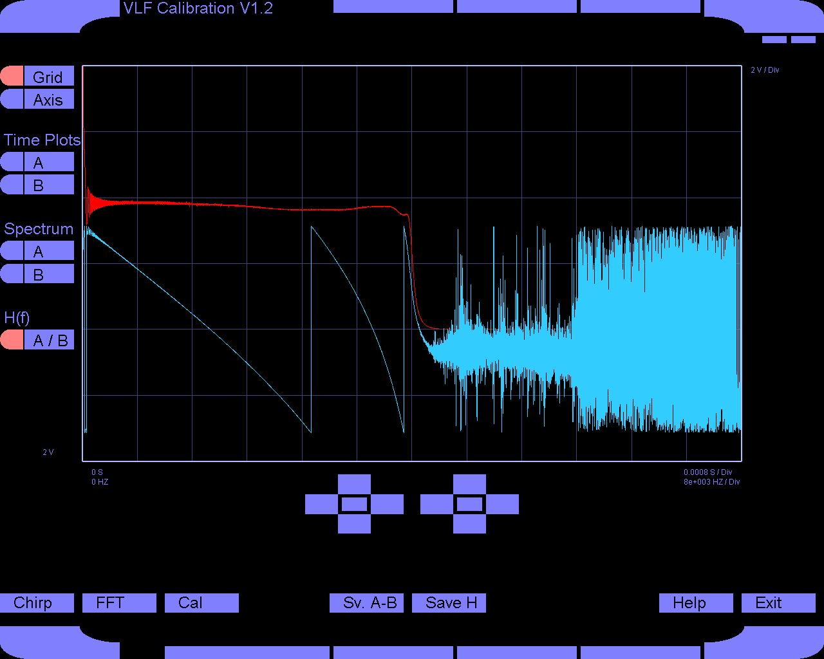
Old VLF Receiver Frequency Response New VLF Receiver Frequency Response

Elimination of external GPS clock: The older VLF systems used a GPS receiver made by TrueTime. The key advantage to it was that it provided not only the 1 Hz GPS signal but also a 100 kHz signal (used for sampling) that is synchronized with the GPS signal and thus very exact (as described earlier, this is important in order to get accurate phase information and to compare data from site to site). In the 2005 VLF receiver, this has been eliminated and replaced with a Motorola GPS receiver contained within the line receiver. Though the Motorola GPS receiver does not generate the 100 kHz GPS-synchronized clock, a frequency-locked loop consisting of a 10 MHz oscillator, an FPGA and a D/A converter (all this is detailed later) generates the 100 kHz sampling signal within the line receiver. The elimination of the external GPS clock saves substantial cost and means one less component to bring and set up at a VLF reception site. Removing the external GPS receiver reduces the physical size of all the equipment, and eliminates a major cost.

Smaller and lighter preamp box: The physical size of the preamp has been shrunk considerably. Formerly placed in a box with 14” x 16” base, and 7” height, the preamp now measures 8” x 10” base and 5” height (about four times less volume).

Smaller, lighter, more stable line receiver box: The line receiver as well was placed in a better box. The old boxes had a 10” x 12” base and 6” height, whereas the new boxes are 7” x 10” with a 5” height (about half the volume). The new boxes are also more stable, with a two piece design rather than the older completely disassembled frame boxes.

Modular card design and solder-less layout: The 2005 VLF receiver was designed with ease of testing and debugging in mind. The older version had modular cards in the preamplifier, but the cards were connected to a backplane that required hours to wire up manually to the inputs and to a monitor and control board. The older line receiver placed everything on one large circuit board, with a lot of soldered connections to the box, so that removal of the card for testing or debugging required cutting a dozen or so wires that had to be re-soldered into place later. The 2005 VLF receiver has modular cards for the filter/clip chips in the line receiver (on each channel), and the amplifier cards in the preamp. The modular design also enables a one channel system to be converted to two-channel with much more ease. The input and connections to the box were all made with Molex power plugs rather than permanent soldering. Though a slight contact resistance is introduced (replacing a solder joint resistance), the main boards in each box can be detached from its surroundings and removed in a matter of seconds for easy replacement, testing, or debugging.

New repeatable dummy loop design: A device called a dummy loop emulates the impedance of the antenna and allows test signals to be injected into the VLF system. The previous VLF receiver did not include an accompanying dummy loop design, so dummy loops were often built by hand, individually. As part of the 2005 VLF receiver, a new repeatable dummy loop has been completely designed and specified, and a sufficient number will be made so that VLF systems can be readily tested when needed.

New repeatable antenna design: The support structure for the wire loop antennas was previously not documented and often built ad hoc. Accompanying the 2005 VLF receiver is a repeatable, clearly specified method for building two orthogonal antennas and a support structure.

New repeatable hum sniffer design: Site selection is facilitated by the use of a hum sniffer, a miniaturized, portable version of the VLF system. The hum sniffer uses a small antenna, and outputs its signal to a laptop, for quick characterization of electromagnetic environment. The 2005 VLF receiver includes a fully specified and repeatable design for a hum sniffer.

Ease of duplication and change: The 2005 VLF receiver includes a complete parts list, including price, part number, and manufacturers. Also included is software to reproduce the circuit boards, box, and every other parts. For future VLF receiver needs, as well as for future design changes, individual portions can be modified and change, without redoing the entire system from scratch as was done for this iteration.

iii.
Sampling Clock Feedback for Accurate Phase Information

One of the most important features of the 2005 VLF receiver is the ability to produce a very exact 100 kHz signal for sampling. This signal is synchronized with a GPS signal and has very small error. When the error is small enough, the data retrieved can be compared from site to site, and in addition, the phase information gathered in the narrowband analysis becomes much more exact. Older versions used an external GPS clock made by TrueTime to provide the 100 kHz signal, but the 2005 model introduces a frequency locked loop to achieve the same result. Figure 5 shows the hardware block diagram

10-Bit D/A Converter
10 MHz Adjustable Oscillator
Figure 5: Clock Maintenance Circuit
FPGA Counter
1 Hz GPS Signal
FPGA Divider
100 kHz Sampling Clock

The FPGA is the main component here. It counts cycles from the 10 MHz oscillator between every 1 Hz GPS pulse, and if the number is greater or less than 10,000,000, the FPGA will change the value of the D/A converter’s inputs, which thereby adjust the oscillator accordingly. The accurate 10 MHz clock is divided down to 100 kHz. Since the 10 MHz signal is synchronized every second, as long as the count rate of the oscillator remains at 10,000,000, the frequency remains accurate within 1 Hz, this the error of the sampling clock will be better than 0.1 parts per million (ppm). Since the error stretches over 1 s (between GPS synchronizations), that corresponds to 100 ns of maximum skew at any time. Since the GPS signal itself has a built-in skew of 200 ns, the total error in the sampling clock is 300 ns, or 0.3 ppm.
Since a 20 kHz signal propagates one degree of phase in 111 ns, and the sampling clock’s error is 0.3 ppm, or 300 ns, the phase error at 25 kHz will be 300/139 = 2.16º. Two thirds of this error originates from jitter in the GPS signal, which is the limiting error in this scheme. The phase error at higher and lower frequencies will be scaled proportionately to 20 kHz and 2.16º (i.e. a 10 kHz signal has a phase error of 2.16º/2 = 1.08º).

The circuit was tested in two ways: First, the oscillator output was connected to a network analyzer which plotted the frequency content of the 10 MHz signal. When the power was turned on, you could visibly see the frequency start at some amount above or below 10 MHz and then slowly (over a few minutes time) zoom in toward 10 MHz exactly. The plots of the steady states taken from the Network Analyzer are shown below. In a second test, the FPGA was programmed to output a digital signal whenever the 10 MHz clock deviated enough to warrant adjusting the DAC. Additionally, the drift between the two signals could be observed on a fast oscilloscope, and it was observed that the new 100 kpps signal drifted by less than 300 ns at any time.

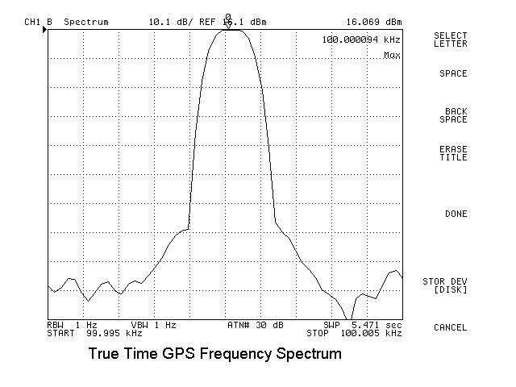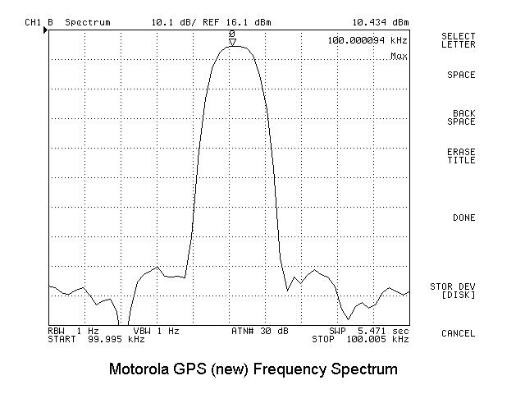

iv.
Hardware Schematics

The following hardware schematics and layout drawings are included:

- Preamplifier Backplane
- Preamplifier Gain Card
- Preamplifier Gain Card Layout
- Line Receiver Motherboard
- Line Receiver Motherboard Layout
- Line Receiver Filter Card
- Line Receiver Sideboard

v.

Preamp DC Biases

The following diagram shows the DC biases for the preamp transistor circuit. This may be useful for troubleshooting or for future design changes.

vi.
Parts list

Here is a parts list for the 2005 Stanford VLF receiver

VLF System
Line Receiver
Qty | Description |  | Supplier | Part #
1 | Motherboard |  | Advanced Circuits | Custom Made
2 | Filter Cards |  | Advanced Circuits | Custom Made
1 | Sideboard |  | Advanced Circuits | Custom Made
1 | External Power Supply |  | PowerOne | HAD15-0.4-A
1 | Box |  | ProtoCase | Custom Made
Preamp
Qty | Description |  | Supplier | Part #
1 | Backplane |  | Advanced Circuits | Custom Made
2 | Preamp Cards |  | Advanced Circuits | Custom Made
1 | Box |  | Adalet | JN4XHA-100804
GPS
Qty | Description |  | Supplier | Part #
1 | Vic100 GPS Timing Antenna w/ Pipe Clamp |  | Synergy Systems | 10001339
1 | GPS N-connector Cable (50m) |  | Synergy Systems
1 | 10ft 1.5 in PVC piping with connector parts |  | Home Depot
Cable Assembly
Qty | Description |  | Supplier | Part #
1 | Four Twisted Pair Shielded Cable (250 ft) |  | Belden | 1217B
2 | Amphenol 12 Pin Cable Connector with Sockets |  | Digikey | 97-3106A-20-27S
Antenna
Qty | Description |  | Supplier | Part #
123 ft | Wire 14 AWG
2 | Amphenol 3 Pin Cable Connector with Rocker |  | Digikey | MS3106R-10SL-3S
A/D System
Qty | Description |  | Supplier | Part #
1 | NIDAQ Card 6034E |  | National Instruments | 187576C-01
1 | 50 Pin Cable SH6850 |  | National Instruments | 776784-01
Line Receiver
Motherboard
Ref | Value | Description | Supplier | Part #
C1 | 4.7 nF | Ceramic Capacitor | Digikey
C2 | 4.7 nF | Ceramic Capacitor | Digikey
C3 | 10 uF | Tantalum Capacitor | Digikey | 399-1335-ND
C4 | 4.7 nF | Ceramic Capacitor | Digikey
C5 | 4.7 nF | Ceramic Capacitor | Digikey
C6 | 0.1 uF | Ceramic Capacitor | Digikey | 399-2155-ND
C7 | 0.1 uF | Ceramic Capacitor | Digikey | 399-2155-ND
C8 | 0.1 uF | Ceramic Capacitor | Digikey | 399-2155-ND
C9 | 0.1 uF | Ceramic Capacitor | Digikey | 399-2155-ND
C10 | 47 nF | Ceramic Capacitor | Digikey | 495-1069-1-ND
C11 | 0.1 uF | Ceramic Capacitor | Digikey | 399-2155-ND
C12 | 0.33 uF | Ceramic Capacitor | Digikey | 399-2174-ND
C13 | 1.0 uF | Tantalum Capacitor | Digikey | 399-1337-ND
C14 | 0.1 uF | Ceramic Capacitor | Digikey | 399-2155-ND
C15 | 0.1 uF | Ceramic Capacitor | Digikey | 399-2155-ND
C16 | 1.0 uF | Tantalum Capacitor | Digikey | 399-1337-ND
C17 | 0.1 uF | Ceramic Capacitor | Digikey | 399-2155-ND
C18 | 0.1 uF | Ceramic Capacitor | Digikey | 399-2155-ND
C19 | 1.0 uF | Tantalum Capacitor | Digikey | 399-1337-ND
C20 | 0.1 uF | Ceramic Capacitor | Digikey | 399-2155-ND
C21 | 0.1 uF | Ceramic Capacitor | Digikey | 399-2155-ND
C22 | 0.1 uF | Ceramic Capacitor | Digikey | 399-2155-ND
C23 | 0.1 uF | Ceramic Capacitor | Digikey | 399-2155-ND
C24 | 1.0 uF | Tantalum Capacitor | Digikey | 399-1337-ND
C25 | 1.0 uF | Tantalum Capacitor | Digikey | 399-1337-ND
C26 | 0.1 uF | Ceramic Capacitor | Digikey | 399-2155-ND
C27 | 0.1 uF | Ceramic Capacitor | Digikey | 399-2155-ND
C28 | 1.0 uF | Tantalum Capacitor | Digikey | 399-1337-ND
C29 | 0.1 uF | Ceramic Capacitor | Digikey | 399-2155-ND
C30 | 1.0 uF | Tantalum Capacitor | Digikey | 399-1337-ND
C31 | 1.0 uF | Tantalum Capacitor | Digikey | 399-1337-ND
C32 | Small | Optional - Typically left out
C33 | 0.1 uF | Ceramic Capacitor | Digikey | 399-2155-ND
C34 | 1.0 uF | Tantalum Capacitor | Digikey | 399-1337-ND
C35 | 1.0 uF | Tantalum Capacitor | Digikey | 399-1337-ND
C36 | 0.1 uF | Ceramic Capacitor | Digikey | 399-2155-ND
C37 | 1.0 uF | Tantalum Capacitor | Digikey | 399-1337-ND
C38 | 0.1 uF | Ceramic Capacitor | Digikey | 399-2155-ND
C39 | 0.1 uF | Ceramic Capacitor | Digikey | 399-2155-ND
D1 | 1N4005 | Diode | Digikey | 1N4005RLOSCT-ND
D2 | 1N4005 | Diode | Digikey | 1N4005RLOSCT-ND
D3 | 1N4148 | Diode | Digikey
J1 |  | 12-Pin Power Header | Digikey | WM1629
J2 |  | 50-Pin Right Angle Header | Digikey | AHZ50K
J3 |  | 0.1" Jumper Header | Digikey | 4-103240-0
J4 |  | 44-Pin 0.1" Card Edge Connector | Digikey | S1223
J5 |  | 10-Pin 0.1" Protected Header | Digikey | A26268
J6 |  | 44-Pin 0.1" Card Edge Connector | Digikey | S1223
J7 |  | 0.1" Jumper Header | Digikey | 4-103240-0
J8 |  | 0.1" Jumper Header | Digikey | 4-103240-0
J9 |  | 0.1" Jumper Header | Digikey | 4-103240-0
J10 |  | 0.1" Jumper Header | Digikey | 4-103240-0
L1 | 22 uH | Inductor | Digikey | 1530B225
L2 | 22 uH | Inductor | Digikey | 1530B225
L3 | 22 uH | Inductor | Digikey | 1530B225
L4 | 22 uH | Inductor | Digikey | 1530B225
Q1 | 2N3906 | PNP Transistor TO-92 | Digikey
Q2 | 2N3904 | NPN Transistor TO-92 | Digikey
R1 | 4.7 kOhm | 1% Metal Film Resistor | Digikey
R2 | 12.1 kOhm | 1% Metal Film Resistor | Digikey
R3 | N/A | Does not exist
R4 | 47 Ohm | 1% Metal Film Resistor | Digikey
R5 | N/A | Does not exist
R6 | N/A | Does not exist
R7 | 10 kOhm | 1% Metal Film Resistor | Digikey
R8 | N/A | Does not exist
R9 | 75 Ohm | 1% Metal Film Resistor | Digikey
R10 | 75 Ohm | 1% Metal Film Resistor | Digikey
R11 | 953 Ohm | 1% Metal Film Resistor | Digikey
R12 | 1 kOhm | 1% Metal Film Resistor | Digikey
R13 | 250 Ohm | 1% Metal Film Resistor | Digikey
R14 | 250 Ohm | 1% Metal Film Resistor | Digikey
R15 | 1 kOhm | 1% Metal Film Resistor | Digikey
R16 | 1 kOhm | 1% Metal Film Resistor | Digikey
R17 | 1 kOhm | 1% Metal Film Resistor | Digikey
R18 | 1 kOhm | 1% Metal Film Resistor | Digikey
R19 | 1 kOhm | 1% Metal Film Resistor | Digikey
R20 | 410 Ohm | 1% Metal Film Resistor | Digikey
R21 | 350 Ohm | 1% Metal Film Resistor | Digikey
T1 |  | 70.7 Line Audio Transformer | Stancor | A-8096
T2 |  | 70.7 Line Audio Transformer | Stancor | A-8096
TP1 |  | Test Point | Digikey
U1 |  | Voltage Regulator uA7805 TO-220 | Digikey | 296-13996-5-ND
U2 |  | Voltage Regulator uA7905 TO-220 | Digikey | LM7905CTNS-ND
U3 |  | 4 Pin Power Header | Digikey | WM1626
U4 |  | Inverters 74ACT04 | Digikey
U5 |  | RS232 Chip Max3323 DIP | Maxim | MAX2232
U6 |  | 10-Bit D/A Converter THS5651 SOIC | Digikey | 296-2992-5-ND
U7 |  | 10-Pin 0.1" Protected Header | Digikey | A26268
U8 |  | 9 Pin Serial Connector | Digikey | 309M
U9 |  | 44-Pin PLCC Socket | Digikey | AE7328
U10 |  | 10 MHz Oscillator DIP | Vectron | VTA1-1B1-10M000
U11 |  | Inverters 74HC04 | Digikey | 296-12772-5-ND
U12 |  | 10-Pin 0.05" Header | Samtec | SFMC-105-01-S-D
U13 |  | Voltage Regulator LM317 TO-220 | Digikey | LM317HVT-ND
U14 |  | Voltage Regulator LM317 TO-220 | Digikey
U9* |  | Altera Max 7000AE EPM7064AE | Arrow | EPM7064AELC44-7
U12* |  | Motorola GPS M12+ Timer Card | Synergy Systems
LTC1562 Filter Card
Ref | Value | Description | Supplier | Part #
C1 | 10 pF | Ceramic Capacitor | Digikey
C2 | 0.1 uF | Ceramic Capacitor | Digikey
C3 | 1.0 uF | Tantalum Capacitor | Digikey
C4 | 0.1 uF | Ceramic Capacitor | Digikey
C5 | 1.0 uF | Tantalum Capacitor | Digikey
C6 | 4.7 uF | Ceramic Capacitor | Digikey
C7 | 47 pF | Ceramic Capacitor | Digikey
C8 | 0.1 uF | Ceramic Capacitor | Digikey
C9 | 1.0 uF | Tantalum Capacitor | Digikey
C10 | 0.1 uF | Ceramic Capacitor | Digikey
C11 | 1.0 uF | Tantalum Capacitor | Digikey
C12 | 39 pF | Ceramic Capacitor | Digikey
C13 | 27 pF | Ceramic Capacitor | Digikey
C14 | 390 pF | Ceramic Capacitor | Digikey
C15 | 0.1 uF | Ceramic Capacitor | Digikey
C16 | 1.0 uF | Tantalum Capacitor | Digikey
C17 | 0.1 uF | Ceramic Capacitor | Digikey
C18 | 1.0 uF | Tantalum Capacitor | Digikey
C19 | 33 pF | Ceramic Capacitor | Digikey
C20 | 0.1 uF | Ceramic Capacitor | Digikey
C21 | 1.0 uF | Tantalum Capacitor | Digikey
C22 | 0.1 uF | Ceramic Capacitor | Digikey
C23 | 1.0 uF | Tantalum Capacitor | Digikey
C24 | 8.2 pF | Ceramic Capacitor | Digikey
C25 | 15 pF | Ceramic Capacitor | Digikey
C26 | 0.1 uF | Ceramic Capacitor | Digikey
C27 | 1.0 uF | Tantalum Capacitor | Digikey
C28 | 0.1 uF | Ceramic Capacitor | Digikey
C29 | 1.0 uF | Tantalum Capacitor | Digikey
C30 | 0.1 uF | Ceramic Capacitor | Digikey
C31 | 1.0 uF | Tantalum Capacitor | Digikey
C32 | 0.1 uF | Ceramic Capacitor | Digikey
C33 | 1.0 uF | Tantalum Capacitor | Digikey
D1 | 1N4005 | Multiplexer SOIC-20 | Digikey
D2 | 1N4005 | Multiplexer SOIC-20 | Digikey
D3 | 1N4005 | 4082 | Digikey
D4 | 1N4005 | Multiplexer SOIC-20 | Digikey
R1 | 20 kOhm | 1% Metal Film Resistor | Digikey
R2 | 130 kOhm | 1% Metal Film Resistor | Digikey
R3 | 10 kOhm | 1% Metal Film Resistor | Digikey
R4 | 150 kOhm | 1% Metal Film Resistor | Digikey
R5 | 75 kOhm | 1% Metal Film Resistor | Digikey
R6 | 133 kOhm | 1% Metal Film Resistor | Digikey
R7 | 40.2 kOhm | 1% Metal Film Resistor | Digikey
R8 | 60.4 kOhm | 1% Metal Film Resistor | Digikey
R9 | 5 kOhm | 1% Metal Film Resistor | Digikey
R10 | 47 Ohm | 1% Metal Film Resistor | Digikey
R11 | 1.75 kOhm | 1% Metal Film Resistor | Digikey
R12 | 56.2 kOhm | 1% Metal Film Resistor | Digikey
R13 | 105 kOhm | 1% Metal Film Resistor | Digikey
R14 | 5 kOhm | 1% Metal Film Resistor | Digikey
R15 | 210 kOhm | 1% Metal Film Resistor | Digikey
R16 | 48.7 kOhm | 1% Metal Film Resistor | Digikey
R17 | 20 kOhm | 1% Metal Film Resistor | Digikey
R18 | 107 kOhm | 1% Metal Film Resistor | Digikey
R19 | 105 kOhm | 1% Metal Film Resistor | Digikey
R20 | 3 kOhm | 1% Metal Film Resistor | Digikey
R21 | 3.9 kOhm | 1% Metal Film Resistor | Digikey
R22 | 4 kOhm | 1% Metal Film Resistor | Digikey
R23 | 3 kOhm | 1% Metal Film Resistor | Digikey
R24 | 3.9 kOhm | 1% Metal Film Resistor | Digikey
R25 | 13.7 kOhm | 1% Metal Film Resistor | Digikey
R26 | 150 kOhm | 1% Metal Film Resistor | Digikey
R27 | 316 kOhm | 1% Metal Film Resistor | Digikey
R28 | 45.3 kOhm | 1% Metal Film Resistor | Digikey
R29 | 698 kOhm | 1% Metal Film Resistor | Digikey
R30 | 32.4 kOhm | 1% Metal Film Resistor | Digikey
R31 | 10 kOhm | 1% Metal Film Resistor | Digikey
R32 | 10 kOhm | 1% Metal Film Resistor | Digikey
R33 | 10 kOhm | 1% Metal Film Resistor | Digikey
R34 | 10 kOhm | 1% Metal Film Resistor | Digikey
R35 | 20 kOHm | 1% Metal Film Resistor | Digikey
R36 | 22.6 kOhm | 1% Metal Film Resistor | Digikey
R37 | 47 Ohm | 1% Metal Film Resistor | Digikey
R38 | 2.2 kOhm | 1% Metal Film Resistor | Digikey
R39 | 22.6 kOhm | 1% Metal Film Resistor | Digikey
U1 |  | LTC1562 Filter Chip | Digikey
U2 |  | LM318 Op-Amp | Digikey
U3 |  | LM339 Comparator Quad | Digikey
U4 |  | LTC1562 Filter Chip | Digikey
U7 |  | BUF634 Buffer Chip | Digikey
U8 |  | LM318 Op-Amp | Digikey
Sideboard
Ref | Value | Description | Supplier | Part #
D1 | LED | Red LED | Digikey | MV3750
D2 | LED | Red LED | Digikey | MV3750
D3 | LED | Blue LED | Digikey | 67-1750
J1 |  | Vertical BNC Connector | Digikey | A24513
J2 |  | Vertical BNC Connector | Digikey | A24513
R1 | 60 Ohm | 1% Metal Film Resistor | Digikey
R2 | 270 Ohm | 1% Metal Film Resistor | Digikey
R3 | 600 Ohm | 1% Metal Film Resistor | Digikey
U2 |  | 10-Pin 0.1" Protected Header | Digikey | A26268
Box Assembly Parts
Qty | Description |  | Supplier | Part #
16 | Female Crimp Terminals |  | Digikey | WM1101
1 | 12 Pin Receptacle |  | Digikey | WM1337
1 | 12-Pin Box Mount Connector |  | Digikey | 97-3102A-20-27P
1 | 4-Pin Receptacle |  | Digikey | WM1333
4 | Screws 6-32 0.25"
1 | Fuseholder |  | Digikey | F1488
1 | Fuse, Slow Blow 1/8W
1 | 60 Hz 110V EMI Filter |  | Digikey | CCM1101-ND
1 | 10 Pin Ribbon Cable 6" |  | Digikey | C3AAT-1006G
1 | Power Switch |  | Digikey | CH755-ND
8 | Box Screws
1 | Metal Enclosure for AC Power Input |  | Home Depot | 50169 00500
1 | MMCX to N-Type Connector |  | Synergy Systems
Preamplifier
Backplane
Ref | Value | Description | Supplier | Part #
C25 | 10 uF | Tantalum Capacitor | Digikey
C26 | 0.1 uF | Ceramic Capacitor | Digikey
D1 | 1N4005 | Diode | Digikey
D2 | LED | Red LED | Digikey | MV3750
D3 | LED | Red LED | Digikey | MV3750
D4 | LED | Red LED | Digikey | MV3750
D5 | LED | Red LED | Digikey | MV3750
J1 |  | 12-Pin Power Header | Digikey | WM1629
J2 |  | 44 Pin 0.156" Card Edge Connector | Digikey | S5223
J3 |  | 44 Pin 0.156" Card Edge Connector | Digikey | S5223
J8 |  | 4-Pin Power Header | Digikey | WM1626
J9 |  | 4-Pin Power Header | Digikey | WM1626
R1 | 1.75 kOhm | 1% Metal Film Resistor | Digikey
R2 | 1.75 kOHm | 1% Metal Film Resistor | Digikey
R3 | 200 Ohm | 1% Metal Film Resistor | Digikey
R4 | 200 Ohm | 1% Metal Film Resistor | Digikey
R5 | 200 Ohm | 1% Metal Film Resistor | Digikey
R6 | 200 Ohm | 1% Metal Film Resistor | Digikey
T1 |  | 25 Volt Audio Line Transformer | Stancor | A8096
T2 |  | 25 Volt Audio Line Transformer | Stancor | A8096
U1 |  | Monitor Switch | Digikey | EG1951
U2 |  | Voltage Regulator uA7805 TO-220 | Digikey | 296-13996-5-ND
Preamp Card
Ref | Value | Description | Supplier | Part #
C1 | 22 nF | Ceramic Capacitor | Digikey | 399-2006-ND
C2 | 22 nF | Ceramic Capacitor | Digikey | 399-2006-ND
C3 | 22 nF | Ceramic Capacitor | Digikey | 399-2006-ND
C4 | 22 nF | Ceramic Capacitor | Digikey | 399-2006-ND
C5 | 22 uF | Tantalum Capacitor | Digikey | 399-1531-ND
C6 | 22 uF | Tantalum Capacitor | Digikey | 399-1531-ND
C7 | 0.1 uF | Ceramic Capacitor | Digikey | 399-2054-ND
C8 | 10 pF | Ceramic Capacitor | Digikey | 399-1888-ND
C9 | 10 pF | Ceramic Capacitor | Digikey | 399-1888-ND
C10 | 22 uF | Tantalum Capacitor | Digikey | 399-1531-ND
C11 | 0.47 uF | Tantalum Capacitor | Digikey | 399-1443-ND
C12 | 10 nF | Polyprolylene Capacitor | Digikey
C13 | 3.3 nF | Ceramic Capacitor | Digikey | 399-2001-ND
C14 | 3.3 nF | Ceramic Capacitor | Digikey | 399-2001-ND
C15 | 0.1 uF | Ceramic Capacitor | Digikey | 399-2054-ND
C16 | 0.1 uF | Ceramic Capacitor | Digikey | 399-2054-ND
C17 | 3.3 nF | Ceramic Capacitor | Digikey | 399-2001-ND
C18 | 3.3 nF | Ceramic Capacitor | Digikey | 399-2001-ND
C19 | 4.7 uF | Ceramic Capacitor | Digikey | 399-1302-ND
C20 | 27 pF | Ceramic Capacitor | Digikey | 399-1891-ND
C21 | 0.1 uF | Ceramic Capacitor | Digikey | 399-2054-ND
C22 | 0.1 uF | Ceramic Capacitor | Digikey | 399-2054-ND
C23 | 4.7 uF | Ceramic Capacitor | Digikey | 399-1302-ND
C24 | 1.0 uF | Tantalum Capacitor | Digikey
C25 | 0.1 uF | Ceramic Capacitor | Digikey | 399-2054-ND
C26 | 1.0 uF | Tantalum Capacitor | Digikey
C27 | 0.1 uF | Ceramic Capacitor | Digikey | 399-2054-ND
C28 | 22 uF | Tantalum Capacitor | Digikey | 399-1531-ND
C29 | 22 uF | Tantalum Capacitor | Digikey | 399-1531-ND
C30 | 0.1 uF | Ceramic Capacitor | Digikey | 399-2054-ND
C31 | 0.1 uF | Ceramic Capacitor | Digikey | 399-2054-ND
C32 | 0.1 uF | Ceramic Capacitor | Digikey | 399-2054-ND
C33 | 10 uF | Tantalum Capacitor | Digikey
C34 | 0.1 uF | Ceramic Capacitor | Digikey | 399-2054-ND
C35 | 0.1 uF | Ceramic Capacitor | Digikey | 399-2054-ND
C36 | 0.1 uF | Ceramic Capacitor | Digikey | 399-2054-ND
C37 | 0.1 uF | Ceramic Capacitor | Digikey | 399-2054-ND
D1 | 1N4148 | Diode | Digikey
D2 | 1N4148 | Diode | Digikey
D3 | 1N4148 | Diode | Digikey
J1 |  | 0.1" Jumper Header | Digikey | 4-103240-0
J4 |  | 0.1" Jumper Header | Digikey | 4-103240-0
JP2 |  | 0.1" Double Jumper Header | Digikey | 4-103240-0
L1 | 10 uH | Inductor | Digikey
L2 | 10 uH | Inductor | Digikey
Q1 | 2N4250 | PNP Bipolar Transistor | Digikey | PN4250-ND
Q2 | 2N4250 | PNP Bipolar Transistor | Digikey | PN4250-ND
Q3 | 2N4250 | PNP Bipolar Transistor | Digikey | PN4250-ND
Q4 | 2N4250 | PNP Bipolar Transistor | Digikey | PN4250-ND
Q5 | 2N4250 | PNP Bipolar Transistor | Digikey | PN4250-ND
Q6 | 2N4250 | PNP Bipolar Transistor | Digikey | PN4250-ND
Q7 | 2N4250 | PNP Bipolar Transistor | Digikey | PN4250-ND
R1 | 267 kOhm | 1% Metal Film Resistor | Digikey
R2 | 267 kOhm | 1% Metal Film Resistor | Digikey
R3 | 200 kOhm | 1% Metal Film Resistor | Digikey
R4 | 200 kOhm | 1% Metal Film Resistor | Digikey
R5 | 1.75 kOhm | 1% Metal Film Resistor | Digikey
R6 | 500 Ohm | Potentiometer | Digikey
R7 | 22.6 kOhm | 1% Metal Film Resistor | Digikey
R8 | 22.6 kOhm | 1% Metal Film Resistor | Digikey
R9 | 9.09 kOhm | 1% Metal Film Resistor | Digikey
R10 | 48.7 kOhm | 1% Metal Film Resistor | Digikey
R11 | 1 MOhm | 1% Metal Film Resistor | Digikey
R12 | 48.7 kOhm | 1% Metal Film Resistor | Digikey
R13 | 48.7 kOhm | 1% Metal Film Resistor | Digikey
R14 | 1 MOhm | 1% Metal Film Resistor | Digikey
R15 | 267 kOhm | 1% Metal Film Resistor | Digikey
R16 | 267 kOhm | 1% Metal Film Resistor | Digikey
R17 | 232 kOhm | 1% Metal Film Resistor | Digikey
R18 | 232 kOhm | 1% Metal Film Resistor | Digikey
R19 | 21.5 kOhm | 1% Metal Film Resistor | Digikey
R20 | 27.4 kOhm | 1% Metal Film Resistor | Digikey
R21 | 27.4 kOhm | 1% Metal Film Resistor | Digikey
R22 | 267 kOhm | 1% Metal Film Resistor | Digikey
R23 | 10 kOHm | 1% Metal Film Resistor | Digikey
R24 | 11.5 kOHm | 1% Metal Film Resistor | Digikey
R25 | 4.12 kOhm | 1% Metal Film Resistor | Digikey
R26 | 26.7 kOhm | 1% Metal Film Resistor | Digikey
R27 | Open | Open Circuit - Do Not Populate | Digikey
R28 | 28.7 kOhm | 1% Metal Film Resistor | Digikey
R29 | 6.81 kOhm | 1% Metal Film Resistor | Digikey
R30 | 2 kOhm | 1% Metal Film Resistor | Digikey
R31 | 10 kOhm | 1% Metal Film Resistor | Digikey
R32 | 61.9 kOhm | 1% Metal Film Resistor | Digikey
R33 | 100 Ohm | 1% Metal Film Resistor | Digikey
R34 | 100 kOhm | 1% Metal Film Resistor | Digikey
R35 | 100 kOhm | 1% Metal Film Resistor | Digikey
R36 | 100 kOhm | 1% Metal Film Resistor | Digikey
R37 | 100 kOhm | 1% Metal Film Resistor | Digikey
R38 | 243 Ohm | 1% Metal Film Resistor | Digikey
R39 | 1.75 kOhm | 1% Metal Film Resistor | Digikey
R40 | 243 Ohm | 1% Metal Film Resistor | Digikey
R41 | 1.75 kOhm | 1% Metal Film Resistor | Digikey
R42 | 10 kOhm | 1% Metal Film Resistor | Digikey
R43 | 10 kOhm | 1% Metal Film Resistor | Digikey
R44 | 100 Ohm | 1% Metal Film Resistor | Digikey
R45 | 100 Ohm | 1% Metal Film Resistor | Digikey
R46 | 2.21 kOhm | 1% Metal Film Resistor | Digikey
R47 | 2.21 kOhm | 1% Metal Film Resistor | Digikey
R48 | 6.34 kOhm | 1% Metal Film Resistor | Digikey
R49 | 6.34 kOhm | 1% Metal Film Resistor | Digikey
R50 | 10 kOhm | 1% Metal Film Resistor | Digikey
R51 | 5 kOhm | Potentiometer | Digikey
T1 |  | Custom Made Transformer | Whistler Radio | Turn Ratio 24:548
TP1 |  | Test Point | Digikey
TP2 |  | Test Point | Digikey
TP3 |  | Test Point | Digikey
TP4 |  | Test Point | Digikey
U1 |  | TL071A Op Amp 8 Pin DIP | Digikey | 296-7185-5-ND
U2 |  | TL071A Op Amp 8 Pin DIP | Digikey | 296-7185-5-ND
U3 |  | TL071A Op Amp 8 Pin DIP | Digikey | 296-7185-5-ND
U4 |  | TL071A Op Amp 8 Pin DIP | Digikey | 296-7185-5-ND
U6 |  | Voltage Regulator LM317 TO-220 | Digikey
U7 |  | Voltage Regulator LM337 TO-220 | Digikey | LM337TFS-ND
U8 |  | Switch AGD442 16 Pin DIP | Digikey
U11 |  | PIC12F629 Microprocessor 8 Pin DIP | Whistler Radio | Custom
U12 |  | 8.192 MHz Oscillator | Digikey
U13 |  | Voltage Regulator uA7805 TO-220 | Digikey
Box Assembly Parts
Qty | Description |  | Supplier | Part #
20 | Female Crimp Terminals (qty 20) |  | Digikey | WM1101
1 | 12 Pin Receptacle |  | Digikey | WM1337
1 | 12-Pin Box Mount Connector |  | Digikey | 97-3102A-20-27P
2 | 4-Pin Receptacle |  | Digikey | WM1333
2 | 3-Pin Box Mount Connector |  | Digikey | 97-3102A-10SL-3P
4 | Screws 10-32 0.25"

vii.
Cabling pin connections

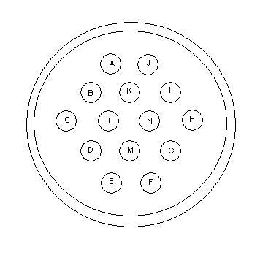 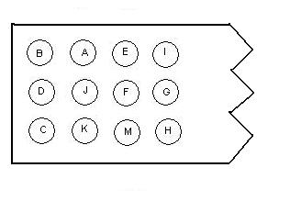
Box Mount 14 Pin Connector PC Mount 12 Pin Power Header
Viewed from inside box Viewed from above

A: +15V (Red Pair, Light Wire)
B: Cal+ (Black Pair, Light Wire)
C: Cal Shield (Black Pair, Shield)
D: Cal- (Black Pair, Dark Wire)
E: E/W+ (Orange Pair, Light Wire)
F: E/W- (Orange Pair, Dark Wire)
G: N/S- (Yellow Pair, Dark Wire)
H: N/S Shield (Yellow Pair, Shield)
I: N/S+ (Yellow Pair, Light Wire)
J: -15V (Red Pair, Dark Wire)
K: Gnd (Red Pair, Shield)
L: No Connection
M: E/W Shield (Orange Pair, Shield)
N: No Connection

______________________________________________________________________________

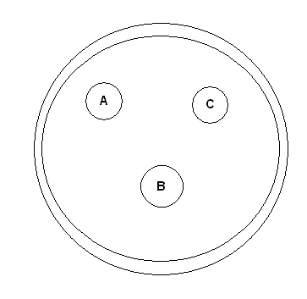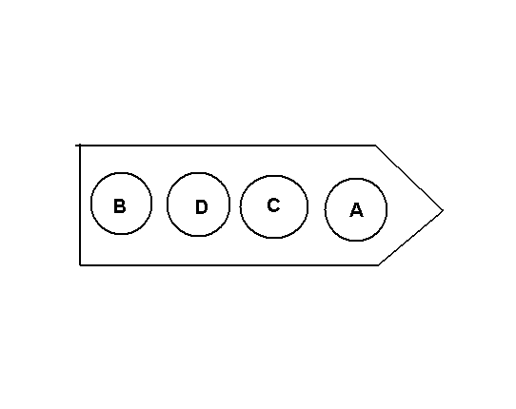
Box Mount Antenna Connector PC Mount 4 Pin Power Header
Viewed from inside box Viewed from above

A: Antenna+
B: Common
C: Antenna-
D: No Connection

viii.

Calibration circuit

The 2005 VLF receiver includes a calibration circuit so that the frequency response of the system can be measured at any given time. The calibration circuit block diagram is shown in figure 6

FPGA Control Line
Output Driver
Cable to Preamp
8.192 MHz Oscilattor
Figure 6: Calibration Circuit Block Diagram
Antenna Input Nodes
PIC Processor
The FPGA controls the calibration circuit, typically turning it on for one second every five minutes, however there are multiple modes selectable with the AuxA and AuxB jumpers. The output driver sends a 15V signal across to the preamp, activating an 8.192 MHz processor and a PIC processor. The PIC processor generates a pseudorandom sequence at 8.192 MHz. The pseudorandom sequence has a Fourier content consisting of uniform height spikes spaced out at 250 Hz. This sequence is applied to the input lines of the preamplifier. It is large enough to overwhelm incoming antenna signals but small enough not to clip the electronics. The calibration signal passes through the entire system. By isolating the 1 second long calibration signal and taking the FFT, it is possible to map out the VLF receiver’s response, at discrete multiples of 250 Hz.

The sample spectrogram in the introductory section shows what the calibration data looks like in the data – each vertical red stripe is a calibration tone.

Using a series of short acquisitions, it is thus possible to characterize the system in all possible modes. Detailed instructions can be found in the calibration section.

The calibrator on each preamplifier card must be tuned to provide a known output. The process of tuning can be found in the calibration section.

ix.

GPS Communication

Prepared by Justin Tan

GPS Timing Card
GPS Timing for the new HAIL system is internal to the Line Receiver. This reduces equipment costs and bulk.
Manufacturer: Motorola
Model: M12+ Timer

GPS Antenna
Any antenna approved for the Motorola M12+ Timer card is acceptable. The choice depends on the distance to the antenna, and the particular application. The antenna of choice for the HAIL system is the VIC-100 Timing Antenna, which is rated for outdoor use.

Model: VIC-100
Connector Type: N-type
Mounting Option: Pipe clamp
Cable Type: LMR-400 up to 150 feet

GPS Operation
The GPS card communicates through the Line Receiver via standard RS-232 serial communication. It uses Motorola Binary format, which always starts with the “@@” sequence, and ends with “<CR?>LF>” characters. The format is 8 bit payload, no parity, and 1 stop bit. Please refer to the Motorola documentation for more details.

The main command used for the HAIL system is the ASCII Position Information message.
To enable 1 pps output of information: “@@Eq<#01>5<CR><LF>”
To poll then disable 1 pps output: “@@Eq<#00>4<CR><LF>”

Cable Delay
Compensation for cable delay between the antenna and the GPS card can be configured. Please use the provided GPS_Console application to configure cable delay, and test the GPS card. Cable length should be set to the GPS antenna cable length.

Notes:
Once activated, the 1 pps information continually outputs information until power is removed or it is disabled with the appropriate command. The Motorola GPS card has a battery on it, which allows it to retain its settings for several days. If the unit is not outputting data, please use the GPS_Console application to ensure that the GPS card is outputting data.
If the computer is rebooted or turned on while the Line Receiver is on and the software has not been properly shut down, problems with PC mouse operation may occur. This is because the GPS card is communicating to the computer’s serial port while the computer is initializing its drivers. If this occurs, turn off the Line Receiver (or disconnect the serial cable), and reboot the computer. Wait for the computer to enter Windows before reconnecting the Line Receiver.
If the GPS Console program does not seem to be working at all, sometimes another program is needed to initialize the COM port. Use a free serial port monitor (Windmill Comdebug) to open then close the port.

Serial settings are:
Data bits: 8
Parity Bit: none
Stop Bit: 1
Baud: 9600

Hardware Source:
Synergy Systems
www.synergy-gps.com

x.
FPGA Code

HAIL System FPGA Specifications

FPGA
The HAIL system uses an FPGA to generate sampling signals.
Manufacturer: Altera Corporation
Model: EPM7064AELC44
Package Type: PLCC 44 Pin
IO Voltage: 3.3V
Internal Voltage: 3.3V
Speed Grade: -3 to -7

Source Clock
The HAIL FPGA is driven by a 10 MHz oscillator.
Manufacturer: Vectron International
Model: VTA1-1B1 10MHz (the VTA2 is just a lower profile version, it would also work)
Frequency: 10.000 MHz
Stability: ±1 ppm
Waveform: 0 V – 3.0 V CMOS square wave
Features: Voltage controlled trim

Verilog
Top Level Module: HAIL_LOGIC.v

100 kpps Sampling
Module: GPS_PULSE_100KPPS.v
The HAIL FPGA controls the 100 kpps sampling frequency. It uses the source 10 MHz clock and counts up to 100 to create a 100 kHz square wave signal. The 100 kpps signal is aligned every second to the 1 pps input signal from the Motorola GPS board.

GPS Communication
Module: HAIL_LOGIC..v
GPS communication signals are routed through the FPGA. Currently nothing is done to the signals but it does allow for future control over the Motorola GPS board.

Calibration Tone
Module: HAIL_CALIBRATOR.v
Timing to turn on the calibration signal (see Calibration Circuit), is controlled by the FPGA. It uses a series of counters driven by the GPS 1 pps signal to turn on the cal signal periodically. There are currently 3 settings for the calibration period. These are controlled by the auxiliary jumpers on the motherboard.

No jumpers – normal 300 second period operation.
AUXA – once per minute for 0.2 seconds each time.
AUXB – 400 second period (Currently not supported, DO NOT place a jumper on AUXB unless you have read the additional notes section – there is an error on the circuit board)
Note: do not place jumpers on AUXA and AUXB at the same time.

Clock Adjustment
Module: CLOCK_ADJUST.v
To ensure accurate sampling with the 100 kpps signal, the FPGA controls the level of the voltage trim on the 10 MHz source clock. Sending values to an external DAC, the FPGA detects once a second if the count to 100 is short or over, and adjusts the value to the DAC accordingly. The value eventually converges to a value, and usually takes up to 5 minutes to converge. (See Clock Accuracy section)

xi.
Antenna Design

The basis of the 2005 VLF receiver is a 1 Ω, 1 mH, antenna. The antenna type is air core magnetic wire loop antenna, which means it consists of a single long wire wrapped one or more times in a loop, in such a way such that the total resistance of the wire loop is 1 Ω, and its self-inductance is 1mH. This introduces a high pass cutoff of 159 Hz due to the electrical properties of the antenna. Magnetic field changes induce electromotive forces in the wire, inducing currents in the loop. The Paschal report lays out several possible configurations of wire that meet these requirements, and derives the physics of current induction. They are reproduced here for convenience

Some Valid Antenna Configurations
 | Length | AWG | Turns | Area | Weight | Wire | mV / pT (Input)
Square | 16.0 cm | 20 | 47 | 256 cm² | 0.132 kg | 30.1 m | 1.652E-02
Square | 56.7 cm | 18 | 21 | 0.3215 m² | 0.331 kg | 47.6 m | 9.271E-02
Square | 1.70 m | 16 | 11 | 2.89 m² | 0.831 kg | 74.8 m | 4.365E-01
Square | 4.90 m | 14 | 6 | 24.01 m² | 2.09 kg | 117.6 m | 1.978E+00
 | 2.60 m | 16 | 12 | 1.69 m² | 0.838 kg | 75.3 m | 2.785E-01
Right | 8.39 m | 14 | 6 | 17.60 m² | 2.15 kg | 121.5 m | 1.450E+00
Isosceles | 27.3 m | 12 | 3 | 186.32 m² | 5.56 kg | 197.7 m | 7.675E+00
Triangle | 60.7 m | 10 | 2 | 921.1 m² | 13.1 kg | 293.1 m | 2.530E+01
 | 202 m | 8 | 1 | 10201 m² | 34.5 kg | 487.7 m | 1.401E+02

There are two shapes of antennae, square and isosceles triangle. The “length” characteristic of the square shape refers to the length of a side. The “length” characteristic of the right isosceles triangle corresponds to the height of the base (which is along the ground). Because it is a right isosceles triangle, the triangle’s height is half that of the base. The antenna thus makes a 45° angle at both corners on the ground, and a 90° angle at the top (mast). The AWG column refers to “American wire gauge”, a measure of the thickness of the wire used to wind the antenna. A lower AWG means a thicker wire. Naturally, the larger antennae will need thicker wire in order to keep the resistance below 1 Ω. The turns column refers to the number of times around the wire is wrapped, and the last column shows the length of wire required for the antenna loop (of course, you will need to leave some extra length on each side as well, to connect it to the receiver.

Antenna size selection should be made based on the desired sensitivity, analysis of data, and noisiness of site. The larger the antenna, the more sensitive the VLF receiver will be. The sensitivity is proportional to the area of the antenna. For noisier sites, when only narrowband data will be useful, either the 2.89 m² square antenna, or the 1.69 m² triangular antenna will probably be sufficient, and its smaller size will make it easier to set up. For quieter sites, or broadband sites, you can use the 24.01 m² square or the 17.6 m² triangle. For very superbly quiet sites, and when only the best in sensitivity is desired, you can use the 921 m² triangular antenna, but of course this will require a lot of effort to hold in place mechanically. The 10201 m2 triangular antenna is probably too big for any application unless you are able to affix it to a permanent structure, but not one that is anywhere close to electromagnetic interference sources.

The antenna should be oriented in a consistent, repeatable, and documented fashion, in order for data from all different sites to be compared. We recommend orienting the antenna in the following fashion: Align the NS antenna so that the loop is in the NS plane, this can be either magnetic north or geographic north. You will need a compass or a GPS device to align it properly, or some way to determine direction to within a few degrees of accuracy. The other antenna should then be aligned along the EW direction, and the orthogonality of the two antennae should be checked with a T-square.

To ensure that the polarity of the antennae is consistent from site to site, we recommend orienting the +/- connections as follows: When you are standing to the north of the EW antenna, looking south at it, if you follow the antenna loop from the + side to the – side, the antenna loop should be clockwise. When you are standing to the east of the NS antenna, looking west at it, following the + connection to the – connection should go clockwise. Connect the antenna to the preamp using these configurations.

Design of an apparatus to physically support the antenna loops should be based on the specifics of the site – the weather, antenna size, ground condition, length of setup, etc. However, here is shown a sample design that has been used for the 8.39m² triangular base antenna. This design is fairly easy to set up, however may not be so durable for high winds or extreme weather conditions. As such, it is only recommended for sites that will not see overly extreme conditions, or that will be monitored on a regular basis by someone who can repair it if it breaks down.

The next page shows pictures of the antenna. The triangular antenna features a single vertical mast, axxifed to the ground via a wooden board that is bolted down. Four guidewires (two attached just below the top of the mast, two about halfway up the mast), stabilize the mast, and are staked into the ground so that guidewire is taut, but not too tense. Finally, the four antenna loops are locked into place at the top of the mast, stretched out, aligned to the proper directions, and then staked into the ground.

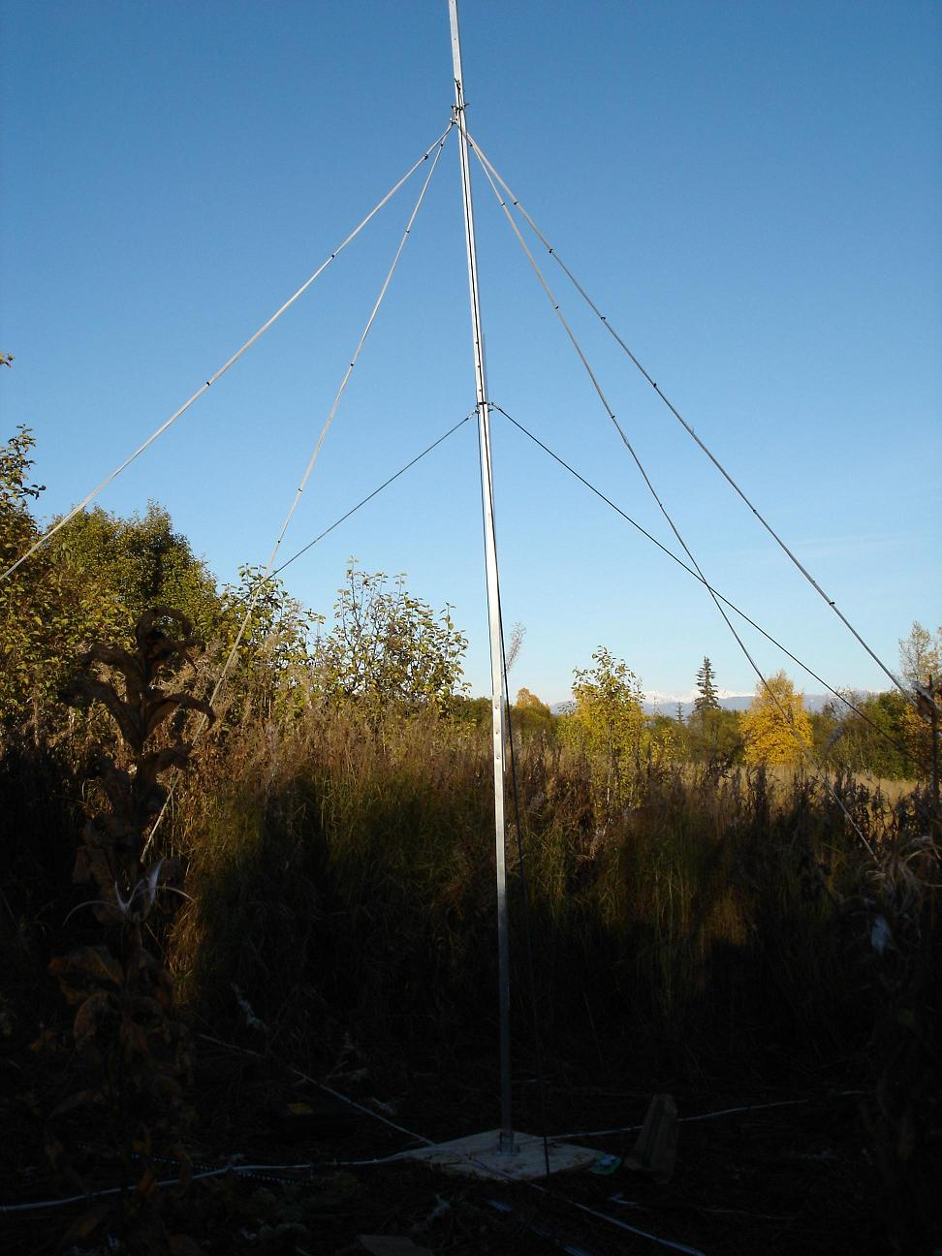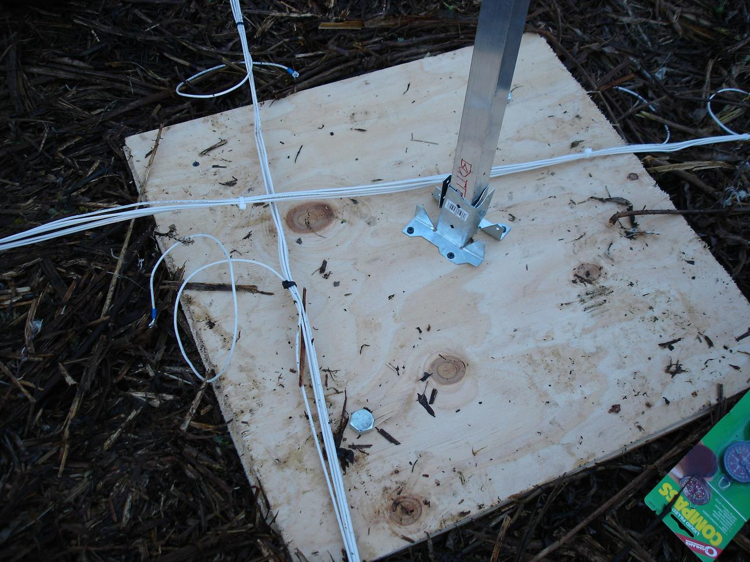
Antenna Mast with Guidewires Base of Mast Secured to Ground

Here is a complete parts list for this particular antenna design

Function | Part Description | Qty
elevate antenna loops on mast | Aluminum poles - square 1.25" OD x 6ft. | 3
 | Antenna wire loops | 2
join sections of mast | 18-8 SS hex cap screw. 1/4" - 20 x 3" | 6
fix cap screws to mast | 18-8 SS Hex nylon insert lock nut | 6
attach guy wires and antenna to mast. | wire eyebolt 5/16"-18, 2" shank | 10
fix eyebolts to mast | 18-8 SS hex nut 5/16" - 18 | 10
 | spring lock washer 5/16" | 10
attach guy wires to turnbuckle | jaw 5/16" left hand thread | 4
tighten guy wires | galvanized turnbuckle 5/16" | 4
quick clip guy wires to mast eyebolts | 316SS spring snap | 6
guy wires | vinyl coated steel rope (2x20ft + 2x15 ft) | 70ft
crimp loops in guy wires | oval compression sleeves | 8
form loops at ends of guy wires | light duty wire rope thimble | 8
stake antenna loops and guy wires into gnd | concrete form board stakes with holes | 8

xii.
Dummy Loop Design

The 2005 VLF Receiver includes a design for a dummy loop. The dummy loop places external signals, like that from a function generator, across an impedance that is equivalent to the antenna’s. It is thus possible to inject signals into the input of the preamp for testing and characterization. Aside from testing and calibration, however, a dummy loop is not needed for operation of the 2005 VLF receiver.

The dummy loop functions by splitting the input signal across two series resistors: one large (usually ~10 kΩ and one small (1 Ω of the antenna). The smaller corresponds to the antenna impedence. So, to figure out the signal that is placed at the input, apply simple voltage divider rules. If you input a 100 mV signal, split between 1 Ω and 10 kΩ, then the signal applied across the input will be 0.1 * 1/(1 + 10000) ~= 10 uV.

The following pages shows a schematic for the dummy loop, and a complete parts list. Each dummy loop has two input circuits into it, allowing separate signals to be injected into the different channels. Below you will also find pictures of a fully built dummy loop, and a parts list.

Dummy Loop
Electrical Components
Ref | Value | Description | Supplier | Part #
C1 | 0.1 uF | Ceramic Capacitor | Digikey
C2 | 0.1 uF | Ceramic Capacitor | Digikey
R1 | 10 kOhm | 1% Metal Film Resistor | Digikey
R2 | 1.1 Ohm | 1% Metal Film Resistor | Digikey
R3 | 10 Ohm Pot | 10 Turn Potentiometer | Digikey
R4 | 10 kOhm | 1% Metal Film Resistor | Digikey
R5 | 1.1 Ohm | 1% Metal Film Resistor | Digikey
R6 | 10 Ohm Pot | 10 Turn Potentiometer | Digikey
J1 |  | Vertical BNC Post | Digikey | A24513
J2 |  | Four Pin Power Header | Digikey | WM1626
J3 |  | Vertical BNC Post | Digikey | A24513
J4 |  | Four Pin Power Header | Digikey | WM1626
L1 | 1 mH | Inductor | Digikey | DN2436
L2 | 1 mH | Inductor | Digikey | DN2436
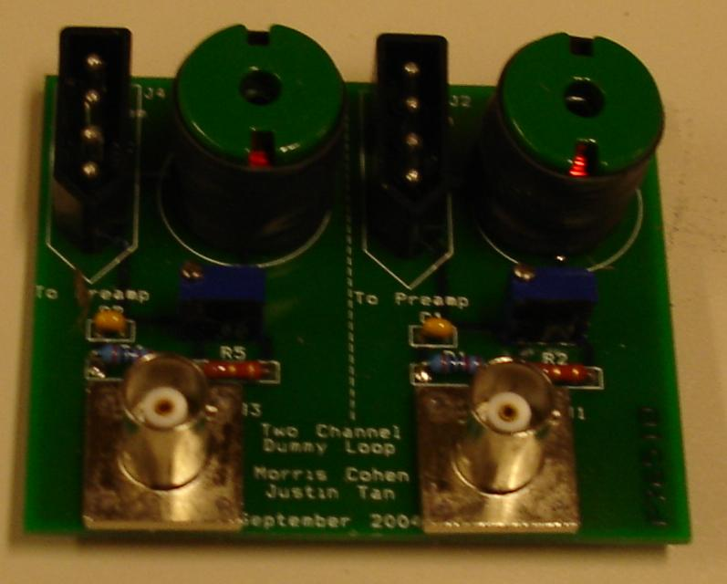

The potentiometer is used to adjust the resistance so that it is exactly 1.00 Ohm.

xiii.

Hum Sniffer Design

The Hum sniffer is being developed over Summer and Fall 2004 by Ambert Ho, and will be described here in detail upon its completion.
.

xiv.

Testing and set-up

Once the antenna is successfully set up, the process of connecting the 2005 Stanford VLF Receiver and readying it for acquisitions is as follows:

- Plug in the computer and monitor, and connect the mouse and keyboard. Make sure the appropriate hardware in installed, including a DVD burner (if necessary) and the NI-DAQ PCI card. Make sure all necessary supporting software is installed on the computer…..including StanfordDAQ, an appropriate DVD burning software, the NI-DAQ software, and Matlab.
- Set up icons on the desktop for the DAQSoftware program, for Matlab, for the DVD burning software, and for the Data folder.
- Create a text file with the sentence “A Reboot has Occurred”. Place this text file in the programs/startup folder in your Windows XP start menu.
- Place a shortcut to the StanfordDAQ program in the programs/startup folder in your Windows XP start menu.
- Open the line receiver (in the red box) and make sure that all screws are tightened, all cards are in place, all connectors are in tightly, the jumper settings are correct. Place the cover on the line receiver but do not screw it shut until testing and calibration is complete, as you will need access to the inside of the line receiver. Make sure there is a working fuse already installed.
- Attach the line receiver to the computer with two cables: A nullmodem serial cable, and an ADC cable which has blue 50-pin connectors on the ends. Both these slots should be labeled on the back of the preamplifier, and should fir it exactly one slow on the back of the acquisition PC.
- Connect the GPS antenna via the N-Type cable to the connector on the back of the line receiver.
- Plug in and then turn on the line receiver.
- Open the “StanfordDAQ” program on the PC. Within a second or two, you should see all the GPS coordinates, times, displayed. If the system has been cold for a long time, it may take a few minutes for the GPS card to locate enough GPS receivers to know the time and location. The “time quality” field reflects on the number of satellites found by the GPS card.
- Run a test acquisition using the instructions described in the software guide. Make sure that the acquisition begins and ends at the proper time and that the correct files appear in the data directory.
- Open up the preamplifier (in the silver box), and check to make sure all screws are tight, now chips or part have fallen out or come loose. If they have tighten or replace them again.
- Connect the preamplifier to the line receiver using the long Belden 1217B cable. This thick four twisted pair shielded cable will transfer power from the line receiver to the preamplifier, and signals from the preamp to the line receiver.
- Turn the gain switch all the way counterclockwise, on the big baseboard of the preamplifier. The LED next to “30dB” should be illuminated, and the mode from that point can be changed by flipping the switch. All modes that are past 0 dB (which aren’t labeled) are also 0 dB, but keep the switch in one of those four positions.
- Run another test acquisition and again make sure it runs as predicted.
- Attach a dummy loop to the ends of the preamplifier (the input) and follow the calibration instructions outlined later in this packet. Be sure to check that the preamp cards are balanced before proceeding with the calibration.
- Replace the dummy loop connection with an antenna connection, and this should complete the setup.

xv.

Calibration and Characterization

All VLF receivers should be characterized in the field, in order for data to be analyzed from site to site with a common reference. The calibration should be done only when the entire unit is set up, so that the effects of the particular antenna, cable, etc, can be included.

All calibration should be done only when the hardware has been fully tested to work. Specifically, make sure the preamplifier cards are balanced. To balance them, use a multimeter to measure the DC voltage at the base of Q3 and Q4. If those DC biases are not equal, tune the potentiometer R6 until they are equal. Balancing the two branches of the amplifier circuit will ensure that the noise rejection, specifically at the common mode, is at its peak.

In addition, the calibration circuit must be tuned to provide a known output before calibration can begin. To do this, measure the voltage between (1) the node between R46 and R48, and (2) the node between R47 and R49. Tune the potentiometer R51 until this voltage difference is 2.0 Volts peak to peak. This will generate a 1.00mV RMS signal at each frequency component (spaced out by 250Hz). Using this, and the antenna sensitivity, you can convert any voltage to a magnetic field, bearing in mind that the ADC card uses 16 bit sampling, and has a range of +/- 5V, all you need to do is look at the values after one recording..

Calibration will require the use of a dummy loop. A dummy loop replicates the impedance of the intended antenna, and enables signals to be injected at the input of the system. The dummy loop’s design and functions is described elsewhere. Throughout the characterization process, the dummy loop (or an antenna) should be connected to the preamplifier’s input, because system’s response (particularly at low frequencies) can be properly estimated only when the VLF input is loaded with the same impedance as it would with an antenna.

The process of calibration in the field requires executing a series of test recordings and observations of the VLF receiver’s outputs. Within DAQSoftware is a folder called “Calibration”. The folder contains a hierarchal tree of folders to divide up the calibration tests by preamp cutoff setting, preamp gain setting, and injected signal type. Initially, all acquisitions will be represented by an empty text file, which act as a place holder until a MATLAB file for that particular test is inserted. Namely, for each preamp frequency setting and gain setting, the following tests should be run:
- 10mV signal injected into both channels
  - 1 kHz
  - 2 kHz
  - 5 kHz
  - 10 kHz
  - 28 kHz
- 100mV signal injected into both channels
  - 1 kHz
  - 2 kHz
  - 5 kHz
  - 10 kHz
  - 28 kHz
- 100mV, 10 kHz signal injected into only NS channel
- 100mV, 10 kHz signal injected into only EW channel
- No signal into either channel
- Sample VLF data

The fourteen different tests, for the four different gain settings, and the three different cutoff sections, make a total of 168 different acquisitions needed. However, any gain mode or frequency cutoff mode that is intended not to be used probably does not need to be characterized.

For tests #1 and #2, in addition to creating and saving a recording of an acquisition, the output of the receiver should be viewed with an oscilloscope, and the observed amplitudes included in the text file called “observed values”. These tests characterize the response of the entire system to common mode signals, both large and small signal. Tests #3 and #4 test the cross talk between the two data channels. It is important that the channel that is not being injected with a signal should have its calibration signal disabled. So if injecting a signal into the NS channel only, it is necessary to remove the Gnd Attach jumper in the EW preamp card. And vice versa. Tests #5 and #6 merely establish the noise response of the system and show it’s ability to acquire VLF data.

During calibration, the jumper AuxA on the line receiver should be connected. This will enable the automatic calibration tone (described elsewhere) to be triggered once every minute. Thus, all test acquisitions for characterization need only be a minute long. It is important to remove the AuxA jumper when characterization is complete, which will restore the calibration tone to the default setting (one trigger every five minutes).

xvi.
Using the software
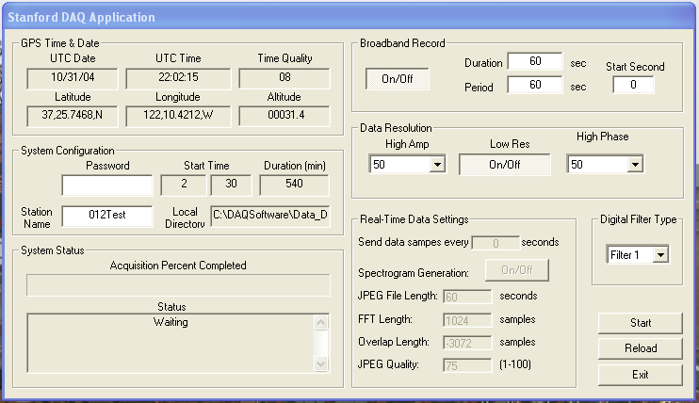
The StanfordDAQ Software
Overview to Using the Stanford DAQ Software

The Stanford DAQ (Data Acquisition) Software acquires data from the Very Low Frequency (VLF) receiver according to a daily schedule, and places the data in files on your computer. This guide will walk you through how to set up the data acquisition schedule, how to find the data and put it on disks, and how to manage the software. See the previous page for a picture of the software.

The software is made up of two components. The main program is called Stanford DAQ Software, this program does all of the work of processing the sampled data from the receiver and writing it to files. The second program is called Matlab. Matlab is a powerful computing software used by scientists and engineers but for our purposes it is used mainly to setup and alter the main DAQ software program.

Any problems with using the software or any errors found should immediately be reported to the Stanford VLF Group. Please contact Morris Cohen (mcohen@stanford.edu, 650-799-3674), or Jeff Chang (jccchang@stanford.edu (650-723-1460). Please include the status of the lights on the receiver (red box) and the time fields from the software if you are sending an email.

Connecting the Receiver to The Computer

To begin, make sure the line receiver (the red box) is connected to the computer properly. The line receiver should be plugged in to the wall, and turned on. When this happens the blue light on the front should be lit.

The line receiver connects to the computer with two cables – the first is a large blue cable labeled “National Instruments”. This goes from the slot on the line receiver labeled “PC ADC” to the corresponding slot on the back of the PC. The second connection is a serial cable (null-modem) which goes from the line receiver slot labeled “PC Serial” to the serial connector on the back of your computer.

In addition, you should have the GPS antenna and the preamplifier cable plugged into the other connectors. Make sure all connectors and cables are on tight.

In general, it is a good idea to leave the line receiver on at all times, even when not acquiring, and only turn it off only when you won’t be acquiring data for many days in a row. It is important, however, that anytime you reboot the computer for any reason, you should turn off the line receiver until the computer has finished booting. If the line receiver is on when you boot up, you may at times see the mouse arrow jumping all over the screen. If this happens, turn off your line receiver and reboot the computer again.

Opening and Viewing the Software

There should be shortcuts on your desktop that allow you to easily open and run either Stanford DAQ Software or Matlab. In addition, the Stanford DAQ Software automatically starts up when the computer is rebooted.

Anytime that you close or open the Stanford DAQ Software, it is important that the line receiver be on. The computer sends some bootup and shutdown information when the program is opened and closed, but if the line receiver is off it will not receive it, of course. The Stanford DAQ program can be opened using the shortcut on your desktop, but if you lose that, the program is located in C:\DAQSoftward\StanfordDAQ.exe

You should close all unneeded programs when using Stanford DAQ, and use only the programs described in this guide.

Soon after you open the Stanford DAQ program, you should see the date, time, and location where you currently reside in the top left area of the program window. This information is derived from a Global Positioning System (GPS) section in the line receiver, which communicates with satellites using the GPS Antenna. Make sure that the time is correct (note that is Universal Time, or UT, which is also Greenwich Mean Time, and not your local time), and appears to be running smoothly.

On the right edge of that section is a field called “Time Quality”. This refers to the number of GPS satellites that the line receiver is currently communicating with. When you first turn on the line receiver, that number should be zero, but after as long as several minutes this number should start to increase. Beyond that, the time quality should remain at 5 or higher at all times, if it does not, notify the VLF group that there may be a problem.

The Stanford DAQ program also shows a number of other settings for broadband acquisition, jpeg creation, but in general these can be ignored. The program is mostly for monitoring the acquisitions, and you should see a field on the left half that shows when the next acquisition is scheduled to take place.

Only some of the field values (i.e. broadband duration, period) can be changed by the user, to change these fields, you need to have the password typed in correctly into the password field. Other values such as the start time cannot be changed even with the password, these settings are changed by using Matlab as is described below.

System Name and Broadband Settings

You may want to change the name of the system. To do this, enter in the password, type in the desired name, then press the start button. Note that the change will not register unless you enter the password before typing the new name, and you press the start button after typing in the new name.

The broadband settings (in the top right corner) determine what kind of broadband recordings you want to do, if any. In order to make any of the changes, you will again need to enter in the password. The “on/off”button enables and disables the broadband recording (shutting it off means only narrowband recordings will be left). The “broadband duration” and “broadband period” determine what kind of cycle to use for the broadband file. For s synoptic recording, set the broadband period higher. For example, if the broadband period is 60, and the duration is one, then the program will capture and save one second of broadband data, once every 60 seconds, beginning at the start of the acquisition. To set up for continuous recording, set the period and the duration equal. So setting them both to 60 means that StanfordDAQ will record all the data continuously, and break it up into 60 second long files.

Since long files tend to be tougher to process, we recommend creating broadband files that are no longer than 5 minutes (300 seconds) in length. The most convenient size is 60 seconds since this can be easily brought up in MATLAB.

Closing the DAQ Software

If for some reason you need to close the Stanford DAQ Software you will need to type in the password to do so, this safety feature was implemented to ensure that data recording is not accidentally interrupted.

Using Matlab to Setup the DAQ Software

As mentioned above, Matlab is used to change settings on the DAQ software. There are two Matlab functions that setup the (1) acquisition schedule and (2) narrowband demodulator channels.

(1) Setting the Acquisition Schedule:
At different times, the VLF group will want to acquire data at different times of the day, which will require changing the daily schedule once in a while.

To change the daily schedule, open up Matlab using the icon on your desktop. Type “vlf” at the command line prompt (at the >>), in other words it should like this, and press enter.

>> vlf

A little dialogue box should then pop up. There are three fields to enter, labeled start hour, start minute, and duration. This is fairly easy to use, simply enter the information for the acquisition you want to perform, then press ok. Then press cancel, which will write the information to the relevant file.

So for example, if you wanted to acquire data for 10 minutes starting at 2:45 UT, you would enter “2”, then “45” then “10”, then press ok, then press cancel. If you look at your Stanford DAQ program, you should see that the program now shows that you are scheduled for 2:45. Note that doing so will erase your old acquisition schedule, not append to it, so the VLF receiver will acquire data at 2:45 for 10 minutes, every day, but other than that will be idle.

To set up multiple acquisitions in a day, simply enter each one individually, pressing ok after each acquisition, and when you’re done with all of the entries press cancel. So for example if you wanted to acquire at 2:00 for 10 minutes, and at 3:00 for 10 minutes, first enter 2, 0, and 10, then press ok, then enter 3, 0, and 10, then press ok, and finally press cancel. Do not make two acquisitions without a space in between. In other words if you have one acquisition at 2:00 for 10 minutes, don’t start another one at 2:10, it is better to make one long one, or start the second acquisition at 2:11 or later.

Make sure the acquisition file was written correctly by looking at Matlab, and you should see a line written that says “file written successfully”. In addition, you should see the next scheduled acquisition fields change automatically in the Stanford DAQ Software. When you are done with this, be sure close Matlab, as it takes up a lot of memory and slows up the DAQ Software.

Once the acquisition times are set, they will remain in place even the computer is rebooted, they only need to be reentered if you need to make a change.

(2) Setting the Demodulator Settings (narrowband recording):
The Stanford DAQ Software does a type of processing called demodulating on all the data acquired. This demodulating works by looking at the data at only a single very exact frequency, like for example VLF transmitters.

To change the list of transmitters and demodulator channels to monitor, open up Matlab, and type “narrow” at the command line (at the >>), in other words, like this, and then press enter

>> narrow

A dialogue box should appear that looks similar to the one for the daily acquisition schedule, except it should have five fields. Similar to the other Matlab script, you will enter the five bits of information for each demodulator station, one at a time, and press ok in between. When you’ve entered all the stations, press cancel which will write everything to the appropriate file. All the old settings will be lost, so only the ones you enter anew will become the list of demodulations.

The options are station name, frequency, scale, board, and channel. Station name is a 3 letter designation corresponding to the transmitter or frequency of interest. The frequency box is that of the channel in interest, typed in Hz, not kHz. Scale is needed for the ADC conversion, this number is typically 1000. Board refers to the number of the A/D card being used – which is only useful if you have multiple A/D cards on one computer. By default, this value should be 1. Finally, the channel field defines whether the N/S (channel 0) or E/W antenna (channel 1) is being monitored. Note that for a typical transmitter channel, you will monitor both antennae, so you will need to enter it separately for each direction.

Finding and Burning the Data

All the data collected will need to be burned to DVDs. Make sure that you do not try to burn DVD’s while the software is acquiring. All the data is located in the folder c:\DAQSoftware\Data_Directory\backup. You will notice within this are several more folders, each one corresponding to the data taken in one day. The folders are labeled accordingly by date, in YYMMDD format so 040926 would be the data from September 26, 2004. Within each folder you will find the raw data files (these files have .mat extension). These data files are also labeled with the data and time, so 040926130500.mat would be raw data beginning at 13:05 UT on September 26, 2004. The data files stored here are known as broadband because they contain the raw data, unprocessed.

Also within the folders for the data are more folders, each one labeled with the start time of the acquisition. The files within this folder should be significantly smaller, as this is what is known as narrowband information. In these files, only a single frequency is recorded. For each narrowband channel there will be two files – one larger and one smaller – corresponding to high resolution and lower resolution data. Both the amplitude and the phase are captured in the file.

To view either the narrowband files or the broadband files, simply double click on them from explorer. MATLAB should automatically open up and load the file. When the command prompt appears, if you are viewing broadband files, type in “vlfspec” to show spectrogram of the data. All other regular MATLAB functions can be used to explore data further, as in each file the actual data is stored to the variable called “data”.

All data captured should be saved or deleted, because the hard drive has limited ability to store data (~1.4 GB/hour of data). To burn to DVD, simply place an empty DVD in the DVD writer slot. When you do this, a program called Nero should automatically open up. If it does not, click the icon on the desktop for Neri. Follow the instructions to set up a DVD burning, and burn as much data as you can fit. Typically, a little more than 3 hours of broadband data should fit on one DVD, so if the acquisition schedule calls for 9 hours a day, you would need to burn 3 DVDs for each day of data.

Include the narrowband information on one of the DVDs. Since narrowband data takes up little space all of the narrowband data from one day should easily fit on a DVD along with other broadband data. Please label all DVDs, and be as consistent as you can as far as having the same DVDs for each day. It is best to write your location, the date and the time span in UT. Also note if narrowband data is included on that DVD.

For example
Valdez, Sept 26, 2004, 0300-7000UT narrowband included

If you always break the day up into 3 chunks of 3 hours, each on a DVD, and you put the narrowband on the first DVD, then please keep this consistent, and label every DVD as best as possible. If you begin to run out of postage materials or DVDs, notify the VLF Group who will get you more. Once you have verified that the data has been burned successfully on DVD, you should delete it from the computer hard drive unless instructed otherwise.

Viewing the Data

To view the data, simply switch to the appropriate directory in MATLAB, and type

>>load nameoffile

To generate a quick spectrogram of the entire file, simply type in vlfspec. This will place all the data in a spectrogram, though for files larger than 60 seconds this may take too long.

Hence, also included is a spectrogram viewer software, created from within the Stanford VLF group. To use this viewing software, simply type in

>>gen_spectro_interfacefinal

and the spectrogram viewing software will appear.

Raw data can also be retrieved directly using the matGetVariable command, which is used as follows:

>> a = fopen ('NAME_OF_FILE.mat','r')
>> rawData = matGetVariable(a, 'data', LENGTH_TO_RETRIEVE,
OFFSET);
>> data = rawdata;
>> fclose(a)

the raw data is always stored in a variable called ‘data’, and be sure to keep the single quotes around it. It is in an interleaved format, so the odd values are samples of the NS channel, and the even values are samples of the EW channel. In the above commands, replace lengthtoretrieve with the amount of data you want to take out. Since this is 100 kHz sampling on each channel, multiply the number of seconds you want by 200,000. So if you want to retrieve 10 seconds of data, lengthtoretrieve should be 2,000,000. Offset corresponds to the spot within the file where you want to take your data. For example, if you have a one minute long data file that begins at 1:00:00, and you want to retrieve the 10 seconds corresponding to 1:00:10 – 1:00:20, then you must offset by 10 seconds, which is again 2,000,000. The offset should always be an even number because the samples are interleaved in pairs. Once you have retrieved the data, you can view the spectrogram with the vlfspec command, or you can plot one channel at a time by entering these commands (this graphs the NS channel).

>> Ts = 1/100000;
>> plot((Ts:Ts:(length(data)*Ts),data(1:2:length(data))

and to plot the EW channel, simply replace data(1:2:length(data)) with data(2:2:length(data))

The Matlab files created by StanfordDAQ also store other useful information, like the data, time, location, etc. You can also retrieve other information about the data file by replacing the variable name ‘data; with another variable name. Here is a list of the variable names and what they mean.

Version
antenna_altitude
antenna_heading
antenna_latitude
antenna_longitude
channel_gain
channel_sequence
comments
data
num_channels
sampling_freq
siteName
start_day
start_hour
start_minute
start_month
start_second
start_year
time_diff_ns

xvii.
Deployment checklist

The following items are needed or recommended for any deployment:
Preamplifier
Line Receiver
Belden 1217B Cabling (for preamp to line receiver)
Short Belden 1217B Cable (for initial testing)
Computer (set up with the following)
  - DVD writer drive
  - DVD burning software
  - MATLAB
  - DAQ Software
  - National Instruments 6034E ADC Card PCI
  - NI-DAQ Software (comes with 6034E)
Monitor, keyboard, mouse
Surge Protector/Powerstrip
Nullmodem Serial Cable
GPS Antenna
N-Type Cable (for connection to GPS Antenna)
Short N-Type Cable (for testing)
Portable oscilloscope
Portable function generator
Antenna post parts (specified for 4.39m base, 2.19m height, 6 turn isosceles triangle)
  - Aluminum poles (3)
  - ¼-20 bolts (6)
  - ¼-20 nylok nuts (6)
  - 5/16 eyebolts (2)
  - 5/16 nuts (6)
  - long guide wires with 5/16 eyebolts and turnbuckle (2)
  - Carabiners (2)
  - Terminal lugs to fit 6-32 screw/nut (4)
  - Metal stakes (8)
  - Plastic rollers (4)
  - Plastic guards (4)
Antenna wire loops (2)
Toolkit, including pliars, wrench, hammer, screwdrivers, wire strippers, snips, spackle
Preamp mounting parts
Soldering iron and solder
Dummy loop
Cable connection for antenna to preamplifier (with 6-32 screwbolts and nuts)
1¼” PVC piping and hose clamps (for securing GPS antenna)
Compass (for aligning antenna)
Handheld GPS
Schematics and documentation
Sharpie (for labeling DVDs)
Blank DVDs
Prayer book or voodoo doll (you’re gonna need this!)
Spare filter cards, preamp cards, programmed FPGA, GPS card
BNC cables, banana plugs, alligator clips, wire
Multimeter
Power cables for computer, monitor, line receiver
Cable to connect line receiver to ADC card
Camera
Tape measure
Electrical tape
Caulk or other form of goop
Heavy duty putty
Drill
Bubble level (for aligning antenna)
Plumb (for aligning antenna)
Hum sniffer (for antenna spot selection and noise characterization)
Emergency help contact information: Morris Cohen (650-799-3674), Packard Room 12 (650-725-8446), Jeff Chang (650-814-0494), Packard Room 30 (650-723-1460), Umran Inan (650-804-0928), Ev Paschal (253-732-6910)
Maps
Cable ties
Spare fuses
Small machete (for clearing debris)
Walkie-talkie pair
Wood screws, nails
T-square

xviii.
Guide to CD Contents

A CD is currently being prepared that will contain all the soft documentation for the 2005 Stanford VLF Receiver. When it is completed, this section will feature instructions and explanations. on the contents of that CD.

xix.
Troubleshooting Guide

xx.

Additional Comments

The following additional notes should be known to those building or using a 2005 VLF Rceiver

      - There is an error on the preamp card, the ADG441BN (U8). Pin 13 should be connected to +15V, but it Is not connected on the circuit board. Thus it is necessary to manually solder a wire to some convenient +15V pin, like the positive side of C29. Note that without this fix, the system will still appear to work, but some distortion will be introduced due to this error.

      - T1 and T2 on both the line receiver’s motherboard and the preamp’s backplane are mislabeled. One of the sides is labeled “10 and Com” but this should really read “1W and Com”. The Stancor A-8096 line transformer does not have a 10W pin.

      - VERY IMPORTANT SAFETY ISSUE: Make absolutely sure, when building a VLF receiver, that all pins that are attached to the 110VAC line are very well shielded and protected so that they cant be touched or shorted out. In the initial run of VLF receivers, the 60Hz EMI filter, power switch and fuse are placed behind a metal box, the same kind usually used in wall power switches. All exposed contacts are covered well with electrical tape or some other insulating material. The two contacts that connect to the external HAD power supply should be especially well covered and protected, since unlike the rest, they are not behind a metal box. IT IS HIGHLY RECOMMENDED THAT YOU AVOID TOUCHING ANYTHING WITHIN THE VLF RECEIVER WHILE THE POWER PLUG IS INSERTED.

      - The AuxB switch was accidentally shorted so one of the power lines, so it will not work. AuxA is not typically needed so this is not a major issue, but in order to use AuxB you will have to follow these instructions:

      - The polarities of the line transformers on the output of the preamplifier and the input of the line receiver are not properly labeled. Please use the following orientation when you are building a receiver.

xxi.

Acnowledgements

Justin Tan and Morris Cohen, the chief creators of the 2005 Stanford VLF receiver, would like to thank the following people for the help and contributions to this long but rewarding process:

Professor Umran Inan – for providing guidance throughout the process, maintaining a high standard
Shaolan Min – for processing PO after PO after PO after PO and still putting on a smile
Dr. Evans Paschal – for endlessly helpful advice and consultations
Robert Moore – for help in updating the acquisition software for use in the new receivers
Jeff Chang – for lots of good suggestions and general help around the lab
Joe Payne – For advice on the anti-aliasing filter card and GPS card

xxii.

User Comments
Use this page for keeping your own comments and notes about the Stanford 2005 VLF Receiver

______________________________________________________________________________

______________________________________________________________________________

______________________________________________________________________________

______________________________________________________________________________

______________________________________________________________________________

______________________________________________________________________________

______________________________________________________________________________

______________________________________________________________________________

______________________________________________________________________________

______________________________________________________________________________

______________________________________________________________________________

______________________________________________________________________________

______________________________________________________________________________

______________________________________________________________________________

______________________________________________________________________________

______________________________________________________________________________

______________________________________________________________________________

______________________________________________________________________________

______________________________________________________________________________

______________________________________________________________________________

______________________________________________________________________________

______________________________________________________________________________

______________________________________________________________________________

______________________________________________________________________________

______________________________________________________________________________

______________________________________________________________________________

______________________________________________________________________________

______________________________________________________________________________

______________________________________________________________________________

______________________________________________________________________________

______________________________________________________________________________

The feedback should be able to improve further on 0.1 ppm since even fractions of a count per second error will eventually lead to clock adjustment. But since 0.1ppm is already below the GPS error we will stay conservative.

